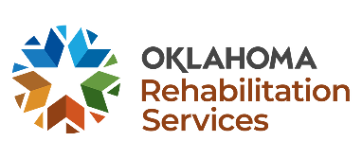
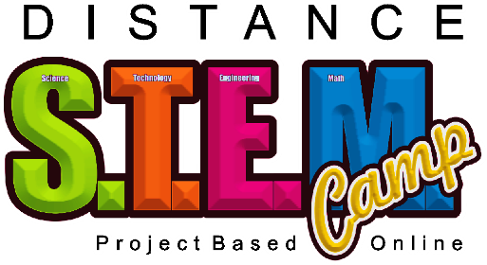
The 2021 DRS Distance STEM Camp is a no cost, three-day online camp.
Times: 10:00 a.m. to 2:00 p.m. Daily
Dates: This is an online, project-based camp with dates in June & July. *Dates and Registration Links are on page 2 of this flyer.
Who? Open to all Oklahoma students with disabilities anywhere in the state, ages 14-19 (i.e., on an IEP, 504 Plan, or other documented physical, mental, or cognitive disabilities). Parents, guardians, and siblings are encouraged to support this learning experience by helping if needed or wanted.
Requirements: Participants must have access to, and skills to use a computer, and inkjet color printer (all the activities have preprinted versions included, but to create custom prints you need a color ink printer).
Must have a high-speed internet access point (lessons will be streamed online).
Sign Up Early - Space Goes Quickly!
Must have an email address (some project files need to be emailed to Tech-Now Inc. for completion).
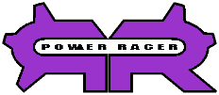
Must install the design software and ZOOM on the computer you are using for camp. Software is available for Windows, Mac OS, and Linux computers, no Android Tablets, or iOS Tablets supported. Links will be supplied as participants enroll in camp.
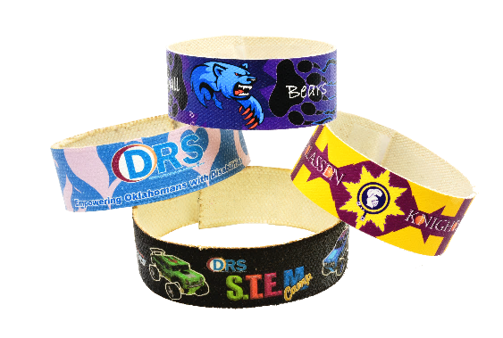
Must have a digital camera (can be a phone), and the ability to move pictures from the camera to the computer.
Must be able to use white glue, and E 6000 glue safely and appropriately.
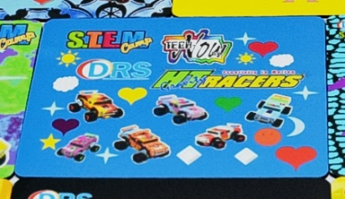
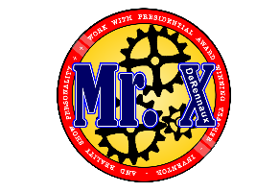
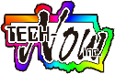
Must be able to safely use scissors.
Must be able to safely use a household iron.
What: Learn to use computers, software, and related technologies to design and create:
Power Racer Dragster – Gravity Racer – Full Color Patches for caps, jackets, and pants – Bracelet – T-Shirts – Mouse Pad – Pin Back Buttons – And More!
Learn about costs associated with manufacturing products, and how companies price products to make a profit to stay in business.
You will create all this using your computer, printer, and related technologies! Most importantly, you will develop technology skills that will last a lifetime!
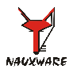
Contact Renee Sansom Briscoe, rsansom@okdrs.gov, at The Oklahoma Department of Rehabilitation Services for more information about the STEM Camp.
For information about Tech-Now email us at:
Tech-Now@hotmail.com
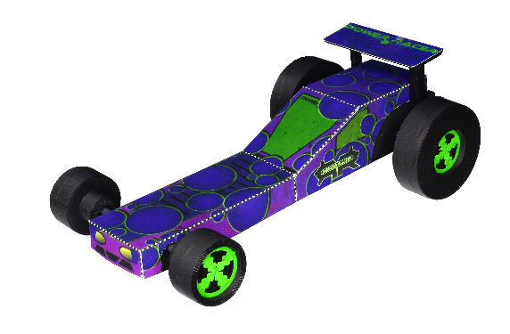
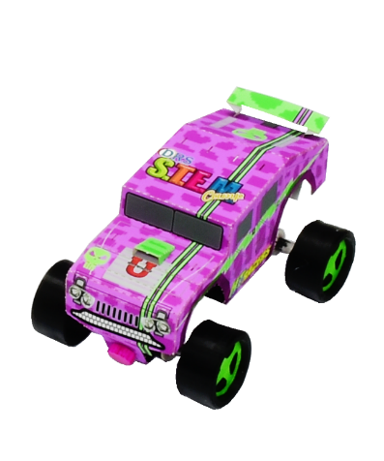
Click the link to view a video that highlights Disability Awareness Day 2021, and some of the activities planned for the 2021 DRS Distance STEM Camps
https://youtu.be/dumtbkS_bgU

2021 STEM Camp Dates

July 6 – 8
USE THIS LINK TO REGISTER: https://www.surveymonkey.com/r/L6322MM

July 13 – 15
USE THIS LINK TO REGISTER: https://www.surveymonkey.com/r/VKV8BKB

Listed below are the text descriptions of the poster images. All the poster images also have Alt Text descriptions.
The DRS Logo
A five-sided star with colored chevrons around the sides, with each chevron made up of three shades of the colors dark blue, blue, green, red, and orange. The star is white and to the right side are the words Oklahoma Rehabilitation Services.
The Distance STEM Camp LOGO.
At the top is the word Distance. At the bottom are the words Project Based, and Online in black. The center of the log has a green S, an orange T, a magenta E, and a blue M, and the word camp in yellow letters.

The word technology in the color green.
The word design in the color orange.
The words product development in the color orange.
The word engineering in the color magenta.
A student created blue mouse pad. The pad has six HT Racer pictures on it with stars, diamonds, hearts, circles, and moon shapes mixed with the racers. The pad includes the DRS, STEM Camp, Tech-Now, And HT Racer logos.
A picture of four bracelets that are stacked upon one another. The bottom bracelet is black with DRS Stem Camp in the center with a green HT Racer to the left and a blue racer to the right. Stacked on the left and right are two bracelets. A blue and pink heart covered bracelet with the DRS Logo, and a yellow and burgundy bracelet with a knight logo with the words Classen Knights.
The HT Racers Logo
The letters HT in neon green with the word Racers in bright yellow next to the HT. The word Gravity at a slight angle over the HT letters and in small letters along the top of the word Racers are the words Creativity In Motion.

An HT Racer Military Vehicle
A magenta-colored racer. Designed on the computer, printed, and assembled. The Racer is approximately 2.5 inches by 3.75 inches. It has the DRS, STEM Camp, and U Make This Stuff logos. The racer has a thin lime green double stripe that runs the length of the vehicle with a darker magenta alligator texture.
Power Racer Logo
The capital letters P & R that are stylized with gear teeth with the words Power Racer overlapping the P & R.
A Power Racer
A blue colored racer. Designed on the computer, printed, and assembled using 3d printed parts and the color printed racer body. The Racer is approximately 3.25 inches by 6 inches. It has the U Make This Stuff logo. The racer has a thin blue stripe on the sides that runs the length of the vehicle and blue flames on the hood.
Mr. X Logo
A red circular ring with the text Presidential Award-Winning Teacher, Inventor, and Reality Show Personality following around the circle. Mr. X is in large blue text with the last name DeRennaux, inserted on, and in alignment of the slash mark of the x. There are three gears inlayed on a yellow circle within the red ring.
Tech-Now Logo
A rainbow of colors surrounds a shape of the state of Oklahoma, with the words Tech-Now Inc. in black letters on the Oklahoma State shape.
The U Make This Stuff Logo
A large red uppercase U with the words Make This Stuff in black in front of the large U.

