MEMO: Compensatory Services Due to the COVID-19 Pandemic

TO: | District Administrators, Directors of Special Education, School Administrators, and Other Interested Parties
FROM: | Todd Loftin, Deputy Superintendent  OSDE Office of Special Education Services

Compensatory Services due to COVID-19 can be thought of as "recovery services". These are services that are determined necessary due to how the pandemic has impacted the student's services and skill progression due to school closures, quarantine, virtual learning, and distance learning.

FAPE (Free Appropriate Public Education)
Local education agencies (LEAs) and Individualized Education Program (IEP) teams remain responsible for ensuring that a FAPE is provided to all children with disabilities despite the changes in circumstances caused by the pandemic. (Click here for additional information)

LEA Review of Data
As schools consider the impact disruptions in learning may have had on student growth during the 2020-21 school year, it is important for schools to develop a plan for district and classroom assessments that allow all students to showcase their knowledge and skills related to various subjects. Quality benchmark and classroom formative assessment can assist educators in identifying gaps in learning and provide educators with the best information to assist them in designing instruction that builds upon students’ knowledge and abilities.
Students receiving special education services should be included in these plans. LEAs and teachers should be using data from these assessments to plan for scaffolding supports students may need and identifying any necessary changes/additions to their instructional plans and strategies. For many students receiving special education services, such additional supports and services provided as part of general education instruction may be all that is needed.

Special education directors and/or other designated personnel need to assist teachers and IEP teams in locating and reviewing LEA and student level data to determine if compensatory/recovery services are necessary. Data gathered and reviewed should include data such as:

Data gathered and reviewed should include data such as:

Advanced Reporting in EDPlan
o Annual Goals Check, Current IEP/Eligibility Compliance, Parent Concerns Report, Present Levels Report, Secondary Transition Annual Goals, Service Report 2021 (ESY & Contingencies), and Shortened Week Length Report
- Progress Monitoring/Benchmark data
  - Special education directors and/or other designated personnel must ensure teachers have the tools and resources available to monitor and track student progress and compare the progress to:
    - The student’s performance before, during and after COVID
Disruptions
    - The progress of all students
- Observation and feedback
  - from teachers, related service providers, parents/family, and students
- Classroom Data
  - including grades, progress reports, classwork, completion progress in virtual programs, and informal/formal evaluation tools
- If applicable, transition data
  - results from transition assessments
  - progress toward transition goals
- Instructional Delivery Models and methods/strategies:
  - Amount, frequency, duration, type, and delivery model
  - Frequent changes in delivery model
  - Length of school closure and/or disruption (e.g., time without any instruction, time with virtual and/or distance learning)

Based on that data, IEP teams may determine that compensatory/recovery services need to be considered. If determined necessary, the team must specify which special education services need to be provided. As part of the IEP team, parents may also request that compensatory/recovery services are considered. As with the provision of compensatory services for the loss of a FAPE under normal circumstances, an individualized decision must be made concerning the time in which the services will be provided. Minute-per-minute replacement of services is not required. That decision, like all decisions regarding a FAPE, should be based on the student’s needs and not administrative convenience.

Determining If Compensatory/Recovery Services are Necessary
The following guiding questions may be utilized in this decision-making process
g data, what was the student’s rate of progress BEFORE the onset of the pandemic for academic and/or

Documenting Compensatory/Recovery Services

IEP teams should use the same documentation processes they have traditionally employed to document determinations of compensatory/recovery services. Many IEP teams document the determined services on a Written Notice and include information as part of the IEP’s objective statements. Importantly, the documentation should include detailed information regarding the services and the IEP team should determine a process to ensure the services are provided as documented.

Extended School Year v. Compensatory/Recovery Services

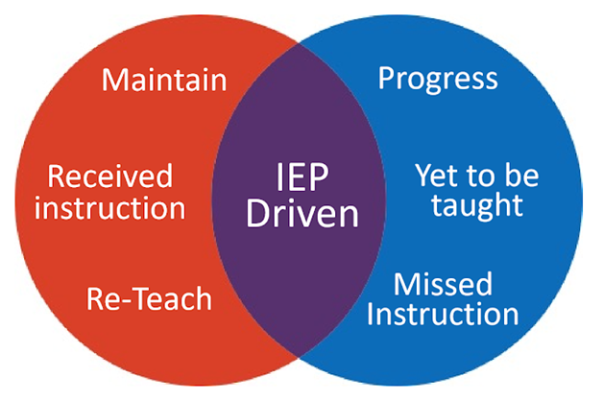

ESY and Compensatory/Recovery Services are not the same thing and a clear distinction should be made during IEP conversations. ESY must be considered for every student during the IEP process, annually, to determine if there is a severe skill regression when school is not in session. Compensatory/Recovery services due to COVID- 19 are services that are determined necessary due to how the pandemic has impacted the student's services and skill progression. The services should be designed to address any skill regression impacting the student’s progress in the general education curriculum and the student’s IEP goals, so that the student has the opportunity to make up lost skills. ESY and Compensatory/Recovery Services are similar in that they can both be provided by extending school day, over school breaks, intensive and targeted individualized programs, or by outside service providers. If compensatory/recovery services are provided during the school day, unlike ESY, the student’s least restrictive environment cannot be altered due to the provision of these services.

