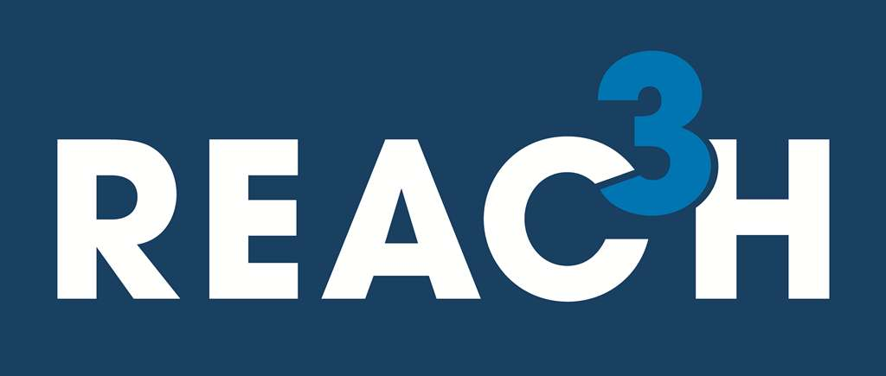
Regional Professional Development

Agenda

Secondary Teacher & Administrator Session:
8:00 a.m. - 11:30 a.m.

- Secondary Session Registration will be from 8:00 a.m. – 8:30 a.m.
- Secondary Breakout Session will be from 8:30 a.m. – 11:30 a.m.
  - 6-12 ELA
  - 6-12 Math
  - 6-12 Science
  - 6-12 Social Studies
  - 6-12 Art-Literacy Integration
  - Administrators

Elementary Teacher & Administrator Session:
12:00 p.m. – 3:30 p.m.

- Elementary Session Registration will be from 12:00 p.m. – 12:30 p.m.
- Elementary Breakout Session will be from 12:30 p.m. – 3:30 p.m.
  - K-2 Literacy
  - 3-5 ELA (including World Languages)
  - PK-5 Mathematics
  - PK-5 Science
  - 3-5 Social Studies
  - PK-5 Art-Literacy Integration
  - Administrators

