Office of Management and Enterprise Services
Job Aid: Running and modifying the Position Funding report
Process to populate and run EIB: Costing Allocation

Table of Contents
Contents
Table of Contents 1
Main Instructions 2
1. Agency Finance Partner running the ‘Position Funding’ report 2
2. Agencies modifying the ‘Position Funding’ report 2
3. Important items of note to reduce unnecessary delays 3
4. Send adjusted file through a SNow Request to Human Capital Management-PATT 4

Main Instructions

Agency Finance Partner running the ‘Position Funding’ report
Depending on the characteristics of the positions within a particular agency, the requesting agency should run one of two reports. Most agencies have costing allocations attached to the position restriction so they would run the ‘Position Funding – Position Restrictions’ report. A handful of agencies have positions that are classified as job managed, so these agencies would run the report ‘Position Funding – Job Management’. Both reports show all PINs that currently have a costing allocation. The requesting agency will need to download this to Excel.
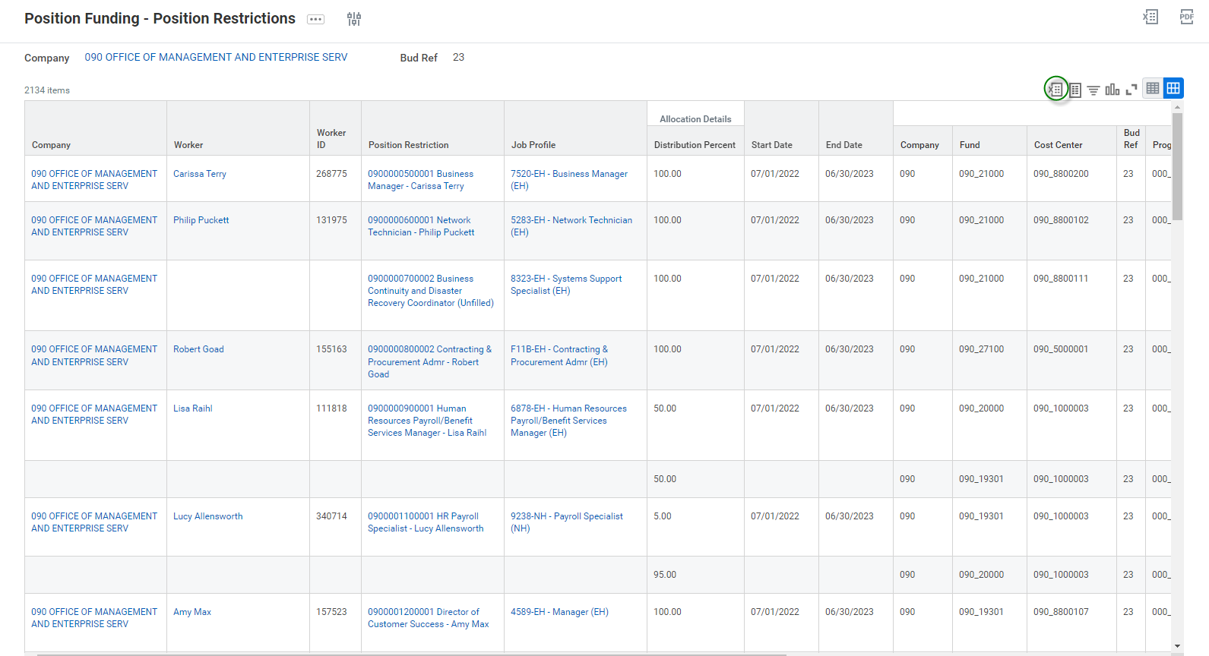

Agencies modifying the ‘Position Funding’ report
After downloading the report to excel, modifications are needed. As an example, in the following screenshots, we will be using the example of conversion from FY 2024 to FY 2025. On this file, agencies need to change the Start date to 07/01/2023, End Date to 06/30/2024, Bud Ref to 24, and any other chart fields that the agency requests to be changed. Do not change any formatting on the worksheet with the exception on the highlight mentioned below. Highlight any changes made to this report in yellow to be quickly able to see what changes are made.
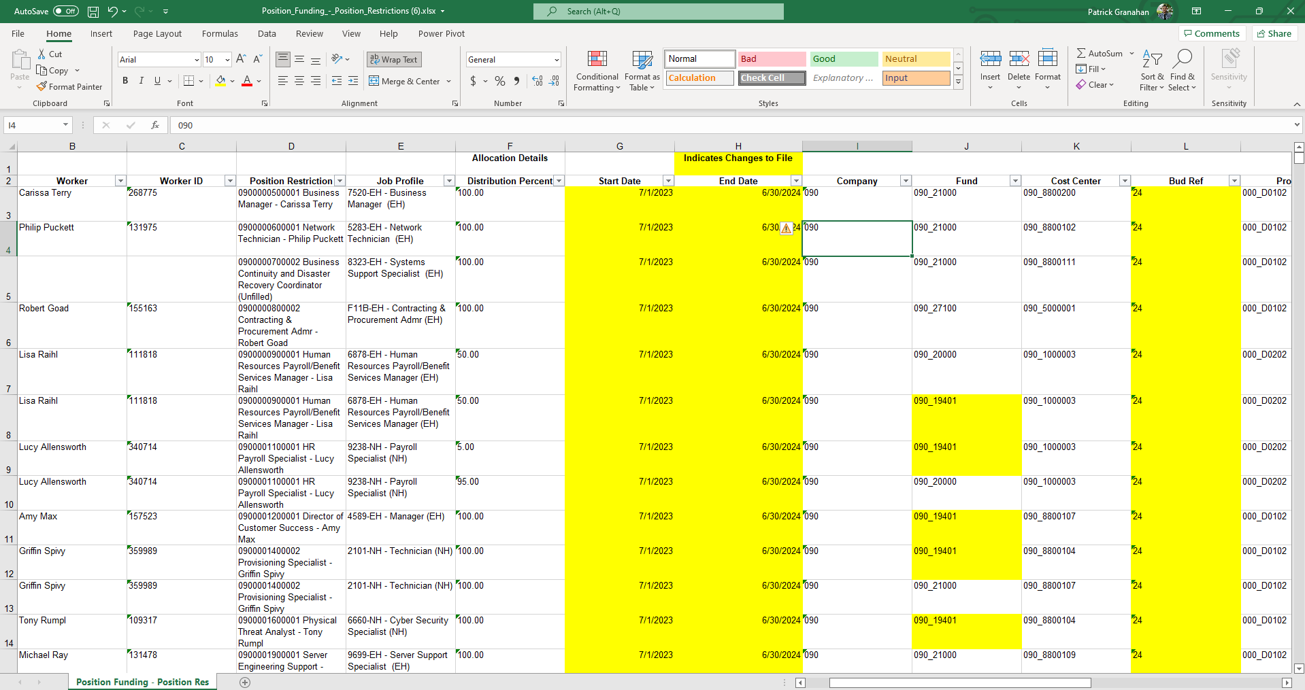

Important items of note to reduce unnecessary delays
- An agency needs to confirm that each Position Restriction has the Distribution Percentage = 100%.
This can be one funding line or numerous lines like 25%, 25%, 25%, 25% adding to 100%, etc. The result is the total of the combined lines for one PIN must equal 100%. This is an issue because the report will pull in all funding attached to the PIN even if it is old. This can lead to a PIN having a distribution percentage > 100%. In this case, enough of the lines need to be deleted where 1 PIN must have 1 or more lines totaling to a distribution percentage of 100%. See example below for an example of something that would need to be deleted.
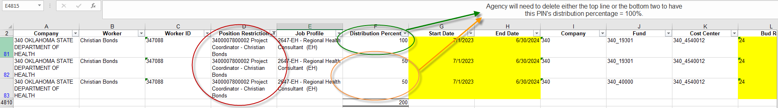
An easy check would be to pull all data into a pivot table by FTE and Distribution Percent, and ensure each FTE sums to 100.

- For unfilled position or those where the report shows the worker field as blank, you can choose to delete these from this costing update report. If a worker is hired to these unfilled positions in the future, then a costing allocation can be manually added by the agency on a needed basis.
Alternatively, you can retain the blank workers and *create dummy information for the file*

Send adjusted file through a SNow Request to Human Capital Management-PATT
After all necessary adjustments described above have been made, please submit the spreadsheet through ServiceNow [hyperlink OMES Employee Center Homepage - Employee Center], select ‘Request Assistance: Submit a Request’. In the body of your ticket request the group Human Capital Management-PATT. Your update will be processed, and when it is completed, you will be notified and the ticket closed.
This will enable our group to prepare and load the funding changes requested by your agency through the submitted document into Workday.

