Keyword Search Function
Users are now able to use the PeopleSoft Search function using the Looking Glass at the top right corner of the screen or the Keyword Search tab on the Regular Entry Voucher page.
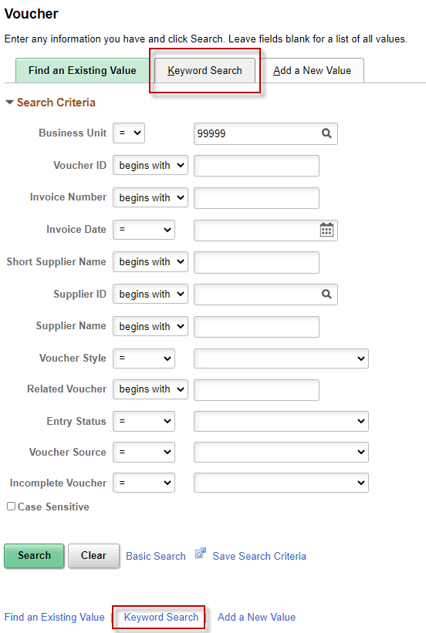

Looking Glass Search
Through the Looking Glass you have the option to search “All” or the “Navigator”.
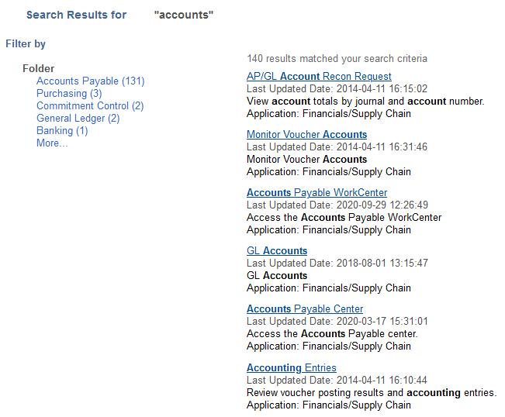
This is helpful when the user is looking for a particular page within the Navigator.

Regular Entry Keyword Search
On the Regular Entry Voucher page users may search by using the Keyword tab. By entering a keyword such as XEROX users can search all vouchers that contain the word XEROX. Users may also narrow their search by Business Unit, if your agency is responsible for more than one Business Unit, Invoice Date, or Supplier Name.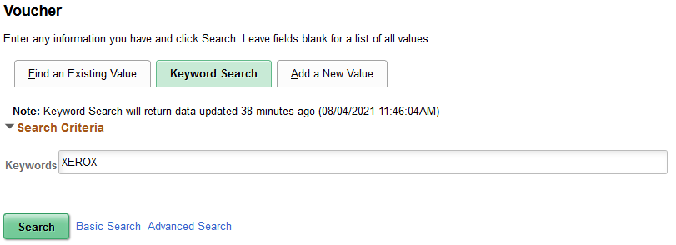
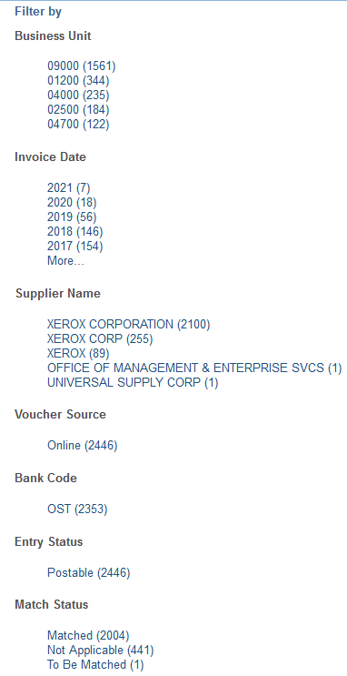
NOTE: The data provided by the search results are updated periodically. Recent Vouchers entered may not be immediately available.
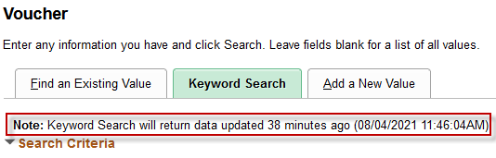

Advanced Search
The Keyword Search also offers an Advanced Search providing additional Search Criteria such as Budget Status, Approval Status, PO Numbers, and Receipts numbers.
