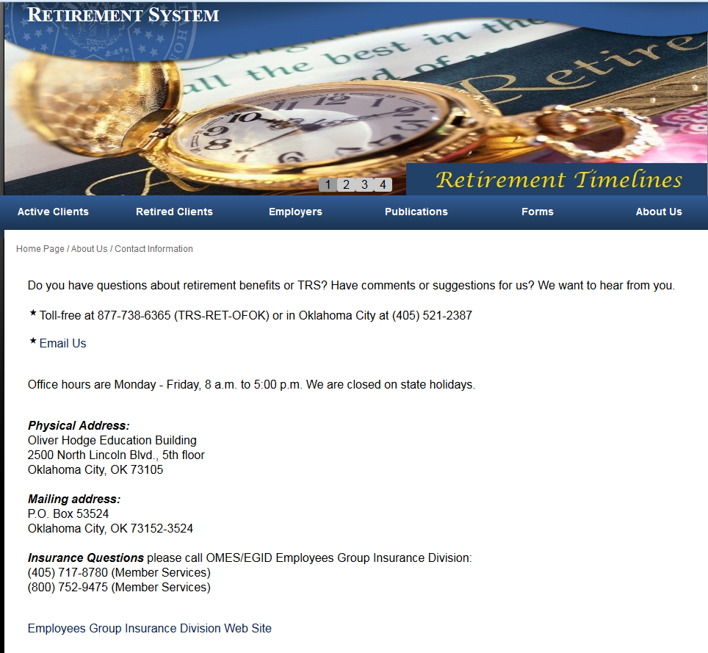
Your TRS Employer Reporting team:
Debra Plog
Employer Reporting Manager
405-521-2389
Debra.Plog@trs.ok.gov

Rocky La Marr
Business Analyst, Employer Reporting
405-521-3990
Rocky.LaMarr@trs.ok.gov

Helpdesk Direct Line 405-522-3130
helpdesk@trs.ok.gov

