2026 Ohio Traffic Safety Office - National Enforcement Mobilizations

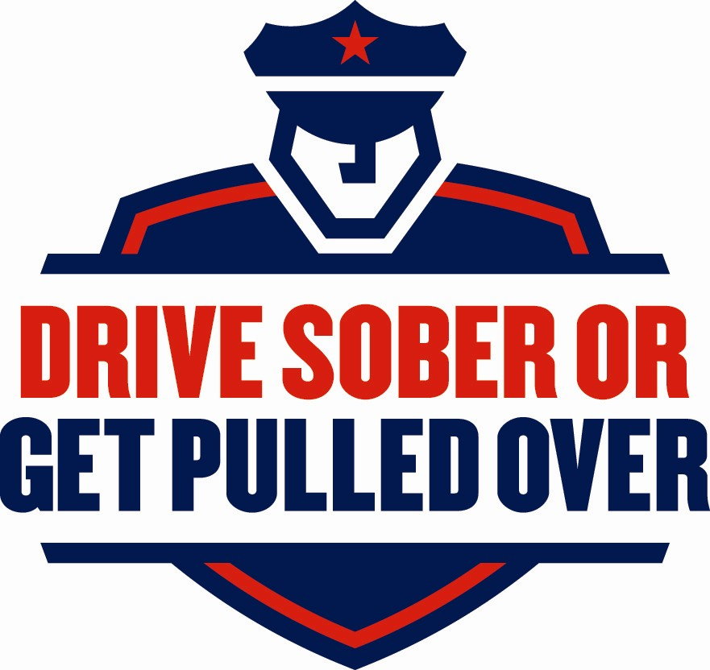
August 19 – Sept. 7
Return to OTSO by Sept. 23

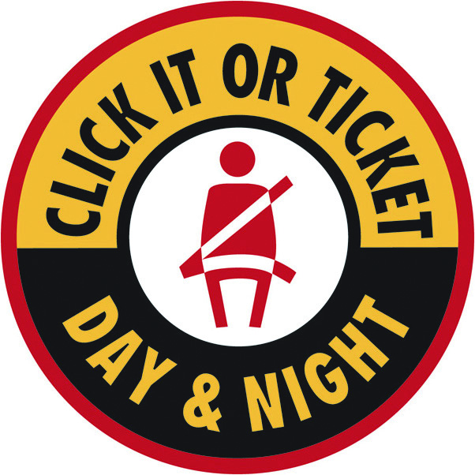
May 11 – May 31
Return to OTSO by June 17

Use this form to report all activities for the “Click It or Ticket” and the “Drive Sober or Get Pulled Over” National Enforcement Mobilizations for 2026. Copy this form as necessary and mark the box above that relates to the mobilization results reported below. Fax or e-mail completed forms by the date provided for each mobilization.

Law Enforcement Agency:_________________________________ Population of Jurisdiction:________________

City:_________________________________________ County: _____________________________________

Report Submitted By (Name/Title): _______________________________________________________________

Phone:________________________ Fax:___________________ Email: _______________________________

Activity for the entire reporting agency during the above mobilization period

Whole numbers only
Driving Under the Influence of Drugs (DUID)………………………………………
OVI Arrests Under 21…...………...….…..…………………………………………..
OVI Arrests 21 and Over…………………………………………………………...
Refusals………………………………………………………………………………..
Adult Restraint Citations…………………………………………………………….
Child Restraint Citations……...……………………………………………………..
Speed Citations……………………………………………………………….………
Distracted Driving Citations…………………………………………………………
DUS Arrests…………………….……………………………………………………..
No Operators License Citations……………………………………………………..
Felony Arrests…………………………………………………………………………
Other Citations………………………………………………………………………...
Enforcement hours worked……………………………………………….….………
Number of traffic stops……………………………………………..………………...

Educational & Media Activities

Did your agency participate in any educational or public awareness event(s) or put up community displays to highlight the above mobilization?

Yes ________ No________

If yes, please give date of event(s), location(s) and brief description of any community displays (signs/banners).
Did your agency participate in any media (Radio, TV, Newspaper, etc) to highlight the above mobilization?

Yes ________ No________

If yes, please give type of media and brief description.
Attach an additional page if needed.
Please attach any sample materials and/or news articles related to your campaign efforts.
RETURN TO: Ohio Traffic Safety Office (OTSO)
1970 West Broad Street, P. O. Box 182074 Columbus, Ohio 43218-2074
FAX BACK TO (614) 752-4646 OR EMAIL TO TRAFFICSAFETY@DPS.OHIO.GOV

