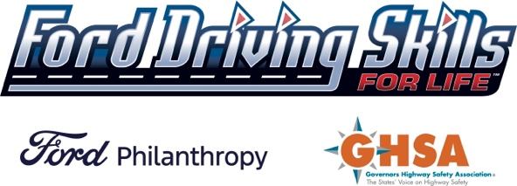
Social Media Messaging Guide

Amherst, OH: Aug. 17-18, 2024, at Marion Steele High School
Below you will find suggested social media messaging to assist with the promotions of the upcoming Ford Driving Skills for Life Safety in Mobility training coming to the Amherst, OH, area.

Handles and #Hashtags: Use the following social media handles, hashtags, and sample copy in your posts:
Ford Philanthropy Governors Highway Safety Association
Facebook, Twitter and Instagram - @FordPhilanthropy Facebook and Twitter - @GHSAHQ
#FordDSFL LinkedIn – Governors Highway Safety Association

SAMPLE POSTS:

FREE TEEN SAFETY IN MOBILITY TRAINING – Enroll your teen in a FREE one-hour course on August 17 or 18 in
Amherst, OH, with Ford Driving Skills for Life. This training will help your teen driver learn electronic scooter safety as well as tips and techniques for keeping pedestrians and cyclists safe on the roads. Sign your teen (ages 13+) up at https://drivingskillsforlife.com/training/hands-on-training. Space is limited. #FordDSFL
@FordPhilanthropy @GHSAHQ

The Ford Driving Skills for Life Safety in Mobility program is a free hands-on course coming to Marion Steele High School in Amherst, OH, Aug. 17-18 to help teens by calling their attention to the needs of vulnerable road users. Participants are able to experience what it is like to be a vulnerable road user from the perspective of a pedestrian, cyclist or scooter rider. Sign your teen (age 13+) up for this 1-hour course at https://drivingskillsforlife.com/training/hands-on-training. Space is limited. #FordDSFL @FordPhilanthropy @GHSAHQ

