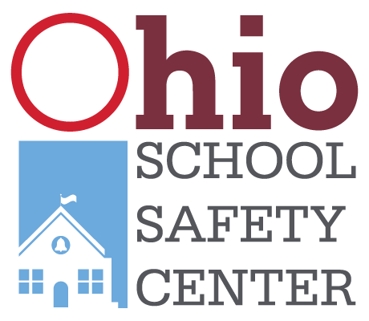
APPLICATION FOR OHIO STUDENT SAFETY ADVISORY COUNCIL
Applications are due by May 6, 2022 11:59 p.m.

Name: ____________________________ Grade level: ___________________________

Email: ____________________________ Phone number: ________________________

School: ___________________________ County: ______________________________
All applicants are required to have a sponsor from their school. This could be a teacher, administrator, school counselor, school resource officer, or other school staff. Please include a recommendation letter from the sponsor with your application.
Sponsor Name: _______________________ Relationship of sponsor: _________________

Sponsor Title: ________________________

Parent/Guardian Name: ____________________________________

Parent/Guardian Signature: _________________________________
Please attach a separate page answering all the questions below. Each answer should not exceed 250 words.
- How do you define school safety?
- Please describe a time where school safety has personally impacted your life.
- Why are you interested in serving on the Ohio Student Safety Advisory Council?
- How would this experience help your school or community?

