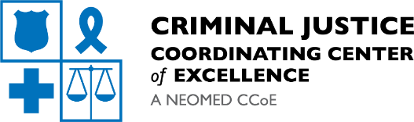
From Trends to Action:
Addressing Xylazine and Medetomidine in the Field

Monday, September 15th, 2025
3:00-4:30 p.m.
Via Zoom

Xylazine and Medetomidine adulteration in the drug supply is creating new challenges for overdose prevention, harm reduction, and public health efforts across the country. These substances can increase overdose risk, complicate reversal efforts, and lead to severe wounds that require specialized care. Deflection and outreach teams are encountering these substances more often and must adapt strategies to meet emerging needs.

Join us for a technical assistance session featuring speakers from research, public health, and harm reduction fields, who will share the latest data, response strategies, and practical approaches to wound management in the field.

Our speakers:

- Claudia Stephens, Research Associate, Begun Center for Violence Prevention Research and Education, Case Western Reserve University
Topic: Harm reduction surveillance data and emerging trends related to Xylazine and Medetomidine

- Rose Laurano, Harm Reduction Manager, Department of Public Health, City of Philadelphia
Topic: Adapting overdose response to Xylazine and Medetomidine adulteration

- Maddy Richards, Community Health Advocate, CompDrug
Topic: Xylazine wound management education, distributing wound care kits, and practical field strategies

Please join us on September 15th at 3pm

Register Now: Meeting Registration - Zoom
Please reach out to amorgan2@neomed.edu with any questions

