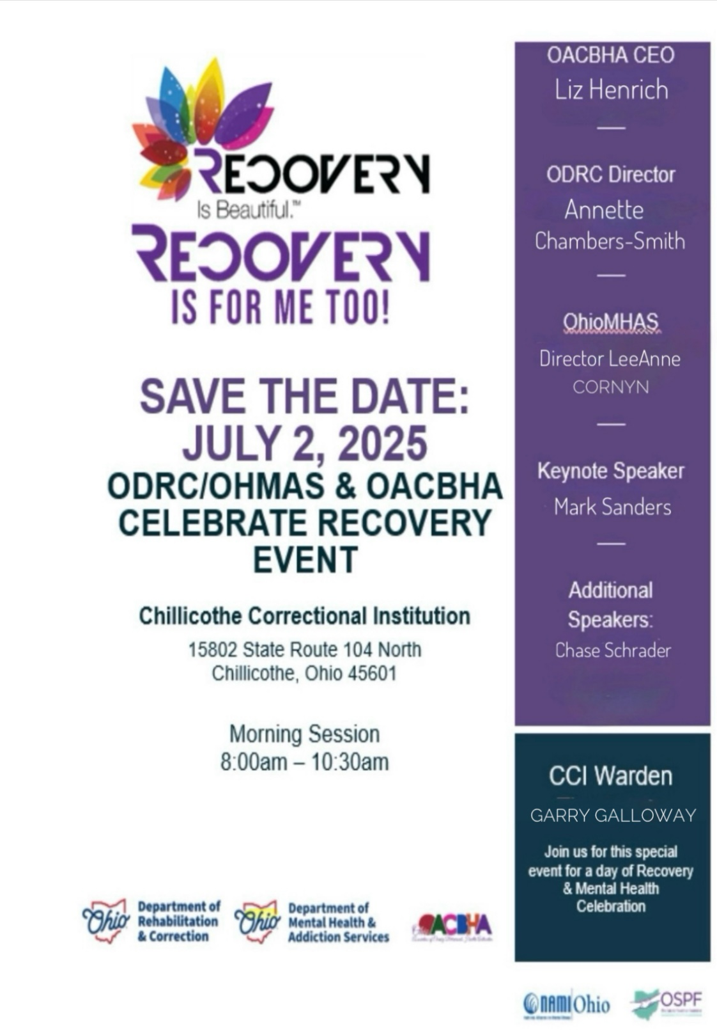

8:00 AM DTP Band Open Up (Two Songs)

8:20 AM Welcome Warden Garry Galloway

8:30 AM MHAS Chief of Staff John Annarino
OACBHA CEA Liz Heinrich

9:00 AM Peer Supporters Russell & Hill

9:15-9:45 AM Speaker: Chase Schrader

9:45 AM Intermission: DTP Band

9:50 AM Keynote Speaker: Mark Sanders

Ohio Prison based Therapeutic Communities
In a joint effort OhioMHAS and ODRC have committed to reducing recidivism within Ohio. Prison based Therapeutic Communities
Are in 6 of the Ohio’s institutions and have been operating since
1991
Objective___________________
The primary objective of the therapeutic community is to provide a social-learning environment that fosters a sense of belonging, accountability, and responsibility. Community members are expected to participate in all program activities and uphold the values and standards of the TC.
Program description
Ohio’s Prison based Therapeutic Communities are a 12–15-month program’s that takes a holistic approach to substance use disorder. Programs are broken into 3 phases (Orientation, Primary treatment, and re-entry).
During those 12-15 months of substance abuse treatment clients will participate in different groups on a daily basis that address work ethics, personal values, attitude, beliefs, anti-social behaviors and substance use.

TC Values_______________
Truth and honesty in words and deeds.
Work ethic.
Necessity of earning rewards.
Value learning.
Personal accountability.
Economic self-reliance
Responsible concern toward peers.
Community involvement.
Good citizenry
Making positive changes in life
“Right-Living” develops from committing oneself to the values shared by the community. “Right-Living” emphasizes explicit values that guide how nindividuals relate to themselves, peers, significant otherand society.
“You are a life worth saving.”
During the course of their residential treatment, they develop and practice new behaviors, which support a substance-free, crime-free lifestyle.

Location of Ohio prison based TC’s
- Ohio Reformatory for Woman- Tapestry
- Pickaway Correctional Institution- OASIS
- Madison Correctional Institution- Vista
- Chillicothe Correctional Institution- SHEILD
- Grafton Correctional Institution- Stepping stone

Incentives______________________________
Earned Credit
Positive living environment
Substance use disorder treatment

Mission Statement
To provide a high-quality holistic treatment experience to incarcerated men and woman.
Vision Statement
To promote the right living and reduce recidivism, for more healthy communities.

A Therapeupeutic Community is a positive,drug free environment where people with similar problems including substance abuse, live together to improve their lives.

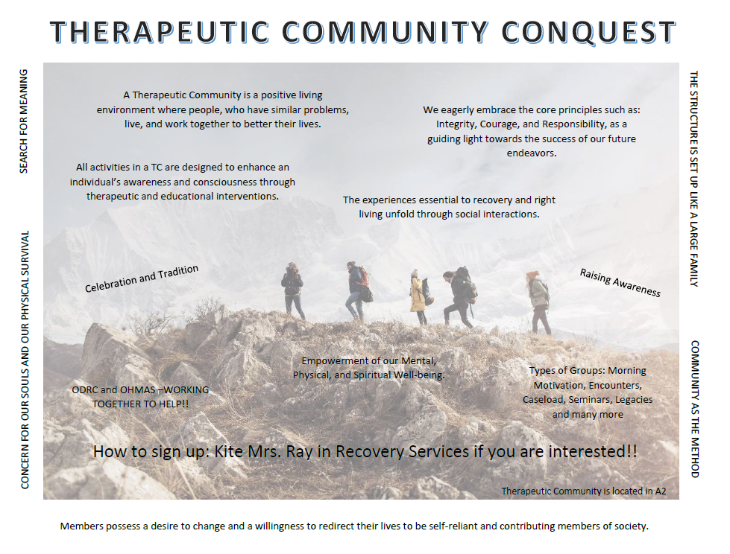

Chillicothe Correctional Institution

Mental Health Services

Services Offered: Diagnostic Evaluations, Psychotherapy, Individual Counseling, Group Programming, Psychiatry & Medication Management, Treatment Planning, Psychometric Testing, Screening Services, Crisis Services
Mental Health Building: North side of the Institution ~ directly beside the chow hall
How to Access MH Services: Send a Kite to MH or ask a staff member to submit a referral Crisis/Walk-in Hours: Monday – Friday 7am - 3pm

CCI Mental Health Programs available for non-caseload IP’s

Stress Management
Description: 6-week psychoeducational group to learn about the signs, symptoms, causes, and effects of stress. As well as how to reduce, prevent, and cope with stressors in our lives.

Grief Support
Description: 8–10-week group focused on providing education and support to those coping with loss in their life. Topics include: the grief process, identifying and expressing feelings, self-care, relationships and dealing with others, telling the story of the loss, exploring the meaning of the loss, unfinished business, honoring what was and taking steps towards closure.

Coping Skills Group
Description: Led by inmates who are trained Peer Supporters.

Transforming Trauma
Description: This Group will be focused on:
1. Psychoeducation- Gain insight about mind/body connection and how our brain responds to trauma, learn triggers, and work through The Living Legacy of Trauma workbook
2. Application-Learning skills (DBT, Mindfulness, and other healthy regulation skills), apply/practice skills in group, and discuss value/outcomes as a result of practice.
3. Connection- We will be reading a novel (A Long Way Home) and discuss in group.

Healthy Living
Description: Living I/P will learn invaluable skills people use every day, that allows I/Ps to create the life they desire to access their inner resources needed to succeed. Life Skills are necessary to help I/P take charge and manage their personal lives. Like skills will help I/P manage change and deal effectively with their environments and the people in those environments. I/P were introduced with decision making process and what kind of decision maker each I/P is by taking a test Problem-Solving Style Scale Directions. The following I/P learned the difference between practical thinking,

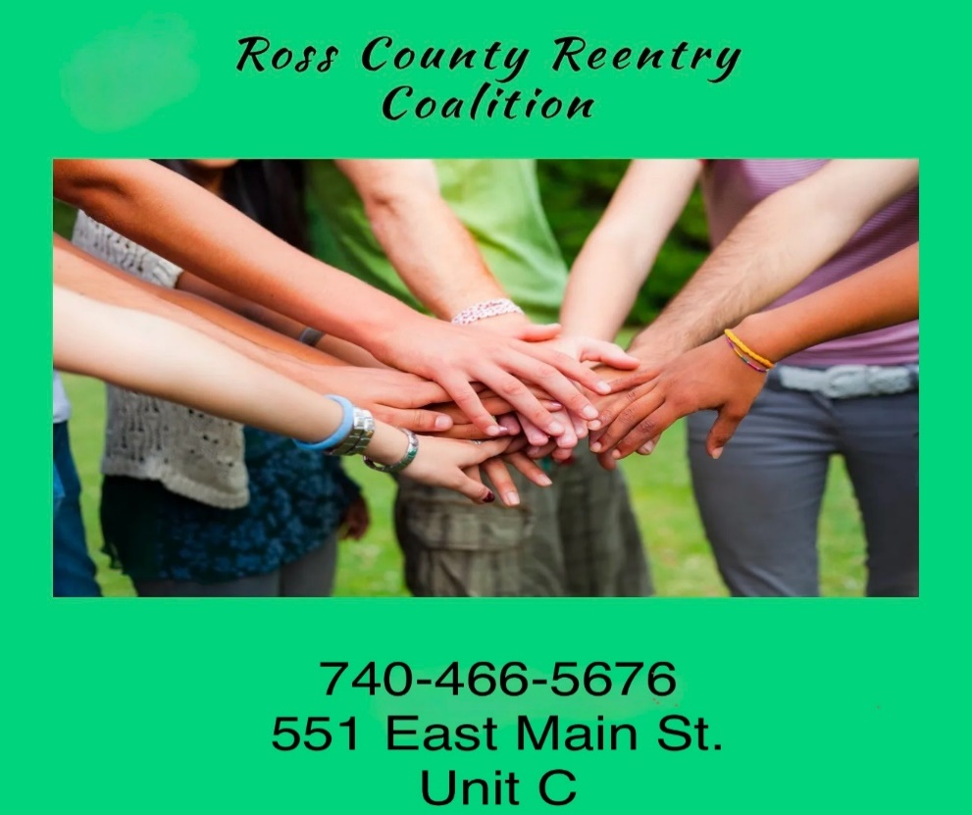
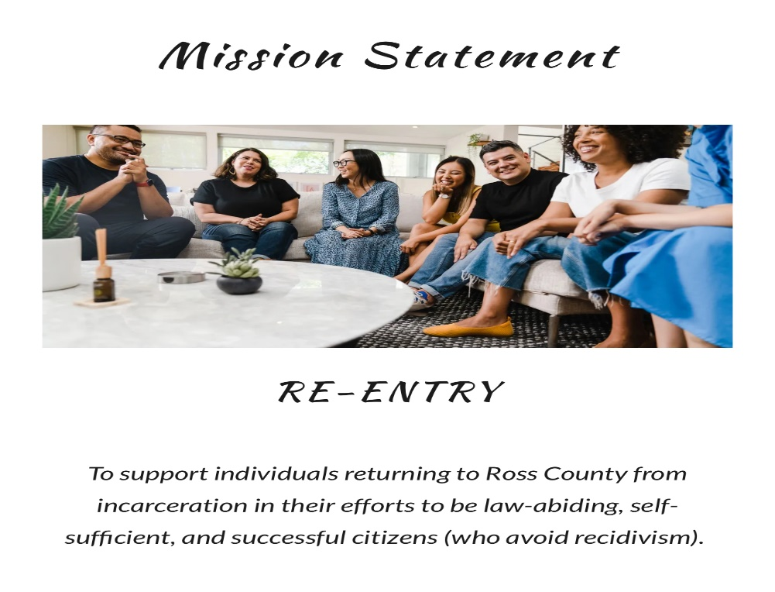

About Us

The Ross County Reentry Coalition was initially established in 2009 and has evolved into an extensive network of information sharing and positive collaborations. The objective of the Ross County Reentry Coalition is to coordinate services with community partners to provide our returning citizens with strong networks to ensure greater success and follow through with obtaining services. As a coalition, we will educate community members, organizations, and employers about the benefits of giving our returning citizens fair treatment and better opportunities. Stigma reduction is an important aspect of the reentry process to minimize obstacles as people return to their communities. We focus on successful second chances utilizing community partners and taking a holistic approach to work towards self-sufficiency.

Types Of Services and Assistance
The Coalition can either provide or send a referral for the below items
Food Assistance
Counseling-Alcohol or Drug Use
Counseling- Mental Health and Wellness
Transportation
Driver’s License Reinstatement
State Id
Medical Card or Medicaid
Veteran’s Benefits
Social Security Benefits
Legal Services
Child Care
Sober Living or Supportive Housing

Coalition Member

Ross County Reentry Coordinator/SKIP Coordinator

Jody Wilson Ross County Reentry Coalition Chair

Brandy Morris-Hafner Ross County Reentry Coalition Co-Chair

Joanna Denny Ross County Reentry Coalition Co-Chair

740-466-5676
rosscountyreentrycoalition@gmail.com

Thank you
for attending the 2025 Celebrate Recovery Event

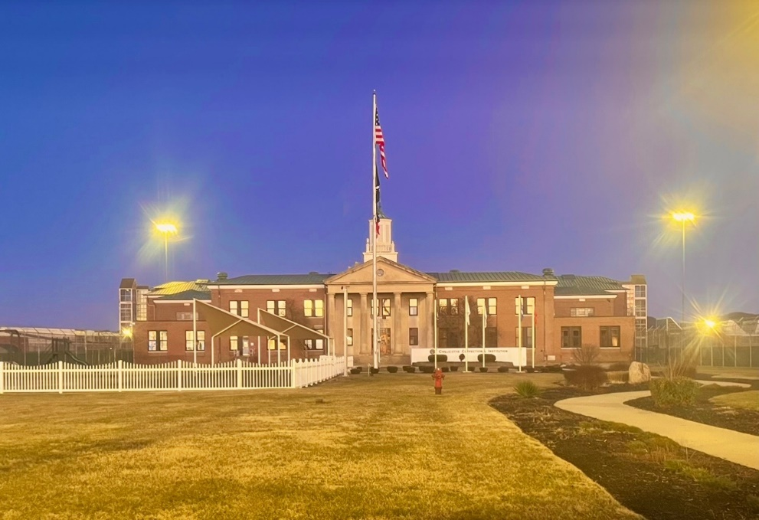

Warden Garry Galloway
P.O. Box 5500
15802 State Route 104 North
Chillicothe, OH 45601
740-774-7080

