BECOME A CERTIFIED  W.I.S.E FACILITATOR  WISE (Wellness Initiative for Senior Education) Certified Facilitator and help make a difference in the lives of older adults you serve.  The WISE Program is a wellness and prevention program targeting older adults, which is designed to help them celebrate healthy aging, make healthy lifestyle choices, and avoid substance abuse. It provides valuable educational services to older adults on topics including medication misuse and management, stress management, depression, and substance misuse.  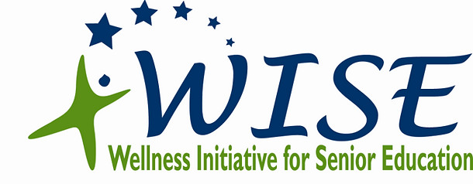  LOCATION: Burkhardt Library  ADDRESS: 4704 Burkhardt Ave  Dayton Ohio 45403  DATE: March 25th AND 26th  TIME: 9:30AM TO 4:30PM  Lunch will be served daily
  Free 2 day in person training
  Email Terry Vandeberg to reserve your spot tvandeberg@smdcd.org
  Opportunity to network with other prevention providers
  Be part of a statewide initiative to educate older adults in making Healthy Lifestyle Choices
  The 2-day training is being brought to you by St. Mary Development Corporation,
  UMADAOP of Dayton and Montgomery County ADAMHS

