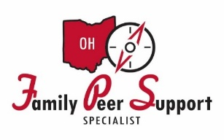

NAMI Ohio Virtual Family Peer Support Training

August 26-28, 2024, and September 4-5, 2024
9am-5pm daily
(Registration closes on August 14, 2024)

This is a free 40-hour training, approved by OHMAS, to pursue Family Peer Support Certification.

Who Can Be A Family Peer Support Specialist?
An individual with a lived experience as the parent or primary caregiver of a child or children for whom they have navigated multiple child serving systems (mental health, juvenile Justice, child protective services, education), on behalf of their child/children with social, emotional, developmental, health, substance use or behavioral health needs.

How Is Family Defined?
The term parent refers to the primary caregiver for a child with mental, emotional or behavioral health need. This Includes:
- Biological Parents
- Adoptive Parents
- Foster Parents
- Kinship Caregivers
What Do Family Peer Support Specialists Offer?
Family Peer Support Specialist services may include:
- Providing empathetic listening and emotional support
- Assisting families in navigating systems
- Supplying information about child‐serving systems, children’s behavioral health and development, and community resources
- Rendering advocacy support
- Encouraging self‐care activities
- Facilitating familial engagement with service providers
- Modeling collaboration between families and professionals
- Engaging in safety and care planning; exploring and eliminating barriers to care plan follow‐through
- Offering skill‐building for parents that enhances resiliency, communication, advocacy and other areas affecting the ability to maintain a child with complex needs in the home, school and community
- Sharing personal stories
- Providing HOPE
Please Register at: Family Peer Support Specialist | NAMI Ohio

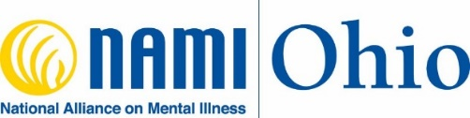
For additional information contact:
Tameika Wright
tameika@namiohio.org
Office: 614-224-2700 Cell: 614-565-2323

