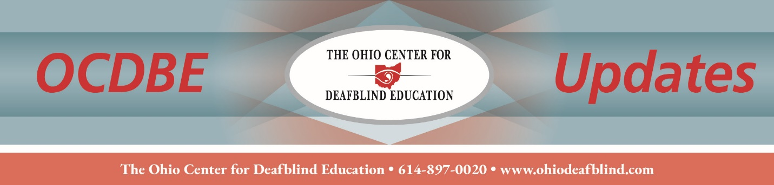
Annual Ohio Deafblind Census

The Ohio Center for Deafblind Education (OCDBE), a federally funded technical assistance and dissemination project, is required to conduct an annual census of Ohio children and youth, birth through age 21, with deafblindness (aka combined vision and hearing loss), regardless of their IDEA identification, and children who are at risk for deafblindness. The annual census is conducted on behalf of the United States Department of Education, Office of Special Education Programs, in collaboration with the National Center on Deaf-Blindness (NCDB). It generates funding to support consultation, professional development, resource information dissemination, technical assistance, and outreach for educators and families. This registration is separate from the Federal Quota Registration for the Blind.

Who can be registered? | - All children and youth, ages birth through 21 years, who have combined vision and hearing loss (deafblindness)  **A student does not need to have the IDEA/Ohio identification of deafblind to be registered on this census**
Who can register a child? | - Parents  - Doctors  - Educational Agencies  - Early Childhood Agencies  - Preschools  - School-age teachers and staff  **Parent permission is not required to register a child**
To register a new child or update a currently registered child: | - Log onto the Ohio Center for Deafblind Education website at https://www.ohiodeafblind.com  - Select “Census: Register/Update a Child”  - Scroll down to “Begin Here” and follow the instructions  - “How to Register a student” Video
Last date for submission: | - Feb. 27, 2026

For more information about the Deafblind Census, please contact Jodi Dowell at dowelljr@ucmail.uc.edu.

