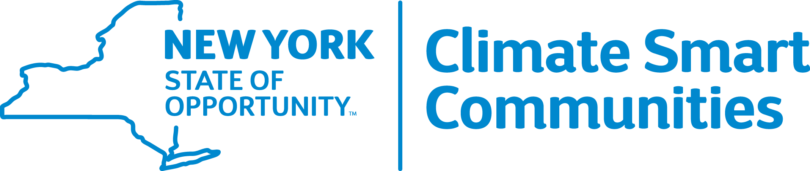

Reducing Community Transportation Emissions

Presented by the New York State Climate Smart Communities Webinar Series

Thursday, April 9, 10:30 a.m. – Noon

Agenda

10:30 Introduction

Kim Farrow, Environmental Program Specialist,

New York State Department of Environmental Conservation (NYSDEC) www.dec.ny.gov

10:35 Announcements

Mark Lowery, Climate Policy Analyst, NYSDEC

10:40 Planning for Pedestrian and Bicycle Travel and Car Sharing

Jennifer Ceponis, Senior Transportation Planner, Capital District Transportation Committee

11:00 Reducing Greenhouse Gas Emissions through VMT Reduction, Operational Practices, Including Travel Demand Management, Incident Management and Alternative Transportation Options

Chris O’Neill, Principal Transportation Planner, Capital District Transportation Committee

11:20 Best Practices from NYSERDA: Electric Vehicle Charging, Traffic Signal Optimization and Complete Streets Legislation
Adam Ruder, Project Manager, Transportation Group, NYSERDA

11:40 Questions, Answers and Discussion
Mark Lowery

