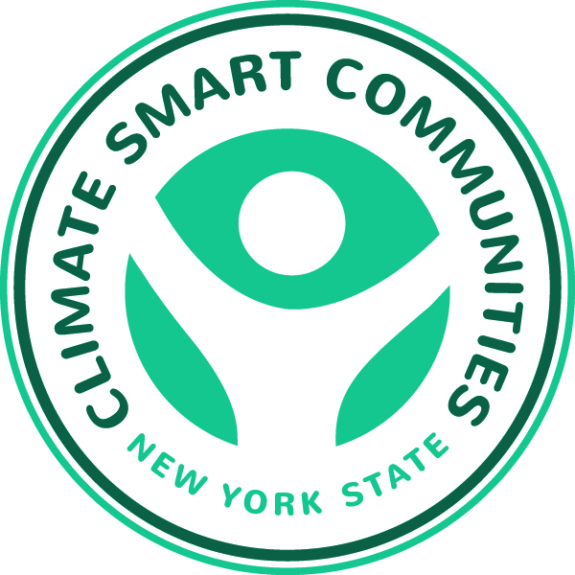

Mobilizing Regional Climate Action

Presented by the New York State Climate Smart Communities Webinar Series

Thursday, March 12th, 10:30 a.m. – Noon

Agenda

10:30 Introduction

Kim Farrow, Environmental Program Specialist,

New York State Department of Environmental Conservation

www.dec.ny.gov

10:35 Announcements

Mark Lowery, Climate Policy Analyst, NYSDEC

10:40 NYS Environmental Excellence Awards – Application Process
Marna Posluszny, Environmental Analyst, NYSDEC
http://www.dec.ny.gov/public/945.html

10:55 Collaborating on Climate Protection in Tompkins County: Toward a More Resilient Community
Peter Bardaglio, Coordinator, Tompkins County Climate Protection Initiative
www.tccpi.org

11:20 Sustainable Westchester: Using the Market to Foment Fundamental Change
Mike Gordon, Co-Chair, Sustainable Westchester
http://sustainablewestchester.org/

11:45 Questions, Answers and Discussion
Mark Lowery

