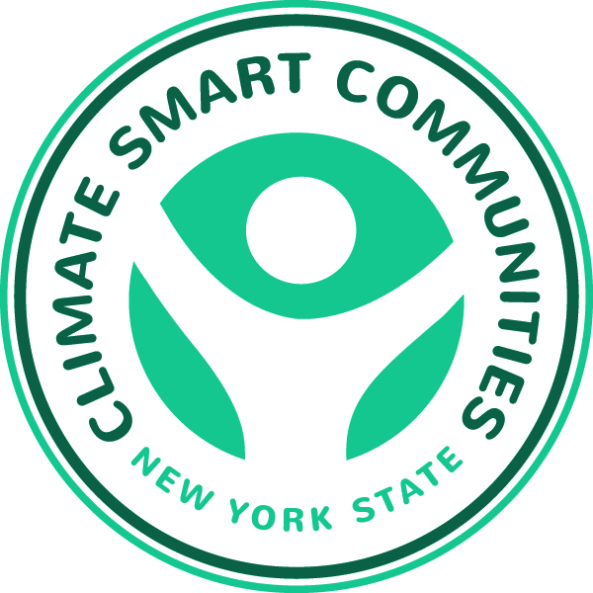

Getting to Net Zero Energy Homes

Presented by the New York State Climate Smart Communities Webinar Series

Thursday, January 8th, 10:30 a.m. – Noon

Agenda

10:30 Introduction

Kim Farrow, Environmental Program Specialist,

New York State Department of Environmental Conservation

www.dec.ny.gov

10:35 Announcements

Mark Lowery, Climate Policy Analyst, NYSDEC

10:40 Best Practices for Communities That Work
Katie Borgella, Deputy Commissioner of Planning, Tompkins County Planning Department
www.community-that-works.org

11:00 EcoVillage at Ithaca: the story of three neighborhoods
Liz Walker, co-founder, EcoVillage at Ithaca; and Executive Director, Learn@EcoVillage
http://www.ecovillageithaca.org

11:20 TREE: a DOE Zero Energy Ready Neighborhood
Kendall Carpenter, Construction Manager, TREE Neighborhood

11:40 Questions, Answers and Discussion
Mark Lowery

