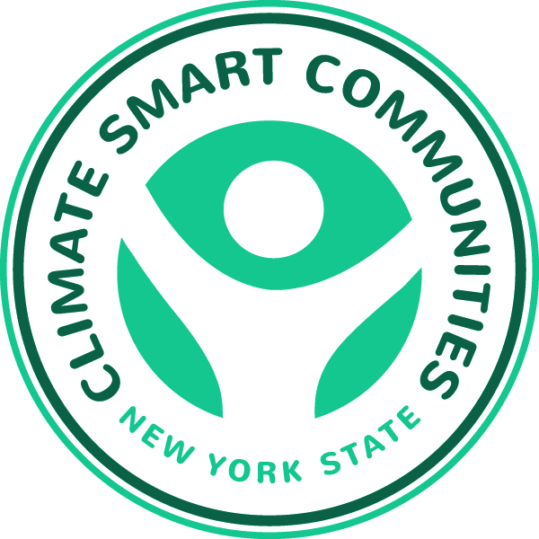

Energy Management Resources for Local Governments

Presented by the New York State Climate Smart Communities Webinar Series

Thursday, June 12, 2014, 10:30 a.m. – Noon

Agenda

Introduction

Kim Farrow, Environmental Program Specialist,

New York State Department of Environmental Conservation, www.dec.ny.gov

Opening Remarks

Mark Lowery, Climate Policy Analyst, NYSDEC

Why an Energy Management Tool?
Kari Hewitt, Sustainability Planner, VHB Engineering, Surveying and Landscape Architecture, PC, http://www.vhb.com/

FacilityDude’s UtilityTrac Tool
Brandon Chaney, Application Engineer, FacilityDude, http://facilitydude.com/

WegoWise Tool,
Dan Teague, Director of Business Development, WegoWise, Inc., https://www.wegowise.com/

Energy Star Portfolio Manager
Juan Gutierrez from EPA is responsible for Region 2’s Energy Star program, https://www.energystar.gov/buildings/facility-owners-and-managers/existing-buildings/use-portfolio-manager

Questions, Answers and Discussion
Mark Lowery

