Copy and paste the below signature block template into your email signatures in Outlook. Then fill in your information. All the fonts and sizes are correct in the below template.

Template:

Name
Title
Department | Division
Phone | Cell
Address | Las Vegas, NV 89101
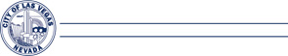
lasvegasnevada.gov

Example:

Jace Radke
Senior Public Information Officer
Communications | Public Affairs
702-229-2205 | 702-249-3514
495 S. Main St. | Las Vegas, NV 89101
lasvegasnevada.gov

