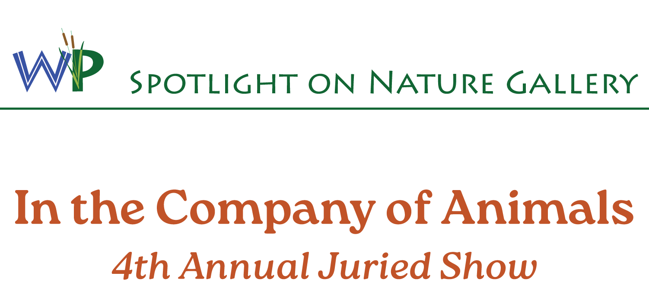
August 2 through November 2, 2025
Juried by Sean Russell
Participating Artists

Terry Adamik  Laura Averill  Laura Backus  Jenny Baham  DeAnna Beachley  Iryna Borshchahivska  Alisha Brown  Sophia Brunner  Angela Caballero-Fields  Denise Capobianco  Andy Carlson  Cesar Ceballos  Charme Curtin  Narz Dela Rosa  Meghan Dragon  Katie Fisher | Stasia Fisher  Laura Gracia  Jeanne Ham  Amber Indurante  Heather Lang-Cassera  Thomas Larson  fairbreak1  Susan Richardson-Kaumans  Clevelle Scherer  Rene Serrano  Casey Southard  Sandra Swan  Christine Taylor  Becca Youngblood  Jamie Zepeda

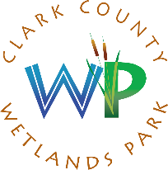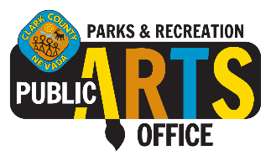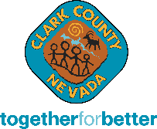

Clark County Wetlands Park
Spotlight on Nature Gallery
7050 Wetlands Park Lane, Las Vegas, NV 89122
art.ccwetlandspark.com (702)455-7522

