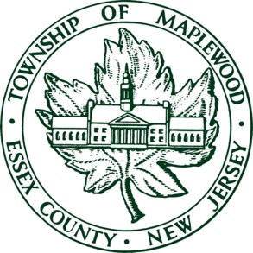
MAPLEWOOD TOWNSHIP PUBLIC NOTICE

COMMUNITY MEETING ON 2025 NEW JERSEY AMERICAN WATER LEAD SERVICE LINE REPLACEMENT PROGRAM
On April 2nd, 2025, New Jersey American Water (NJAW) and Maplewood Township will hold a community meeting to discuss NJAW’s 2025 lead service line replacement program. The meeting will be held at Maplewood Town Hall at 7:30 p.m., and residents can attend live or via Zoom (details below). The meeting will also be recorded and made available to residents.
First things first: Customers can still use their water as they normally would, as the water provided by NJAW continues to meet state and federal water quality standards, including those set for lead.
About the forthcoming meeting: In July 2021, the state of New Jersey enacted legislation that requires utility companies to replace utility-owned and customer-owned lead and galvanized service lines by 2031. In previous years, NJAW scheduled the replacement of lead and galvanized service lines in Maplewood at a rate that would meet the 2031 deadline. NJAW now wants to dramatically increase the pace of service line replacements and complete all of the necessary work within the next year – which means residents will see an increase in NJAW’s work around town.
In light of this, NJAW has coordinated with the Township to hold a Community Meeting to discuss the replacement program and answer resident questions. They are aware that this work requires robust communications with residents who may be impacted by the work associated with service line material identification, service line replacement, and overall construction activity. The Township will work with NJAW to ensure residents receive necessary communications before, during, and after the lead service line replacement program. To learn more about the program, including to find out if your service line is made of lead, please visit www.newjerseyamwater.com/leadfacts.
In anticipation of the expected increase of their work around town, NJAW is strongly encouraging customers to update their contact preferences and opt-in for service-related notifications from New Jersey American Water at www.amwater.com/mywater. Customers can decide how they are notified - via phone, email or text - and can add up to three phone numbers and three email addresses.
Meanwhile, we welcome anyone who has initial questions to attend this joint meeting with NJAW and Maplewood Township, whether attending live or via Zoom.

COMMUNITY MEETING DETAILS:
April 2, 2025
7:30 pm
Maplewood Town Hall, 574 Valley Street
Join Via Zoom:
Join from PC, Mac, iPad, or Android:
https://twp-maplewood-nj-us.zoom.us/j/89984252017?pwd=UimBdmcV14Y1yJtwQbwaELAiZqSlut.1
Passcode:372589
Phone one-tap:
+19292056099,,89984252017#
Join via audio:
(929) 205-6099
Webinar ID: 899 8425 2017

