TOWNSHIPOF MAPLEWOOD
ESSEX COUNTY, NEW .JERSEY

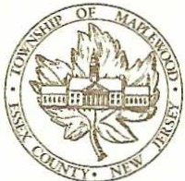
NANCY .J. ADAMS MAYOR

Proclamation
'Black History Month

WHEREAS, every February, Black History Month is recognized to not only encourage the study of African American life and history but also act as a reminder that Black history is an integral part of the history of the United States of America; and
WHEREAS, what began as a week recognizing Black history, championed by Dr. Carter G. Woodson and minister Jesse E. Moorland in 1926, when they founded the Association for the Study of African American Life and History (ASALH), evolved into a month by 1976, after official recognition by then President Gerald Ford; and
WHEREAS, each year, the Association presents a new theme, and the theme for 2025 is African Americans and Labor; and
WHEREAS, work-whether skilled, voluntary, or vocational-has always been at the heart of African American history, culture, and dignity. From Henry Blair, whose agricultural inventions in the 1830s transformed farming, to Marian Croak, whose videoconferencing breakthroughs changed how we communicate, African American contributions to labor have shaped our economy and society. This includes Alice H. Parker, a Morristown, New Jersey native, who left a lasting mark in the early 1900s with her invention of a natural gas­ powered central heating system, improving comfort in homes and workplaces for generations; and
WHEREAS, whether through industries, government, or public service, the legacy of African American labor has been nothing short of transformational. Be it the struggles of post-Civil War sharecroppers or the leadership of labor figures like A. Philip Randolph, African Americans have fought against exploitation and discrimination while building vital community institutions; and
WHEREAS, the impact of African Americans extends beyond paid labor with shaping social justice movements, organizing for labor rights, and leaving an indelible mark on cultural and architectural landmarks. Notably, 2025 marks the 100th anniversary of the Brotherhood of Sleeping Car Porters and Maids, the first African-American union chartered by the American Federation of Labor. The ongoing labor struggles, exemplified by figures like Randolph, Bayard Rustin, Congresswoman Bonnie Watson Coleman, and Martin Luther King Jr., underscore the vital connection between economic justice and civil rights in American society.
NOW, THEREFORE, BE IT PROCLAIMED THAT I, Mayor Nancy Adams, on behalf of the Maplewood Township Committee, highlight these important contributions during Black History Month and encourage the public to further educate themselves on the impact of African American labor, its history, and its ongoing role in shaping our nation and the world.
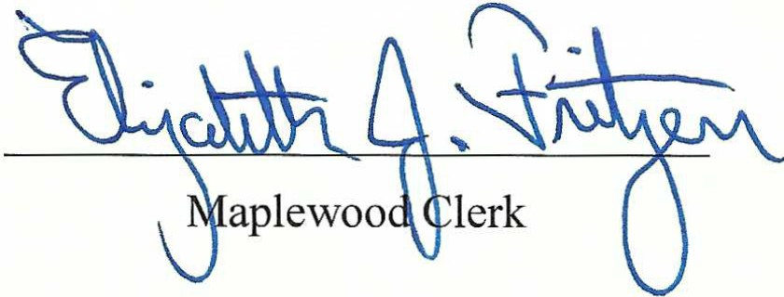
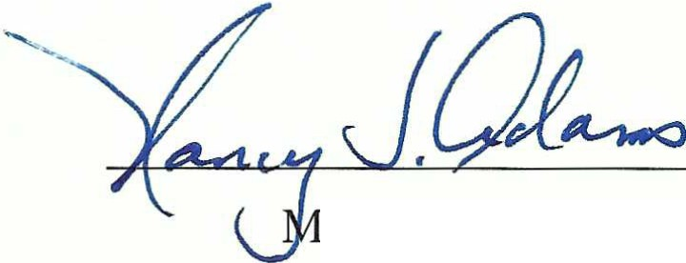

ayor of Maplewood

