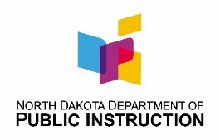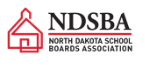**7th Annual Co-Sponsored School Board Member Bootcamp**

**August 1, 2024**

**9:00 am – 12:30 pm CDT**

**Virtual**

**AGENDA**

|  |  |
| --- | --- |
| 9:00 - 9:20 | Welcome |
|  | * Executive Director Amy DeKok, ND School Boards Association (NDSBA) * State Superintendent Kirsten Baesler, ND Department of Public Instruction (NDDPI) |
|  | |
| 9:20 – 9:40 | Cyber Security/Computer Science Plans and AI Guidance for ND Schools |
|  | * Steve Snow, NDDPI School Approval & Opportunity Assistant Director |
| 9:40 – 10:10 | PK12 Strategic Vision, RU Ready, and Choice Ready   * Kirsten Baesler, NDDPI State Superintendent * Laurie Matzke, NDDPI Assistant Superintendent |
| 10:10 – 10:20 | Break |
|  | |
| 10:20 – 10:50 | Funding Your Plan Work and Tools |
|  | * Ann Ellefson, NDDPI Academic Support Director * Amanda Peterson, NDDPI Educational Improvement & Support Director |
|  | |
| 10:50 -11:20 | ND Assessment Scores and Learning Recovery |
|  | * Stan Schauer, NDDPI Assessment Director |
|  |  |
| 11:20 – 11:45 | Be Legendary School Board Institute   * Kirsten Baesler, NDDPI Superintendent * Joe Kolosky, NDDPI Director School Approval & Opportunity * Marty Bratrud, Westhope Superintendent * Lyndsi Engstrom, Westhope School Board Member |
|  |  |
| 11:45 – 12:10 | Overview of NDSBA and NDDPI Resources to Support School Boards   * Amy DeKok, NDSBA Executive Director |
|  | |
| 12:10 – 12:30 | Closing Remarks and Q&A |
|  | * Kirsten Baesler, NDDPI State Superintendent * Amy DeKok, NDSBA Executive Director |

|  |
| --- |
| NDDPI 701-328-2755 [jkolosky@nd.gov](mailto:jkolosky@nd.gov)  NDSBA 701-255-4127 [amy.dekok@ndsba.org](mailto:alexis.baxley@ndsba.org) |