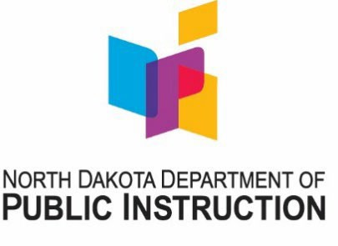

North Dakota Comprehensive Literacy Four-Year-Old GPRA Reporting 2022-23

Please report the following information about assessment results for four-year-old oral language. It is not necessary to attach any documents or printouts of student data to this report, but always maintain those records on site.

The number in the grayscale box will be used for Federal USDE reporting.

Name of Reporting District/Early Learning Partner(s):

Reporting Percentage
Percentage of four-year-old children achieving significant gains in oral language during the 2022-2023 school year.

out of (total # of children served) = %
Reporting Justification
To determine the number of children achieving significant gains in oral language, it is necessary to document which assessment was used, determine a baseline and end-of-year assessment window, and understand how scores will be interpreted to determine significant gain. In the boxes below, describe the process used at your site
during the 2022-2023 school year.

Assessment: What assessment did you use to measure oral language in four-year-old children? If the assessment has subtests, please indicate which subtests were used to assess oral language.
Baseline and End-of-Year Assessment Window(s): When did you determine baseline indicators? When was the final assessment for yearly growth? Or, if using an ongoing observational model, what were the beginning and ending dates?
Significant Gains: Be explicit about subtests that were included and how the final score was compiled. How did you determine a cut score to indicate which students achieved significant gains?
Please return this report to Taylor Olsen by June 30, 2023. If you have questions, please contact Taylor at (701) 328-2629.

