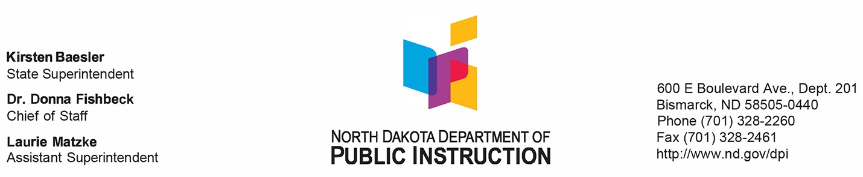

To: School Food Service Directors/Managers
From: Linda Schloer, Director, NDDPI Child Nutrition Program Administration Date: February 8, 2022

Subject: Allocation of Supply Chain Assistance (SCA) Funds to Alleviate Supply Chain Disruptions in the School Meal Programs

On December 17, 2021, the United States Department of Agriculture – Food and Nutrition Service released $1 billion to enhance local school districts’ ability to purchase foods for school meals during the extraordinary challenges that the pandemic has brought about. The memo SP 03-3033 relating to this allocation is available at: Allocation of Supply Chain Assistance (SCA) Funds (azureedge.net)
NDDPI-CNFD has been allocated $2,841,142 in relief funding in Supply Chain Assistance (SCA) funds to assist school districts experiencing supply chain disruptions. The SCA funds will be distributed to eligible school food authorities (SFAs) to be used exclusively to purchase unprocessed or minimally processed domestic food products to help SFAs deal with challenges, such as unanticipated cancellation of food and supply contracts, reduced availability of certain foods, the unexpected substitution of certain products, unpredictable increases in food and supply prices, and other obstacles related to the pricing and/or availability of food for Child Nutrition Programs. As these challenges are both extensive and widespread, the SCA funds are targeted to provide a rapid and direct response to affected school districts.
To receive these funds, an SFA authorized representative must read, sign and return the attached Attestation by February 28, 2022. Funds will be disbursed at the beginning of March. Each SFA will receive a base payment of $5,000 plus a per-student amount to be determined by the October enrollment submitted with the October 2021 claim in ND Foods.
Once the SFA has received the funds, they are available to be used for the purchase of unprocessed or minimally processed foods produced in the United States immediately.
Please contact our office at (701)328-2294 or email if you have any questions.

DATE:

FROM: Authorized Representative Name: _________________________ Title: ___________________
School Food Authority (SFA) Name: ________________________________________________
TO: Linda Schloer, Director
North Dakota Department of Public Instruction, Child Nutrition & Food Distribution

SUBJECT: Attestation for use of Supply Chain Assistance (SCA) Funding

Instructions: The following statement must be certified by checking the boxes and initialing the certification statement and signed by a duly authorized representative of the School Food Authority (SFA) operating the National School Lunch (including SSO) and/or School Breakfast Programs and returned to NDDPI Child Nutrition and Food Distribution at dpicnfd@nd.gov by February 28, 2022.

I, ____________________________ , as the Authorized Representative of the School Food Authority (SFA) __________________________________________ as reported to NDDPI-CNFD, do hereby attest that the aforementioned SFA and all schools under its jurisdiction operating the National School Lunch Program authorized under the Richard B. Russell National School Lunch Act (42 U.S.C. 1751 et seq), and/or the School Breakfast Program authorized under the Child Nutrition Act of 1966 ( 42 U.S.C. 1773), will utilize the Supply Chain Assistance (SCA). Funding as described below:

- The SFA is experiencing supply chain disruptions;
- Disruptions have caused financial difficulties;
- Funds will only be used to purchase domestic unprocessed or minimally processed foods;
- Funds will not be used for labor, indirect, or other administrative costs;
- SFA will comply with all record-keeping and review requirements per 7CFR 210.9(b)(17) and
7CFR 210.18, which would include maintaining documentation demonstrating appropriate use of SCA funds; and
- SFA will comply with all applicable Federal procurement and financial management requirements per 2CFR 200.

- Districts will maintain documentation, including purchases made and other records such as invoices and receipts to document SCA funds were used for allowable purchases.

- I understand during Administrative Reviews the SFA will need to provide documentation of SCA funds usage.

_____ I certify that this attestation is true and correct and agree to the terms and conditions above.
(Initial)

_____________________________________________ ______________________________________ ____________________
(Signature of Authorized Representative) (Title of Authorized Representative) (Date)

(OFFICIAL USE ONLY)

North Dakota Department of Public Instruction – Child Nutrition & Food Distribution

Received By:

Initials: _____________ Date: ___________________

