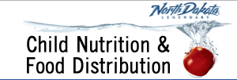
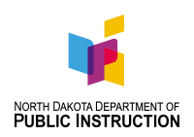
School Nutrition Programs
Important Dates to Remember for the School Year

2021-2022

Beginning of School Year - - - Send out information about the School meal programs – Menus, meal pricing, kitchen contacts.

Unpaid Meal Charge Policy – Parents and staff must receive a WRITTEN copy of the school district’s unpaid meal charge policy at the beginning of each year. Students transferring during the year must also receive a written copy of the policy.
10th of Each Month - - - The claim for reimbursement for each site is due for submission over the ND Foods system for prompt payment. (You do have 60 calendar days to submit your claim.)
Annually - - - Civil Rights training must be done annually for everyone working with the School Foodservice program including substitutes, front office personnel and cafeteria cleaners. Document the person trained, day of training and training material. There is a 2-page training document available in the front of the Lunch Production Record book or on the NDDPI website.

Hours of Professional Development for school foodservice staff must also be documented: 12 hours for foodservice directors, 10 hours for foodservice manager, 6 hours for all other full time staff and 4 hours for part time (<20 hr/wk). Civil Rights training can be used as professional development.

Site monitoring reviews for any school districts that have more than one meal site… Every program year, sponsors with more than one foodservice site must perform at least one on-site review of each site under its jurisdiction. The on-site review must take place prior to February 1. The review is to ensure that the claim is based on the approved counting system and that the system, as implemented, yields the actual number of reimbursable free, reduced-price, and paid meals served for each day of operation. A “Site Monitoring for National School Lunch and Breakfast” form is located on the Child Nutrition web site.

Monitoring Reviews for After School Snack Program Each Afterschool Snack Program must be reviewed by the Sponsor two times a year. The first review must be conducted during the first four weeks of each school year. A “NSLP/After School Snack Program Sponsor Monitor Review” form is located on the Child Nutrition web site.

Breakfast/Summer Meals Outreach If a school is participating in either or both of these programs, there is a requirement to inform families of the availability of these meals just before the program begins (before school starts with breakfast and before school ends for summer meals) and then send reminders several times throughout the school year in different formats – PA announcements, articles in the school newspaper, email, etc… so all families are reached.
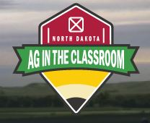
September - - -ND Farm to School Month

September 16, 2021- - -Ag in the Classroom School Lunch Day
(originally Pride of Dakota)
October 1st - - - This is the date that determines the number of applications to be verified. Record the number of approved applications on the district Verification Collection Report, then start the process to verify 3%. Verification ends November 15th, the report is due on December 15.

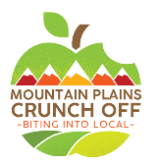
September 16 to October 15 - Apple Crunch-Off (All students-crunch-an-apple contest)
Register your participation here: https://www.surveymonkey.com/r/79XXHNM
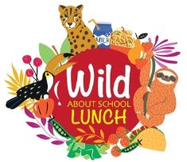

October 11-15, 2021 - - - National School Lunch Week This year’s theme:
Wild About School Lunch Check the School Nutrition Association website for more details: www.schoolnutrition.org
November 15 - - - Verification of 3% of Free and Reduced-Price Applications must be completed.

December 15 - - - Verification Summary Report due. Complete the fillable form on ND Foods.

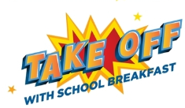
January 31 - - - On Site reviews for school districts with more than one foodservice site serving NSLP/SBP and 2 on site reviews for all After School Snack programs must be completed before February 1st each year.
March 4-8, 2022 - - - School Breakfast Week This year’s theme: Take Off with School Breakfast! Check the School Nutrition Association website for more details: www.schoolnutrition.org
April - - - Two health inspections need to be performed on each school kitchen, annually. Check to make sure the health inspector has been at each school twice. The PLE tool will be posted this month. Every school must do the tool annually to determine school lunch price for the following year. Exemptions from the State office for mandatory price increases have been available, but the PLE tool still must be filled out.

May 6, 2022: 1st Friday - - - School Lunch Hero Day

May 2-6, 2022 1st week - - - School Nutrition Employee Week
NDDPI encourages you to recognize staff members involved with providing nutrition to your students.

June/July - - - Check your 05 Fund for Food Service for Excess Funds. Do this by taking ONLY 05 Fund expenses, divide by 9 (months of school) multiply by 3 (months allowed for operating reserve). Compare the 3-month average expense to the 05 Fund Ending Balance. If the Ending Balance is greater, then make sure to plan for dealing with the excess funds. You report your 05 Fund information to NDDPI in Sept/Oct and the State calculates Excess Fund report from those numbers.

Also assess your non-program food revenue versus cost. All schools who purchase and sell non-reimbursable food including ala carte, seconds, adult meals, catered meals, etc. are required to make sure the revenues from all these areas exceed the cost to purchase and serve them. This is a simple math calculation using 4 numbers from the food service revenues and expenses. This tool is available on NDDPI website. This tool must be filled out annually as well. It will be checked during an administrative review.

Update the Sponsor, Site and Program Details online at NDFoods. Remember to check all contact information for correct names, emails, and phone numbers so messages get to the right person. Delete any staff that are no longer there and add new staff as needed.

Get ready for another awesome school year!

