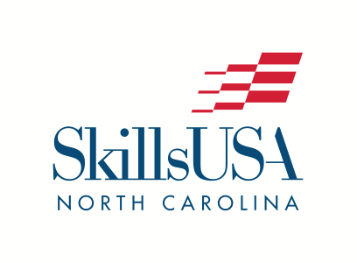
2026 NLSC PRESS RELEASE

P.O. Box 88
Oxford, NC 27565
Phone: (919) 675-1241
info@SkillsUSAnc.org
www.SkillsUSAnc.org

FOR IMMEDIATE RELEASE

June 8, 2026:

Over 530 North Carolina Career & Technical Education students, instructors, administrators, parents and other participants from 42 high schools, 5 middle schools and 26 community colleges participated in the 61st annual SkillsUSA National Leadership and Skills Conference in Atlanta June 1-5, 2026.

North Carolina was very well represented with 312 students engaging in the SkillsUSA Championships, earning a total of 79 medallions (2nd highest in the nation!). North Carolina student-contestants earned 25 gold, 23 silver, and 31 bronze medals.

- 29% of North Carolina student-contestants were medalists. 69% placed in the top 10 in their contests.
- The Postsecondary delegation consisted of 121 student-contestants – 47 medalists and 105 placing in the top 10.
- The High School delegation consisted of 129 student-contestants – 22 medalists and 60 placing in the top 10.
- The Middle School delegation consisted of 20 student-contestants – 10 medalists and all 20 placing in the top 10.

Student members competed at the state level at the SkillsUSA North Carolina State Conference in April. Each student-member competing had to place first in their respective competition at the state level in order to qualify to compete at the national level.

Eight SkillsUSA North Carolina State Officers engaged in the LEVERAGE State Officer Training at the National Conference and served as voting delegates for the SkillsUSA national officer team elections.

In addition to excellence in competitive events, North Carolina was honored to have Nash Community College selected as 1 of 24 national Models of Excellence, a distinction given to the top 24 chapters in the country.

Brody Pettipas from West Carteret High School was elected as the SkillsUSA National Region 2 Vice President for the 2026-27 year.

SkillsUSA North Carolina also received an award for increase in membership for the high school and college postsecondary divisions.

“We are incredibly proud of our students and teachers for embodying our slogan of being ‘Champions at work’”, said Paul Heidepriem, SkillsUSA North Carolina Executive Director. “Our teachers and instructors are ensuring that the Framework of Personal, Workplace & Technical Skills are developed in each classroom.”

###

SkillsUSA is a nonprofit partnership of education and industry founded in 1965 as Vocational Industrial Clubs of America (V.I.C.A.) to strengthen our nation’s skilled workforce. Driven by employer demand, SkillsUSA helps students develop necessary personal and workplace skills along with technical skills grounded in academics. This SkillsUSA Framework empowers every student to succeed at work and in life, while helping to close the skills gap in which millions of positions go unfilled. Through SkillsUSA’s championships program and curricula, employers have ensured schools are teaching relevant technical skills, and with SkillsUSA’s new credentialing process, they can now assess how ready potential employees are for the job. SkillsUSA has hundreds of thousands of members nationwide in high schools, middle schools and colleges, covering over 140 trade, technical and skilled service occupations, and is recognized by the U.S. Departments of Education and Labor as integral to career and technical education. With the addition of our alumni, membership last year was over 440,000. SkillsUSA receives in-kind and financial support from more than 650 national partners. SkillsUSA has served more than 14 million members since 1965. For more information, go to SkillsUSA.org and SkillsUSAnc.org .

