Weblink Text Option #1:
Interested in becoming [a/an LEA] educator? Our partners at TeachNC can help! Sign up for a FREE 1-on-1 coaching call to determine your next steps and find a licensure program that meets your needs!
Weblink Text Option #2:
Are you interested in teaching? Our partners at TeachNC will reimburse you up to $100 of the cost to apply to a teacher prep program! Not sure where to start? Set up a free coaching call to get support with identifying your next steps!
Image linked here
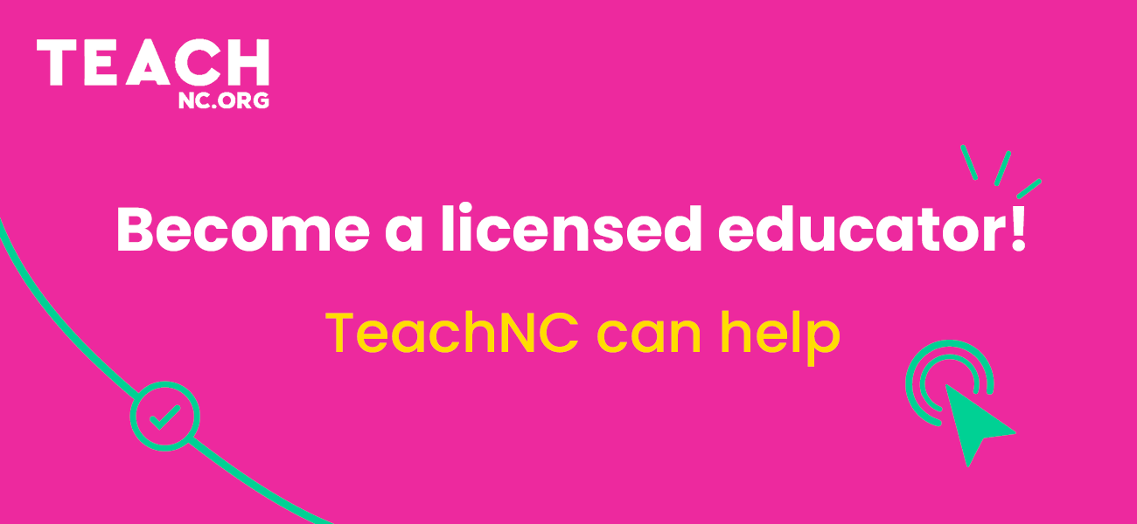

Weblink screenshot examples below.
