The Carter G. Woodson School Board of Directors Announces Appointment
Of a New School Leadership Team Effective 2024-2025 School Year

The Carter G. Woodson School (CGWS) has operated as a public charter school since 1996, originally chartered as Challenges of the Twenty-First Century, Inc. Currently serving 500 students, grades K-12, the CGWS Board of Directors is thrilled to announce the formation of our new leadership team. This team of dedicated and experienced professionals will guide our school toward continued success, ensuring that our students receive the highest quality education in a nurturing and supportive environment.
Kenneth Love, CGWS Board Chair says, “The Board is excited for the new school year and our new leadership team of professionals who have a proven record of putting the needs of our students first. “
TRANSITION TO TRANSFORMATION
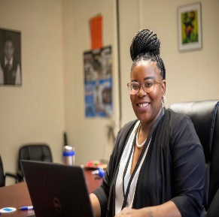
Darlene Steele as Senior Executive Director
Ms. Steele is a dynamic leader with over a decade of experience in motivating and guiding teams toward success. In her new role she is dedicated to fostering a challenge-friendly, nurturing, and constructive learning environment under the motto “Strive to Excel, Not to Equal.” She holds advanced degrees in Organizational Development and Leadership and is currently pursuing a Ph.D. focused on Inclusive Leadership for Social Justice, researching Black women's experiences with tokenism in the workplace. She strives to amplify and honor Black women’s voices through narrative inquiry, validating their contributions and experiences. [Photo by: Ken Branson at Basement to Balcony Inc.]
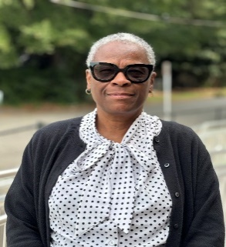
Debra Gaines as Principal/Director of Curriculum Services- Assessment
Ms. Gaines is a Winston Salem native who has served Carter G. Woodson School in a myriad of roles. Starting as a lateral entry teacher, she completed the teacher education program at WSSU. She earned a master’s degree in School Administration and an Educational Specialist Degree in Educational Leadership from Appalachian State University. As the school enters another chapter in its evolutionary brand, Ms. Gaines is glad to be a part of the dynamic transformation taking place in this vibrant academic community.

Celene Mais, T.Dip, BEd, JP as the new Dean of Instruction
Mrs. Mais is an experienced academic leader with a vast background in teaching and educational leadership for over twenty-nine years. She officially joined Carter G Woodson School as an Instructional Coach in 2023 and was later promoted to Dean of Academics. She is responsible for executing the academic mission of Carter G Woodson School, Kindergarten to High School. She has extensive experience in teaching, mentorship, coaching, and school leadership. Mrs. Mais is family-oriented, hails from Jamaica, and advocates for youths. She decorates, plans events, and does floral arrangements in her spare time.
Together, this dynamic team will bring a fresh perspective, collaborative spirit and a renewed commitment to our school’s mission - building on our past successes while embracing new opportunities for growth and development. Their combined expertise and vision will play a pivotal role in enhancing the educational experience for all our students, supporting our teachers, parents and general staff, and engaging with our community.
Hazel Mack, CGWS Founder/Original Board Chair/Board Member says, “CGWS adopts a new leadership structure that will keep us growing into the future while we maintain and bring with us our cultural foundation as we remain true to the needs of our community. Our board is confident that Steele, Gaines and Mais will lead us forward!”
Please join us in celebrating 28 years of transition and transformation, and Ms. Steele, Ms. Gaines, and Ms. Mais to their new roles. We look forward to the positive impact they will have on our school. Contact us at 437 Goldfloss St., Winston-Salem, NC; 336-723-6838 to learn more about our offerings and to request a tour; also visit https://www.cartergwoodsonschool.org/
------

