Planned Update to Clear the IEP Workspace in ECATS

Beginning July 1, 2023, the IEP Process workspace will clear when the user selects ‘Initial’ or ‘Annual Review’ for Meeting Purpose. Clearing the IEP workspace ensures that the user develops the new IEP with current and relevant information, rather than manually deleting information that is no longer appropriate. This is consistent with the requirement to review and revise the IEP at least once annually with present levels of academic achievement and functional performance. After selecting the Meeting Purpose, Initial or Annual Review, and clicking Save and Continue, the Meeting Purpose section of the IEP will display an alert that the meeting purpose selected will clear the IEP Workspace.

Clearing the IEP workspace occurs when:
- User opens the IEP process under the student’s EC Process menu.
- User clicks to open the Meeting Purpose page.
- User selects ‘Initial’ or ‘Annual Review’ for the Meeting Purpose dropdown.
- User completes remaining required information and clicks ‘Save & Continue’.
- Any information on the rest of the pages for the IEP clears out (including the services page).

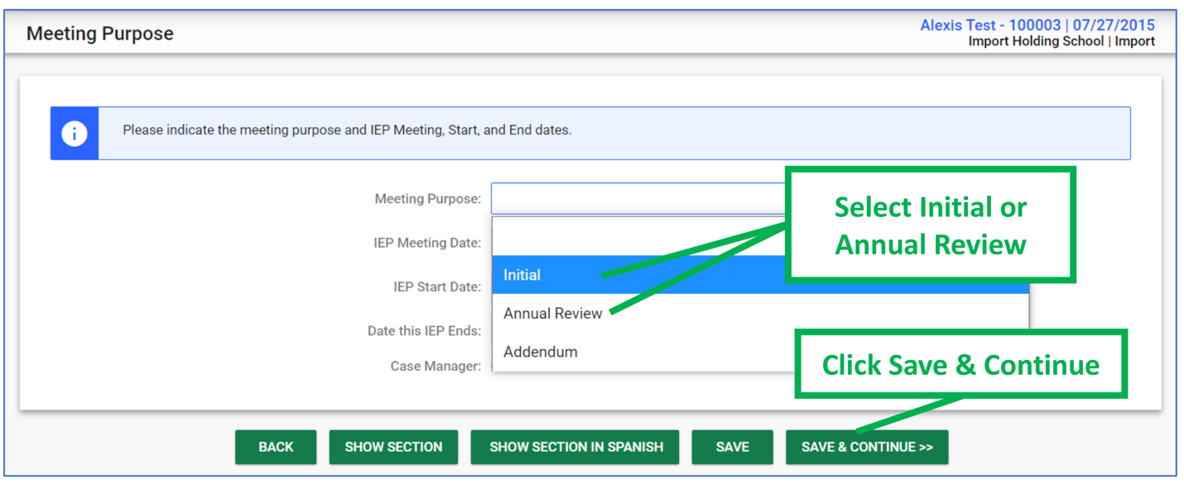

Reminders:
- Users should carefully review and update information on the Services page for an Annual Review.
- Information from previous finalized IEP documents will remain as historical data in ECATS, accessible via the Advanced Reporting platform and Student History page.
- Any assessment data, existing or new, that has been entered into the Assessment Summary remains a part of the student’s ECATS record and will not clear when the meeting purpose is selected. If the information is current and relevant to the IEP being drafted, the user will need to add the relevant assessments on the Source of Relevant Info page of the new Annual Review IEP.

