NC DEPARTMENT OF HEALTH AND HUMAN SERVICES &
NC DEPARTMENT OF PUBLIC INSTRUCTION
SUMMER 2023 P-EBT: LINKS & TOOLKIT OVERVIEW

This toolkit is intended to provide materials and information to stakeholders involved with P-EBT for Summer 2023. All items in this toolkit should assist stakeholders in becoming trusted sources for information on the program. See below for a list of key links and documents included in the toolkit with descriptions.
KEY LINKS
- NCDHHS P-EBT Website: [English - NCDHHS.gov/PEBT] [Spanish - https://covid19.ncdhhs.gov/programa-de-transferencia-electronica-de-beneficios-pandemico-p-ebt] This is where any updates with the P-EBT program are posted.
- Updated FAQs: [English - https://covid19.ncdhhs.gov/information/human-services/pandemic-electronic-benefit-transfer-p-ebt-program/p-ebt-frequently-asked-questions] [Spanish - https://covid19.ncdhhs.gov/infoguidance/individuals-families/pandemic-ebt-p-ebt-program/en-espanol/preguntas-frecuentes-sobre-p-ebt] This can answer common questions families have about the program.
- Eligibility Quiz for Summer P-EBT: [English - https://covid19.ncdhhs.gov/summer-2023-p-ebt-eligibility-quiz] [Spanish - https://covid19.ncdhhs.gov/prueba-de-elegibilidad-de-p-ebt-de-verano-2023] This is a “self-serve” tool for families to see if their children are eligible.
- Eligibility Notices for Summer P-EBT: [English - https://covid19.ncdhhs.gov/summer-2023-p-ebt-eligibility-notice/open] [Spanish - https://covid19.ncdhhs.gov/summer-2023-p-ebt-eligibility-notice-spanish/open] This is the official notice posted to the P-EBT website addressing eligibility for the Summer 2023 program. Notices will NOT be mailed to households.
- NCDHHS FNS Website: [NCDHHS.gov/FNS] This is where families can learn more about FNS.
- ePASS: [ePASS.NC.gov] This is where families can apply for FNS.
- ebtEdge: [ebtEdge.com] This is where eligible families can go to activate their cards and check their balances.
KEY MATERIALS
- P-EBT Overview: A basic overview of the program with key pieces of information and changes between the program last summer and this summer and between the school year program and the summer program.
- Social Media Content + JPGs: Stock content which can be utilized on partner/stakeholder websites and social media handles.
- Desk Reference: High level overview of Summer 2023 P-EBT in a quick reference format.
- Summer 2023 P-EBT Flyer (ENG and SPAN): informational flyer that will be posted on the P-EBT website and which can be distributed to and used by community partners.

NC DEPARTMENT OF HEALTH AND HUMAN SERVICES &
NC DEPARTMENT OF PUBLIC INSTRUCTION
SUMMER 2023 P-EBT: SOCIAL MEDIA STOCK

MESSAGE #1: Summer approved; general information; program ending
FACEBOOK + INSTAGRAM
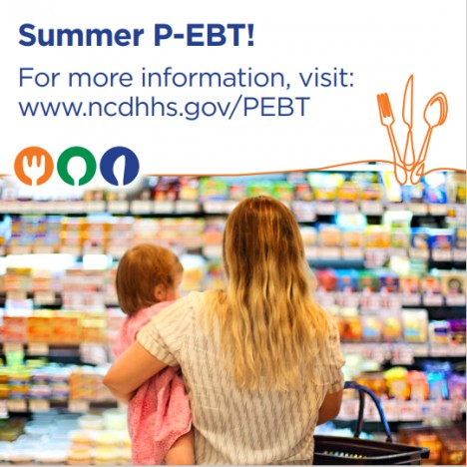
The United States Department of Agriculture has approved summer 2023 P-EBT for some but not all groups of children because of federal rules for the summer 2023 program.
Included for summer: This summer, only traditional in-person students are included for Summer P-EBT. This is the last cycle of this pandemic-related program.
Not included for summer: For young children under age 6, and fully virtual and homeschool students, the program will end with the school year in May 2023 in compliance with federal rules.
Eligible in-person students will receive a one-time payment of $120 for Summer P-EBT in July, but some may see the benefit in August. The summer benefit amount is the same for all recipients and is NOT dependent on COVID-19 related absences during the school year. More information on summer 2023 program eligibility will be posted soon, so look for updates here and on the P-EBT website.
After this summer, the P-EBT program will end and will not continue next year.
Visit www.ncdhhs.gov/PEBT. #NCPEBT
TWITTER
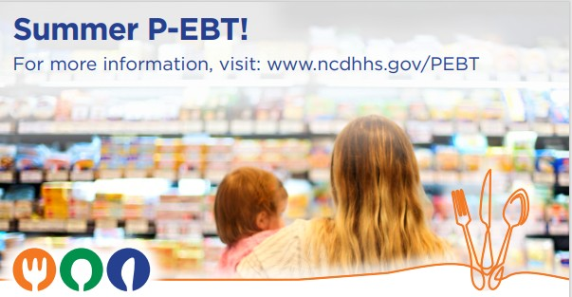
Summer 2023 P-EBT is approved for some but not all groups of children according to federal P-EBT rules and marks the last iteration of P-EBT before the program permanently ends. For more information and eligibility answers, visit www.ncdhhs.gov/PEBT. #NCPEBT
MESSAGE #1: Summer approved; general information; program ending - SPANISH
FACEBOOK + INSTAGRAM
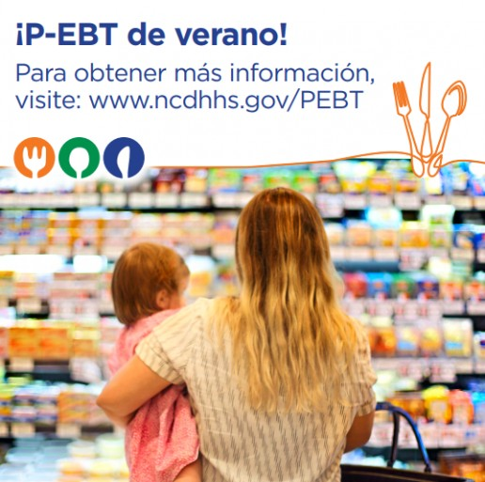
El Departamento de Agricultura de los Estados Unidos ha aprobado el P-EBT de verano 2023 para algunos, pero no todos los grupos de niños debido a las reglas federales para el programa de verano 2023.
Incluido para el verano: Este verano, solo se incluyen estudiantes tradicionales en persona para el P-EBT de verano. Este es el último ciclo de este programa relacionado con la pandemia.
No incluido para el verano: Para niños pequeños menores de 6 años y estudiantes totalmente virtuales y de educación en el hogar, el programa finalizará con el año escolar en mayo de 2023 de conformidad con las normas federales.
Los estudiantes elegibles en persona recibirán un pago único de $120 por P-EBT de verano en julio, pero algunos pueden ver el beneficio en agosto. El monto de los beneficios de verano es el mismo para todos los beneficiarios y NO depende de las ausencias relacionadas con COVID-19 durante el año escolar. Pronto se publicará más información sobre la elegibilidad del programa del verano 2023, así que busque actualizaciones aquí y en el sitio web de P-EBT.
Después de este verano, el programa P-EBT terminará y no continuará el próximo año.
Visite www.ncdhhs.gov/PEBT. #NCPEBT
TWITTER
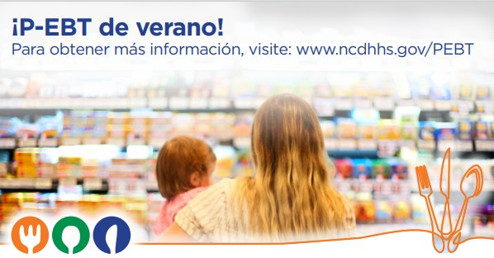
P-EBT de verano 2023 está aprobado para algunos, pero no para todos los grupos de niños de acuerdo con las reglas federales de P-EBT y marca la última iteración de P-EBT antes de que el programa finalice permanentemente. Para obtener más información y respuestas de elegibilidad, visite www.ncdhhs.gov/PEBT. #NCPEBT
MESSAGE #2: Eligibility and timing; required actions; application deadline
FACEBOOK + INSTAGRAM
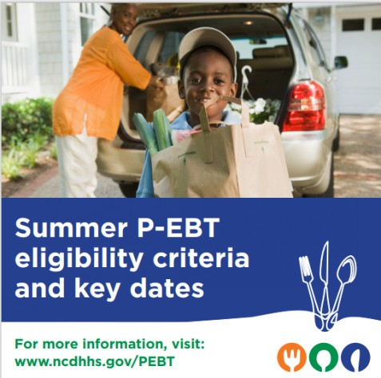
This year, to comply with federal rules, only traditional in-person students will be able to get summer 2023 P-EBT. Young children under age 6, and fully virtual and homeschool students are not eligible for the summer 2023 program. Students are eligible for summer 2023 P-EBT if:
- Student attends a traditional, in-person school in May 2023, AND
- Student is eligible for NSLP free or reduced-price school meals by May 31, 2023.

Unlike last year, it is NOT possible this year to apply during the summer. Key summer 2023 P-EBT dates to watch for:

May 1: Apply for free or reduced-price school meals / NCFNS to be considered for P-EBT eligibility by this date because applications can take 30+ days to process.
May 31: Deadline for program eligibility.
End of July: The one-time summer 2023 benefit of $120 is deposited for most households. Benefits will be made available within 10 days of issuance. Some students may get the benefit in August.

Summer 2023 is the last cycle of Pandemic EBT and the pandemic-related program will come to an end. There will be no more P-EBT benefits issued after this 2023 summer. For more information and eligibility answers, visit www.ncdhhs.gov/PEBT. #NCPEBT
TWITTER
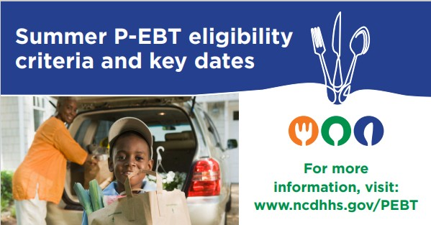
Summer 2023 P-EBT: Only students approved for free or reduced-price school meals by May 31, 2023 will be eligible to get the summer benefit in July. To comply with federal rules, young children and virtual and homeschool students cannot get the summer 2023 P-EBT benefit. For more information, visit www.ncdhhs.gov/PEBT. #NCPEBT
MESSAGE #2: Eligibility and timing; required actions; application deadline - SPANISH
FACEBOOK + INSTAGRAM
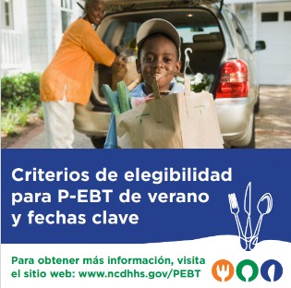

Este año, para cumplir con las reglas federales, solo los estudiantes tradicionales en persona podrán obtener el P-EBT de verano 2023. Los niños pequeños menores de 6 años y los estudiantes totalmente virtuales y de educación en el hogar no son elegibles para el programa de verano 2023. Los estudiantes son elegibles para P-EBT de verano 2023 si:
- El estudiante asiste a una escuela tradicional en persona en mayo de 2023, Y
- El estudiante es elegible para las comidas escolares gratuitas o a precio reducido de NSLP antes del 31 de mayo de 2023.

A diferencia del año pasado, este año NO es posible aplicar durante el verano. Fechas clave para P-EBT de verano 2023 de tener en cuenta:

1 de mayo: Solicite comidas escolares gratuitas o a precio reducido/NCFNS para ser considerado elegible para P-EBT hasta esta fecha porque las solicitudes pueden tardar más de 30 días en procesarse.
31 de mayo: Fecha límite para la elegibilidad en el programa.
Finales de julio: El beneficio único del verano de 2023 de $120 se deposita para la mayoría de los hogares. Los beneficios estarán disponibles a los 10 días posteriores a la emisión. Algunos estudiantes pueden obtener el beneficio en agosto.

El verano de 2023 es el último ciclo de EBT pandémico y el programa relacionado con la pandemia llegará a su fin. No habrá más beneficios de P-EBT emitidos después de este verano de 2023. Para obtener más información y respuestas de elegibilidad, visite www.ncdhhs.gov/PEBT. #NCPEBT
TWITTER
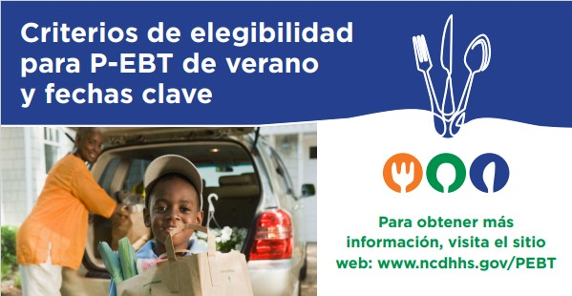
P-EBT de Verano 2023 : Solo los estudiantes aprobados para comidas escolares gratuitas o a precio reducido hasta el 31 de mayo de 2023 serán elegibles para recibir el beneficio de verano en julio. Para cumplir con las reglas federales, los niños pequeños y los estudiantes virtuales y de educación en el hogar no pueden obtener el beneficio P-EBT del verano de 2023. Para obtener más información, visite www.ncdhhs.gov/PEBT. #NCPEBT

