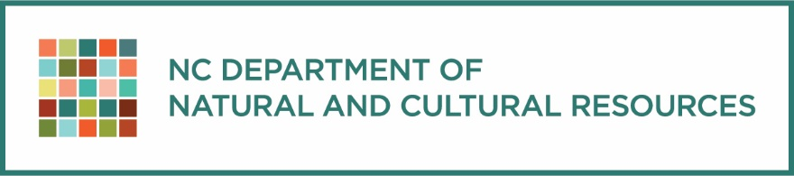
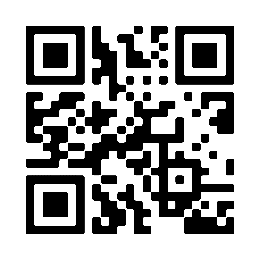
Explore the education material collections from the North Carolina Department of Natural and Cultural Resources! DNCR educational resources come from the NC Aquariums, State Historical Sites, State Parks, Symphony, the NC Zoo, and the Museums of Art, History, and Natural Sciences.

OWL – Outdoor Wonders and Learning Workshop (NC Aquarium at Fort Fisher)
Saturday, December 3rd, 2022
9:00 AM - 4:00 PM COST: $25
Are you a: Classroom teacher looking to incorporate more Environmental Education into your lessons? Non-formal educator hoping to incorporate more grade level standards into your programs? K-5 pre-service teacher looking for more resources to implement Science Methods? If you said “Yes!” to any of these questions, then an OWL Workshop is the place for you. OWL (Outdoor Wonders and Learning) is an Environmental Education-based curriculum guide written and designed to match North Carolina Essential Standards for elementary grades.
For additional workshop information, call 910-772-0546. To register online, visit: https://reservations.ncaquariums.com/fortfisher/Info.aspx?EventID=20

American Indian Heritage Celebration Virtual Education Day (NC Museum of History)
Friday, November 18, 2022. FREE
Join us virtually on Friday, November 18, for free interactive presentations and LIVE! streaming of music and dancing from North Carolina’s state-recognized tribes.
Presentations
9:00-9:45 a.m.: Senora Lynch, Haliwa-Saponi, pottery
10:00-10:45 a.m.: Gwen Locklear, Lumbee, storytelling
11:00-11:45 a.m.: Chi Shipman, Eastern Band of Cherokee, language and culture
12:00-12:45 p.m.: Patrick Suarez, Meherrin, regalia and American Indian Symbols
LIVE! performances
9:30 a.m.-1:45 p.m.: Watch online and enjoy dance and music performances of North Carolina American Indians. Performances will begin every 45 minutes.

The (un)Civil War in North Carolina LIVE! (NC Museum of History)
Monday, February 6, 2023. FREE
This LIVE! virtual event journeys to several historic sites highlighting North Carolinians who lived during the Civil War to help students understand the choices faced and decisions made in response to the changes that the war brought.

COSTA RICA ECOLOGICAL EDVENTURES COURSE (NC Aquarium at Fort Fisher)
JULY 11-19, 2023 - SAN JOSÉ, COSTA RICA
Explore the ecology of Costa Rica, earn continuing education credits, and help save sea turtles! Study sea turtles and collect data on them, hike through rainforests, restore mangroves, learn how to make chocolate, and so much more!
CONTACT: Gail Lemiec, Unique Experiences Coordinator. https://www.ncaquariums.com/ecological-edventures

NC Museum of Natural Sciences
The Museum is committed to increasing educators' understanding and appreciation of the natural environment through outstanding professional development workshops onsite, online and outdoors, and through helping teachers turn their school grounds into areas for wildlife and learning. https://naturalsciences.org/learn/educators

The Story of North Carolina 360° Student Tour (NC Museum of History)
On-demand. FREE
Explore 14,000 years of history from our 20,000 square foot exhibit, The Story of North Carolina, in 360°—one gallery at a time. Watch videos, look at artifacts in 360°, see photos, and “meet” some of the people who shaped our state. Zoom in, spin around, and take a closer look. Plus, discover engaging educational resources connected to each 360° tour, for students, teachers, everyone!

