Use of Social Media Content
Please use the following messages to post on your Facebook and Twitter accounts. We encourage you to use #NCPEBT so we can monitor progress and review how your communities are responding to this next round of P-EBT.

Post-Launch Message #1
Goal: Inform the households / customers that January and February 2021 benefits will be issued in the coming days
Suggested date to be posted: 3/24
Graphic(s):
- Facebook: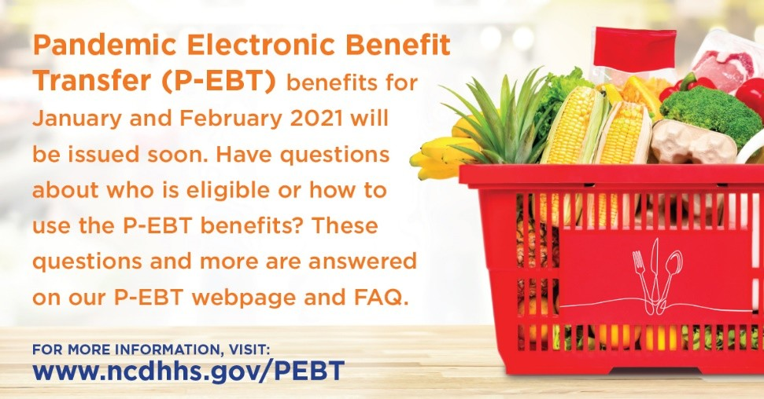
- Instagram: 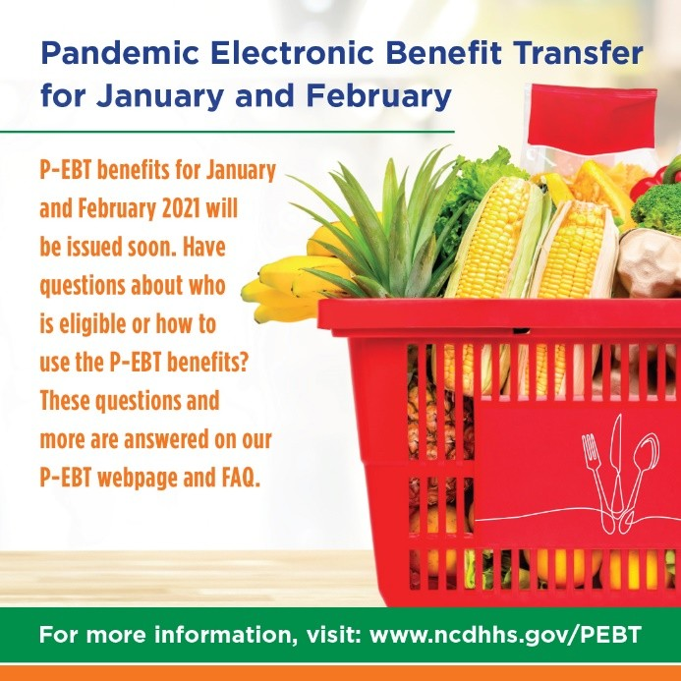

FACEBOOK FEED POST
P-EBT benefits for students received in March will be for the months of January and February 2021. Benefits will begin being issued by the end of March and staggered over several days.

The amount of P-EBT received for each month will be one of two distinct amounts based on if a student is either in a remote (all virtual) or hybrid learning mode (combination of virtual and in-person) for January or February. Please use the table on the P-EBT website for an explanation on the hybrid and remote benefit amounts eligible students will receive for the month of March. This table can be found under the “P-EBT Amount and When to Expect the Benefit“ section of the webpage - www.ncdhhs.gov/PEBT.

If you’ve received P-EBT in the past, check your current card for funds to appear the week of issuance. Those who do not have an EBT card (FNS or P-EBT) and are eligible during these months should anticipate receiving their cards by the end of April.

No longer have your P-EBT card and need to request a new one? If you have previously registered your EBT card online and created an account requesting a new card is easy! Simply log on to www.ebtedge.com or through the ebtEDGE mobile application and click on “More Information” under EBT Cardholder. You will be prompted to login. To check if you have an account, please select “Trouble Signing In?” and follow the prompts listed.

Visit www.ncdhhs.gov/PEBT for more info on P-EBT for students. #NCPEBT

TWITTER
P-EBT benefits for January and February 2021 will be issued by the end of March. If you’ve received P-EBT in the past, check your card for funds on the date of issuance. Visit www.ncdhhs.gov/PEBT for more info. #NCPEBT

Post-Launch Message #2
Goal: Reminder that only students learning in virtual instruction for at least some of the time will receive P-EBT benefits as NC schools go back to in person attendance
Suggested date to be posted: 4/9
Graphic:
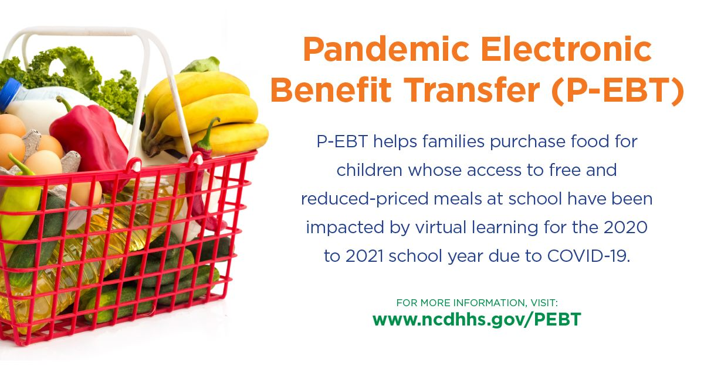

FACEBOOK FEED POST

P-EBT provides food assistance benefits to North Carolina families whose school-aged children are eligible to receive free or reduced-price meals at school, but who have not been able to access those meals because they have been learning in virtual instruction due to the COVID-19 pandemic.

For a student to receive P-EBT benefits, the student must be enrolled in a school that participates in the National School Lunch Program (NSLP) and be eligible for free or reduced-price meals. Additionally, the student’s school must have been closed or operating with reduced attendance for at least 5 consecutive days during the 2020 to 2021 school year, and the student must be in either a “remote learning mode” (all virtual instruction) or in a “hybrid learning mode” (combination of virtual and in-person instruction) during the month of eligibility.

Students who have returned to school full time will not receive P-EBT benefits for the months they were in 100% face-to-face instruction.

The P-EBT program is designed to help feed students who are not receiving free or reduced-price meals at school during the day as a result of virtual learning instruction.

For more information on student eligibility, visit www.ncdhhs.gov/PEBT. #NCPEBT

TWITTER
P-EBT provides benefits to families whose children are eligible to receive free or reduced-price meals at school, but who have not been able to access those meals because they have been learning in virtual instruction. For more information, visit www.ncdhhs.gov/PEBT. #NCPEBT

Post-Launch Message #3
Goal: Inform the households / customers that March 2021 benefits will be issued in the coming days
Suggested date to be posted: 4/19
Graphic(s):
- Facebook: 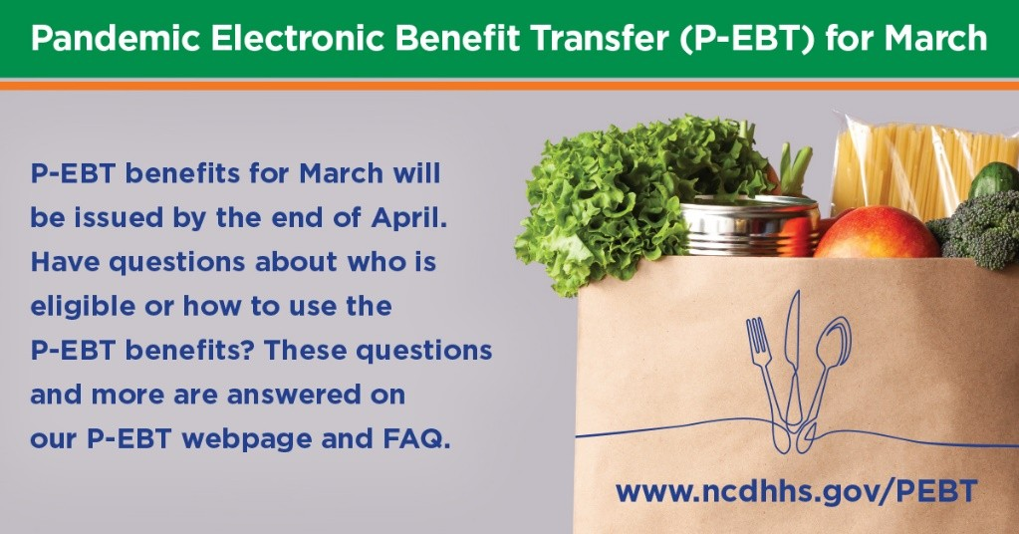
- Instagram: 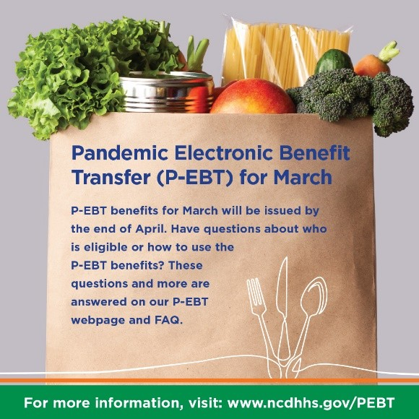
FACEBOOK FEED POST

NCDHHS plans to issue P-EBT benefits to eligible students for the month of March in the coming days. Benefits will begin being issued by the end of April and will be staggered over several days.

A school-aged child is eligible for the P-EBT program if their school is eligible to provide free or reduce-priced meals at school this year, and the child was eligible to receive free or reduced-priced meals during the 2020-2021 school year. Additionally, the amount of P-EBT received for the month will be one of two distinct amounts based on if a student is either in a remote (all virtual) or hybrid learning mode (a combination of virtual and in-person).

If you’ve received P-EBT in the past, check your current card for funds to appear the week of issuance. Those who do not have a card and are eligible during the month of March should anticipate receiving their cards by the end of May. Need to replace your card? Visit www.ncdhhs.gov/PEBT for more information on how to do so.

For more information on P-EBT, visit www.ncdhhs.gov/PEBT. #NCPEBT

TWITTER (Post 2 to 3 times over 48 hours)
NCDHHS will issue P-EBT benefits for March in the coming days. If you’ve received P-EBT in the past, check your card for funds the week of issuance. Those who don’t have a card should receive their cards by the end of May. For more information, visit www.ncdhhs.gov/PEBT. #NCPEBT

