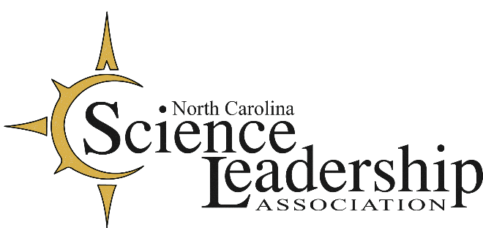

NCSLA 2020-2021 Webinar Series
Webinar #5 The Science of Self-care
Monday, February 15, 2021, 5:30-7 PM

Going beyond the rhetoric around self-care, Dr. Steven Scoggin, Wake Forest University Chair of Psychiatry, will describe the current medical model for chronic stress. Ashley Hawkins Parham, Health and Wellness Coach from the Office of Wellbeing at WFU, will guide us through an interactive session demonstrating trauma-informed mind-body skills. You will leave the webinar with skills for managing emotions and tools to create your own resilience plan. NCDPI’s state social worker, Pachovia Lovett, will share how DPI is supporting educators through the pandemic challenges.

Presenters:
Steven N. Scoggin, M.Div. Psy.D., LCMHC
Department of Psychiatry
Wake Forest Baptist Medical Center

Ashley Hawkins Parham, M. Psych
Health and Wellness Coach, Koru Mindfulness Teacher
Wake Forest University Wellbeing Center

Pachovia Lovett, MSW
School Social Work Consultant - NCDPI

Sponsor Highlights: BWF/SMT and Legends of Learning

FREE to NCSLA Members but you must register to attend.
$40 for Non Members: includes all four webinars plus one-year NCSLA membership
Register at ncsla.net/fall20webinar



 Delta Education/FOSS  


Pachovia Lovett
School Social Work Consultant
NC Department of Public Instruction
Pachovia.Lovett@dpi.nc.gov

Pachovia Lovett is the State School Social Work Consultant at the NC Department of Public Instruction. As a part of the NC Healthy Schools team, she uses a whole child approach while working with school social workers and directors of school social work across the state to develop and support efforts that eliminate barriers to student achievement and overall success. Pachovia received a BSW from the University of North Carolina at Greensboro and a MSW from Texas State University. She has 14 years of experience in public education and school social work. She is passionate about advancing the profession and promoting comprehensive student wellness. As a state level advocate, it is her goal to ensure that NC school social workers are in the best possible position to serve as the vital link between school, home, and community.

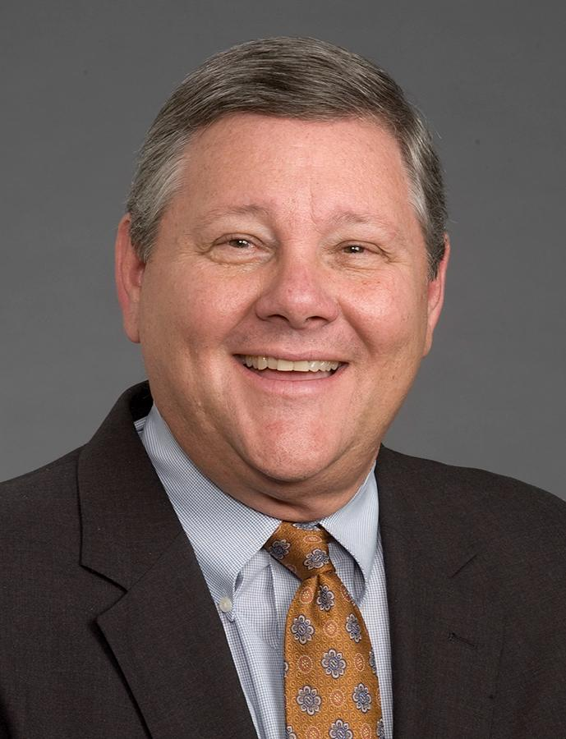
Steven N. Scoggin, M.Div.,Psy.D, LCMHC
Associate Vice-President of Behavioral Health
Interim Chair, Department of Psychiatry and Behavioral Medicine
Assistant Professor in Psychiatry and Behavioral Medicine, Wake Forest Baptist Medical Center
sscoggin@wakehealth.edu

Steve Scoggin is a licensed clinical mental health counselor and ordained minister whose thirty-five years as a clinician and behavioral health leader have been embedded at the boundaries of behavioral health, psychiatry and faith. Dr. Scoggin served as president of CareNet, Inc., a subsidiary of Wake Forest Baptist Health, a statewide outpatient behavioral health network of 35 clinics covering 70 counties (2001-2018) until August of 2018 when he assumed the Interim-Chair position of The Department of Psychiatry and Behavioral Medicine, and as Assistant Professor in Psychiatry and Behavioral Medicine. Dr. Scoggin was appointed by former North Carolina Governor McCrory to serve on The Governor’s Task Force for Mental Health and Substance Use. He is a gifted presenter on a wide variety of topics focused on building functional integration collaborations between behavioral health and the community.

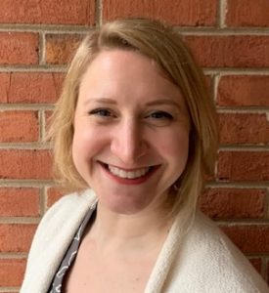
Ashley Hawkins Parham, MA
Program Manager of Wellbeing
Wake Forest University Office of Wellbeing
hawkinaa@wfu.edu

Ashley Parham dedicated time as a student, researcher, practitioner, and student affairs professional over the last 15 years to understanding the science of behavior change and motivation, addiction, risky health behaviors in college students, personality and personality change, character development, wellbeing in the workplace, post-traumatic growth, mindfulness and meditation, the mind-body connection, and resilience. She creates and manages initiatives and services for the entire Wake Forest community – students, faculty, and staff – to build resilience, to prioritize diversity, equity, and inclusion, to increase daily, joyful movement, and elevate wellbeing in the workplace. Ashley graduated from the College of Charleston’s Honors College with a BS in Psychology and Wake Forest University’s Master’s in Experimental Psychology Program. She is a certified Health and Wellness Coach, Koru Mindfulness teacher, and Community Resiliency Model guide.
Four Part Spring Webinar Series (#5-#8) - 5:30 - 7 pm on February 15, March 16, April 21, and May 20
Webinars will be posted on ncsla.net after each date. Must be a member to view.

