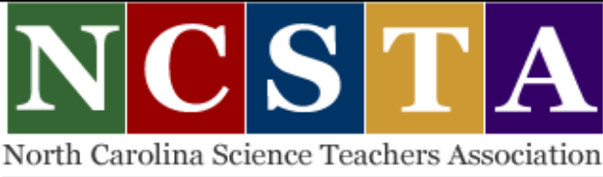

Spring 2021 Workshop Series
ELEMENTARY SCIENCE CONTENT
&
Evaluating for Understanding
Thursdays
Feb. 18, March 4 and 18, April 15
from 4:30 until 6:30 p.m.

FREE for NCSTA Members
$30 for Non-members (complimentary membership included)
One Registration covers all four sessions.
Credit Card Payments Only.
Registration opens Feb. 1st at www.ncsta.org/events

A Zoom link will be sent to those who register on the day of each session.
Contact Manley Midgett at 919-218-7917 or midgettm@meredith.edu

Presenters: Laura Lowder, Pfeiffer University
Michael Lowder, Stanly Community College
Brad Rhew, Winston-Salem/Forsyth County Schools
Warren Potts, Winston-Salem/Forsyth County Schools
Manley Midgett, Meredith College
Angela Adams, Cumberland County Schools

Description of Sessions:

Feb 18 - Activities will be identified and explained so that teachers will know what to teach and not teach for the topics below:
Weather and Climate at grades K, 2 and 5
Properties of Matter at grades K through 5
Mar 4 - Activities will be identified and explained so that teachers will know what to teach and not teach for the topics below:
Plants for grades K through 5
Animals for grades K through 5
Mar 18 - Leaders will explain when to use and not use Multiple Choice test items as well as tips for writing effective items. Science Note-booking and classroom activities will be demonstrated for use in creating formative science evaluations.
Apr 15 - Leaders will share as many K-5 summative science evaluations as time allows and explain how each is effective in gauging student understanding rather than expecting memorization and rote-learning.



