Dear Teachers,

***Why Should Your Students Take the Student Perception Survey?***

One of the strongest correlations to improved student achievement/growth is data from student surveys. In his report of North Carolina’s educator effectiveness model, Dr. Gary Henry (UNC/Vanderbilt) reported that the most compelling comment he received from teacher focus groups was a lack of specific feedback that could help them improve instruction. Dr. Henry said our teachers could greatly benefit from the information gleaned from the surveys and that it could lead to school improvement.

***Who Should Request Feedback?***

**All teachers** can request student feedback, regardless if they are teaching in a district that opted-in or not.

If you are not in a district that opted-in, the only way for your students to take surveys is for you to request feedback. If you are in a district that opted-in, you may request student feedback so all of your students will have the opportunity to take the survey and give you feedback.

***Who Sees Results from Student Perception Surveys?***

When you request feedback, only you can see the results from your students’ surveys. NCDPI encourages you to share your data with your administration to help support your improved instruction.

If you are in a district that opted-in, you will the only one who can see your census data. Your district and school admin can see data from a sample of your students.

***How do My Students Take the Surveys?***

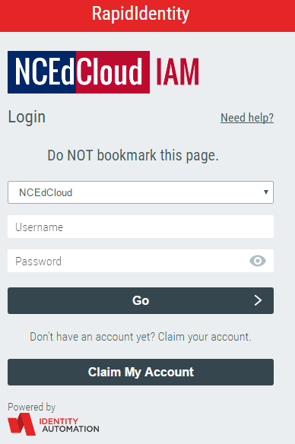 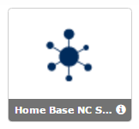

1. Log in to your NCEdCloud using your log in and password.
2. Choose the Student Survey Icon.
3. Once you click on the Student Survey Icon, you will have 2 icons on the next page.

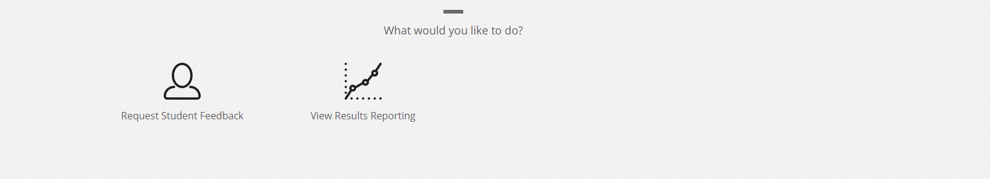

1. Choose the Request Feedback icon to the far left.
2. To have a class of students take surveys, please choose the course you would like to survey and click on the blue “add” button to the right of your course.

1. Once you request feedback, the system will load the courses you are teaching.
2. Your students can now log into their NCEdCloud account to take their survey.

***What is the Student Survey Calendar?***

|  |  |  |
| --- | --- | --- |
| Activity | Start | Finish |
| Teacher Request Feedback | 3/12/18 | 4/20/18 |
| Student Can Take Survey | 3/19/18 | 4/20/18 |
| Results Reporting Window | 4/23/18 | 5/4/18 |

***How do I View the Surveys Before my Students Take Them?***

Please view our [wiki](http://ncstudentsurveys.ncdpi.wikispaces.net/) here for further information including the [surveys](http://ncstudentsurveys.ncdpi.wikispaces.net/Resources).

Any further questions email [paul.marshall@dpi.nc.gov](mailto:paul.marshall@dpi.nc.gov).

Thank you,