
IFLE Newsletter - December 2017
12/11/2017
US Department of Education Newsletter

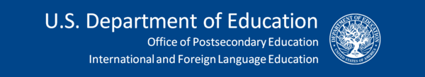

TOP NEWS

#BeGlobalReady Initiative
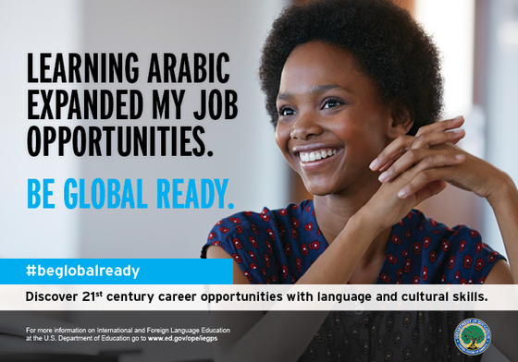

The International and Foreign Language Education (IFLE) office of the U.S. Department of Education is proud to debut a new series of images and messages to encourage U.S. students, teachers, and citizens to "be global ready."

Please visit our website (link below) to download the #BeGlobalReady series. We encourage you to use the images and messages in your schools, classrooms, and communities to spread the word about the value of international and foreign language education!
Image files are available for free download and use at the link below.


IFLE Celebrates International Education Week 2017
To celebrate International Education Week 2017, IFLE hosted a November 13th workshop for K-12 educators on the topic of "Adding a Global Dimension to Your School or Classroom". Approximately 60 teachers and school administrators attended, participating in mini workshop demonstrations and receiving resources from four of IFLE's Title VI grant recipient centers:
- The Assessment and Evaluation Language Resource Center (AELRC) at Georgetown University
- The Center for African Studies (CFAS) at Howard University
- The Center for Contemporary Arab Studies (CCAS) at Georgetown University
- The Institute for Middle East Studies (IMES) at The George Washington University
The Department also marked IEW 2017 with a TED-talks style event on November 6th organized by the International Affairs Office: "The Role of Global and Cultural Competency in National Security and Diplomacy".

We look forward to continuing this work over the coming year to prepare U.S. students, teachers, and communities to be global ready. We'll see you next year for International Education Week 2018!

PROGRAM NEWS

FY 2017 Grantees Announcement
IFLE is pleased to announce our new grant recipients for Fiscal Year 2017. IFLE awarded more than $71 million in new and non-competing continuation grants to help strengthen the capacity and performance of American education in world languages, world area and international studies, and research. The grants are under the Fulbright-Hays Act, also known at the Mutual Educational and Cultural Exchange Act of 1961, and Title VI of the Higher Education Act of 1965, as amended.

“There has never been a more critical time to ensure that all our students are prepared for the challenges of an increasingly interconnected global economy,” said U.S. Secretary of Education Betsy DeVos. “At the Department, we strive to help all students master the skills necessary to succeed in postsecondary education and in-demand careers. More and more, these careers involve working across cultures, in multinational organizations. The work our students will pursue – even some we can’t imagine yet -- will be increasingly technical and global in nature. We can and must prepare them for what lies ahead.….”

The Department aims to address the nation’s need by preparing leaders who are highly competent in world languages and international studies and will fulfill roles critical to our national security and diplomacy, fill key positions in international business, and be the educators to help America’s students achieve greater global competence. These grants support our students, teachers, faculty, administrators, and institutions of higher education as they engage in projects focused on international studies, world languages, cross-cultural understanding and research.

Google Map of IFLE Grant Recipients, Fiscal Year 2017
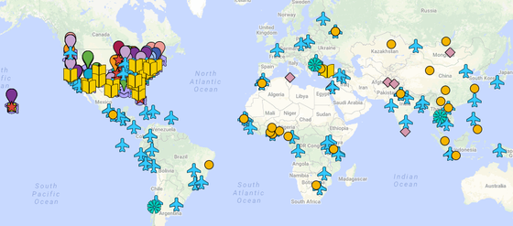

Explore our Google map of FY 2017 IFLE grantees to learn more about the institutions that are currently funded under Title VI and Fulbright-Hays programs administered by IFLE. Discover some of the projects being implemented on campuses all across the country and throughout the world that are strengthening international and foreign language education for all!

The goal of this map is to offer a user-friendly way to get a sense of the extent of our work and the variety of our grantee institutions. The map features both Title VI and Fulbright-Hays grantee institutions.

IFLE GRANTEE SPOTLIGHT

Centers for International Business Education Help Develop USA Trade Guide
For American companies looking to take their business to the next level, IFLE's Title VI Centers for International Business Education (CIBEs) are a source of help.

San Diego State University’s Center for International Business Education and Research (CIBER) recently partnered with the State International Development Organizations (SIDO), ThinkGlobal Inc., and more than a dozen other Title VI CIBE programs across the nation to create the new USA Trade Guide.

The colorful, magazine-style guide is a resource for U.S. exporters, offering the business tools they need to succeed in global markets. The free guide is available in print and online.
The purpose of the guide is to provide U.S. companies and foreign investors with expert advice and answers to frequently asked questions about exporting, foreign direct investment and global business. It includes key contacts, websites and other important resources for exporters and investors to connect with service providers nationwide.

SDSU undergraduate students assisted in compiling the guide by developing an extensive list of international trade resources in countries around the world.
“The CIBER program at SDSU is the only one in the state of California, and the work students complete through the program provides crucial hands-on experience that will help them succeed in their careers,” said Mark J. Ballam, SDSU CIBER managing director. “The USA Trade Guide is one example of how we accomplish the university’s goal of providing a first-class educational experience while helping to improve U.S. business competitiveness at the same time.”

Print copies of the guide are being distributed nationwide by state and local economic development agencies, chambers of commerce, world trade centers, ports, and private sector service providers.
“State international trade offices are on the front line, steering companies through the export process, and working to attract investment in to our respective states,” says David Mathe, president of SIDO. “The guide is a valuable resource for both exporters and companies interested in site selection and investment anywhere in the United States.”

UISFL Grantees Recognized for Excellence in International Education
Several current and past recipients of Title VI Undergraduate International Studies and Foreign Language (UISFL) grants have been honored with Senator Paul Simon Awards for Campus Internationalization. These awards, administered by NAFSA Association of International Educators, recognize excellence in integrating international education throughout all facets of university and college campuses.

Four institutions received awards for comprehensive efforts to internationalize their campuses in 2017: Florida State University, Santa Monica College, the University of Iowa, and the University of Pittsburgh. Three of these institutions received FY 2016 and FY 2017 UISFL awards to conduct projects focused on expanding language and international studies programming at their schools:
- The Foreign Language Advantage (Santa Monica College)
- Rethinking Russian Language Programming for 21st-Century Students (University of Iowa)
- Broadening the Reach of African Studies at Pitt (University of Pittsburgh)
The fourth institution, Florida State University, is a prior UISFL grant recipient. In addition, three institutions received spotlight awards for innovation and creativity in a specific area of internationalization: Spelman College, Texas Christian University, and the University of North Texas (also a prior UISFL recipient).

The 2017 Simon awards demonstrate the long-term impact of UISFL awards on college campuses across the country. The UISFL program provides seed funding to plan, develop, and carry out new programs to strengthen and improve undergraduate instruction in international studies and foreign languages. A large majority of UISFL grantees are community colleges, small four-year colleges/universities, and Minority-Serving Institutions.

VOICES FROM THE FIELD

Fulbright-Hays Group Project Abroad Video: Learn All About Ethiopia!
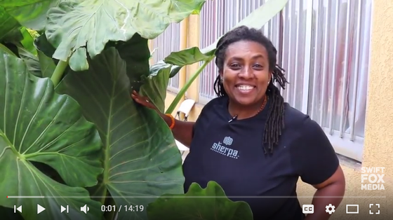

Eighteen (18) American teachers collaborated this past summer to produce a highly informative and entertaining video about Ethiopia thanks to their experiences abroad through the Fulbright-Hays Group Projects Abroad (GPA) program.

The video opens with the teachers' contribution to the five question challenge, a world-wide internet curriculum phenomenon, and then features discoveries from their experiences learning about the Wolaita culture. Curriculum units will accompany each section of the video so that teachers can focus on areas that interest them and can adapt them for K-12 settings.

The University of Pittsburgh's African Studies Program received a Fiscal Year 2016 Fulbright-Hays Group Project Abroad grant to organize the study trip aimed at strengthening the teaching of African(a) Studies in U.S. schools and educational organizations.

American and Ethiopian educators, working in intercultural teams, investigated and documented the folklife of the region in order to build engaging multi-media curriculum units available online. Teachers used folklife as a lens to explore learning across generations and places, participating in and observing what people believe, know, make, say, and create. Participants honed their ethnographic research abilities, investigatory skills and listening practices through activities including site visits, hands-on practice, and classroom exercises. Teachers attended Amharic language class daily in order to develop the language skills necessary to dive deeper into Ethiopia's rich culture.


How One Harlem Teacher is Sharing his Fulbright-Hays Experience in Peru with Students Back Home
Frederic Bernal Lim is an English Language Learner Specialist at the St. HOPE Leadership Academy Charter School in Harlem, New York. Frederic participated in the 2016 Fulbright-Hays Seminar Abroad in Peru for K-8 educators, and he recently shared with IFLE how he is using that experience to infuse a global dimension into his curriculum back home. Frederic writes:
"Since my participation in the Fulbright-Hays Seminar Abroad to Peru in 2016, I have incorporated what I learned about ancestral Peruvian agricultural methods into my Project Based Learning unit on plants called “Medicine in My Backyard” (available on https://iearn.org/). My English as a New Language (ENL) students in Harlem compare plants grown traditionally in soil with those grown in a hydroponic system. Students track growth, then write short poems about culinary and medicinal herbs, combining social studies, science, math, and English language arts. Our school teamed with Harlem Grown and plans to Skype with students at Colegio Marionistas in Lima and Colegio Boston in Guatemala to compare plant growth (specifically potatoes)."

The Fulbright-Hays Seminars Abroad Program provides short-term study and travel seminars abroad for U.S. educators in the social sciences and humanities for the purpose of improving their understanding and knowledge of the peoples and cultures of other countries.

RESOURCES

For the Classroom: Diplomacy Simulations from the U.S. State Department
The U.S. Department of State's Diplomacy Simulations Program is a great opportunity for teachers looking to add a global dimension to their classrooms.

This new program provides collaborative learning experiences in which students step into the role of real-life diplomats. Diplomacy simulations help students develop skills in critical thinking, teamwork, collaboration, problem-solving, persuasive communication, and global competence, while serving as a complement to lessons on history, international relations, U.S. foreign policy, and current events. Middle school, high school, college, and graduate-level students can successfully participate, depending on the simulation.

Simulation materials are available online for free download and include a teacher’s guide with links to instructional videos and seven different historical or hypothetical (but very real) scenarios with background information. Several of the simulations include short video links with subject matter experts.

If you have any questions about the Diplomacy Simulations Program or would like to discuss how to further integrate the expertise of State Department Foreign Affairs Specialists into your classroom or school, please contact DiplomacyCenter@state.gov.

Copies of Title VI 50th Anniversary Conference Book Available
International and Language Education for a Global Future: Fifty Years of U.S. Title VI and Fulbright-Hays Programs published by Michigan State University Press is available for the cost of shipping. In the book, sixteen contributing authors review the history of the programs, including their founding and cumulative impacts on internationalizing American universities at the graduate and undergraduate levels. Chapters review how Title VI programs have built the foundations of U.S. language-learning through their support of in-depth research abroad, improved language-learning curricula, and enhanced capacity to teach more than 200 less commonly taught languages in U.S. schools and institutions of higher education.

This offer is for requests to U.S. mailing addresses only. To order a copy of the book, please click the link below.

If you have questions regarding ordering a copy of the book, please contact Barbara Doty (dotyb@msu.edu; 517-353-8574) in the Center for Advanced Study of International Development at Michigan State University.

ENGAGE WITH US

Follow us on Twitter @GoGlobalED
IFLE is on Twitter with the latest from the world of international and foreign language education. Follow us @GoGlobalED and tell your friends! We'll see you in the Twittersphere!

Subscribe to Our YouTube Channel!
We're on YouTube with informative webinars and exciting grant program videos. Subscribe to IFLE's YouTube channel to enjoy the latest content!

Join our FLAS and Fulbright-Hays Alumni Groups on LinkedIn
Have you received a Foreign Language and Area Studies (FLAS) fellowship or participated in a Fulbright-Hays grant program? Join our alumni groups on LinkedIn!
FLAS Program Alumni Fulbright-Hays Program Alumni

Intern with IFLE!
We seek motivated students who are anxious to learn and work as part of our team during an unpaid full- or part-time internship during the summer, fall, and/or spring. Visit our website for more information.

Send Us Your Feedback and Comments
We want to hear from you! Do you have suggestions for webinar topics? Ideas for things to include in future newsletters? Send them to Carolyn Collins at carolyn.collins@ed.gov.

INSPIRATION
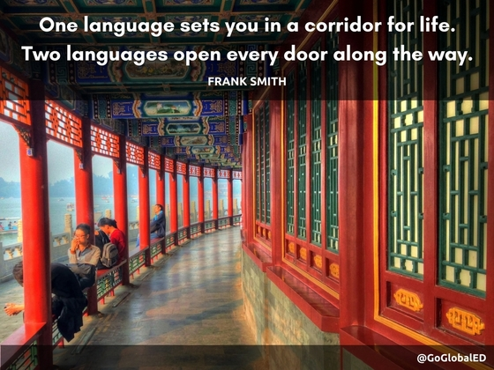
If you know someone who would like to receive the IFLE newsletter, encourage them to sign up HERE!

