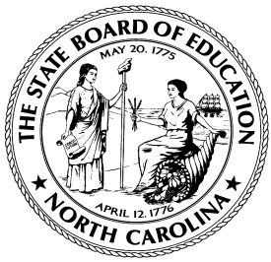

Agenda
Meeting of the
North Carolina State Board of Education

State Board Room, Seventh Floor,

Education Building, 301 N. Wilmington Street

Raleigh, North Carolina 27601-2825

December 20, 2016

State Board of Education Vision: Every public school student will graduate ready for post-secondary education and work, prepared to be a globally engaged and productive citizen.

State Board of Education Mission: The State Board of Education will use its constitutional authority to lead and uphold the system of public education in North Carolina.
tuesday, december 20, 2016
10:00 AM NORTH CAROLINA STATE BOARD OF EDUCATION Meeting
Call to Order
- Chairman Bill Cobey

Approval of the Agenda for December 20, 2016

Review of House Bill 17

Closed Session

Return to Open Session

12:00 PM Adjourn

