
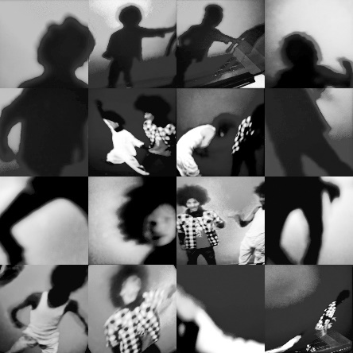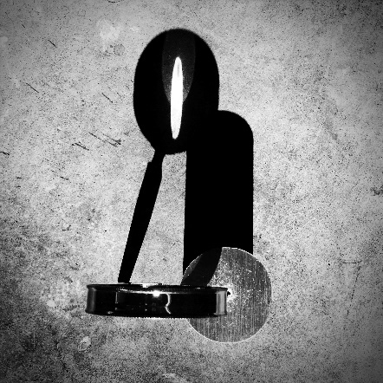
FOR IMMEDIATE RELEASE
Contact:
Stacy Bloom Rexrode, Curator at stacy.bloom-rexrode@raleighnc.gov
October 4, 2019
Celluloids and Light Voids
Warren Hicks and Tama Hochbaum

Artist Reception: December 6, 2019, 6 – 8 PM
October 4, 2019 – January 10, 2020

Block Gallery – Raleigh Municipal Building
222 W. Hargett St., Raleigh, NC 27602

“In photography there is a reality so subtle that it becomes more real than reality.”
— Alfred Stieglitz

Photography has long been a rapidly evolving medium with the introduction of new technologies, making it ever easier to capture an image. Very few artists continue to produce images using tintypes, wet plate negatives or for that matter even rolled film. The introduction of the cell phone camera jettisoned these past image methods to art appreciation lectures and the history books for the most part. These compact mobile devices provide a viable instant image capture with the possibilities of multiples at a time. Long gone is the stress of waiting to learn if you got that perfect shot or waving the Polaroid in a futile effort to speed up the developing time. Both artists of Celluloids and Light Voids utilize their cell phone cameras for convenience and inspiration.
Warren Hicks approach to photography is related to his painting practice, taking on abstracted forms with particular attention to shadow, space, and geometry. Speaking specifically to this series, The Shadow Knows, Hicks states, “I positioned the camera directly above the object to obscure its defining characteristics, only revealing them via their shadow. Shadows can often be more interesting than the objects that cast them.”
Tama Hochbaum uses snippets of dancers to portray fragments of memory and time, and more precisely the passage of time. She shares, “Whether it be the piece I consider to be my first work as an artist, a composite family portrait/landscape etching that I produced in college, or the pieces included in this exhibition, my Silver Screen: Dancers, or the images I worked on this morning, time passing has been the notion that haunts me, the idea that obsesses.”
Both Hicks and Hochbaum use cues from a common language in their works by abstracting or breaking an image down to a more simplistic form. Each requires the viewer to be inquisitive and spend a bit more time with the photograph discovering the magic in the mundane.
BLOCK GALLERY
Connecting local artists to community through ongoing exhibitions and public outreach, the Block Gallery was dedicated in 2006 to honor Miriam Preston Block, a former Raleigh City Council member and community leader. Greeting all visitors to the Upchurch Government Complex, the gallery’s marble walls and elegant staircase provide an ideal setting for showcasing original artworks. Exhibits change every eight to 12 weeks.

OFFICE OF RALEIGH ARTS
The Office of Raleigh Arts, a part of the City of Raleigh’s Parks, Recreation and Cultural Resources Department, fosters and promotes the arts in Raleigh by administering the programs of the Raleigh Arts Commission and the Public Art and Design Board and supporting the Pullen and Sertoma Arts Centers.

Image Credit:
Tama Hochbaum, Les Twins, 2015, Dye sublimation print on aluminum, 40” x 40”
Warren Hicks, The Shadow Knows #1, 2016, Photograph mounted on Dibond, 24” x 24”

