November 2025

To all Laboratorians,

Norovirus season is upon us, and the Montana Department of Public Health and Human Services (DPHHS) needs your help! To improve our outbreak surveillance for norovirus, we are asking you to submit your positive norovirus specimens to the Montana Public Health Laboratory (MTPHL). Outbreaks occurring in congregate settings such as schools, nursing homes, hospitals, and childcare settings are reportable and help public health understand which infectious diseases are circulating in Montana.

Confirming the causative agent for an outbreak is an important task and is necessary to determine the burden of disease, respond appropriately to the disease threat, and accurately understand the pathogenicity of the organism. We are very interested in receiving specimens from these outbreaks to perform further surveillance testing, but unfortunately do not always get specimens submitted.

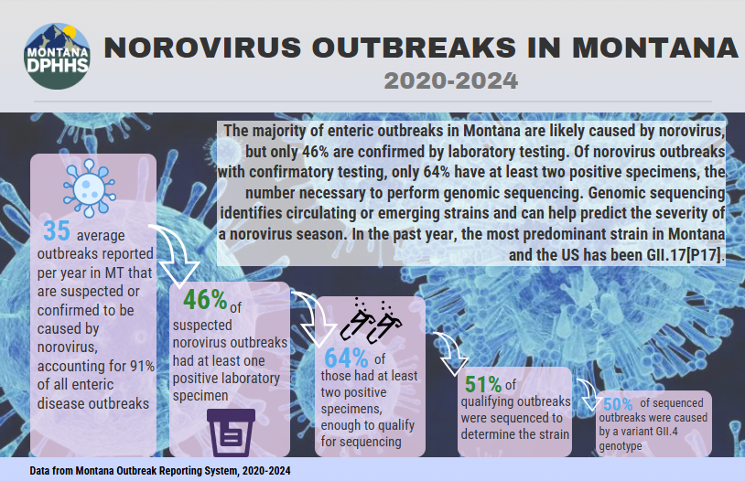
The MTPHL and the Communicable Disease Epidemiology program (CDEpi) partner with the Idaho Bureau of Laboratories to participate in CaliciNet, which is a national database that collects information on norovirus strains associated with gastroenteritis outbreaks. Over the last five years in Montana, from 2020-2024, the majority of norovirus outbreaks were caused by a GII.4 variant, with an increasing number of outbreaks caused by GII.17[P17] occurring in late 2023 and 2024. According to the Centers for Disease Control and Prevention (CDC), the most common strain of norovirus circulating across the United States between September 2024 and August 2025 was GII.17[P17]. CDC data show that in years when a new strain of the virus is introduced, there can be 50% more norovirus illness.

To help in our surveillance efforts, we are asking you to submit positive norovirus specimens to the MTPHL. These specimens will be placed in storage and if an outbreak is identified, they will be further tested and sequenced to determine the outbreak strain.
- If feasible, please send all positive norovirus specimens to the Montana Public Health Laboratory for storage and possible testing in the event of a confirmed outbreak (Fall 2025 – April 2026 only).
  - A minimum of one (1) mL of raw stool (without preservation liquid) is required for testing. Stool should be refrigerated and shipped to MTPHL in cold condition. (Please consider this if you are sending transport swabs to a reference laboratory for PCR testing.)
  - Laboratories on the courier route should use the courier system to send specimens.
- Please order “Hold” using the MTPHL web portal. Choose “Norovirus hold” in Reason for hold.
- Further norovirus testing and sequencing will be performed at no cost on identified outbreak specimens and as requested by CDEpi.
- If your laboratory does not test for norovirus, the MTPHL does provide routine diagnostic testing for norovirus in raw stool specimens.

Thank you in advance for helping improve our understanding of norovirus in Montana.
Please contact the MTPHL (1-800-821-7284) or CDEpi (406-444-0273) with any questions.

https://www.cdc.gov/norovirus/php/reporting/calicinet.html?CDC_AAref_Val=
https://www.cdc.gov/norovirus/php/reporting/calicinet-data.html
https://www.cdc.gov/norovirus/data-research/index.html

