How to Create an OKTA Account
If you have any questions or application issues with the Okta application, please contact the DPPHS Help Desk at 406-444-9500.
- Visit login.mt.gov
  - If you are taken to a screen like this, click the “Citizen Login” button
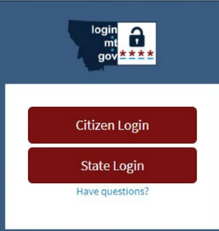
- Click the Sign up link at the bottom of the Sign In screen.
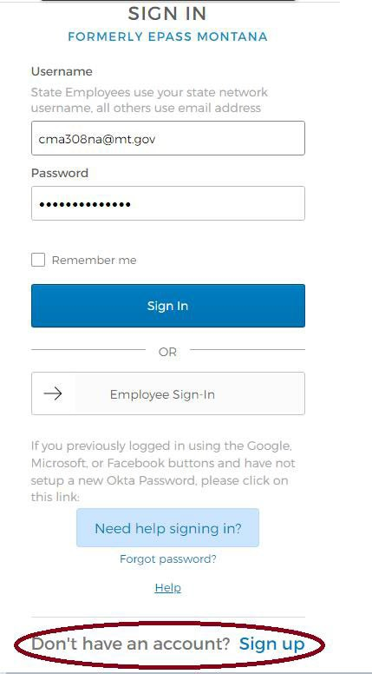
- Enter your email address (the one you use for work), create a new password for your Okta account, enter your first and last name, and click the Register button.
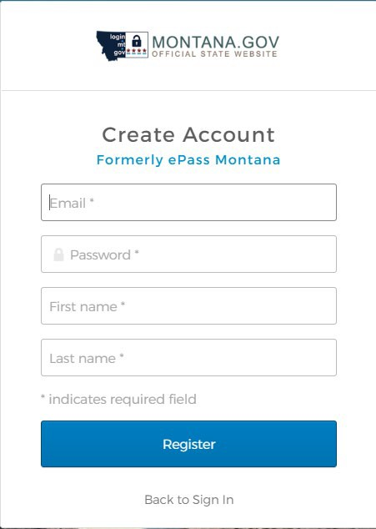
You will see verification message like the image here:
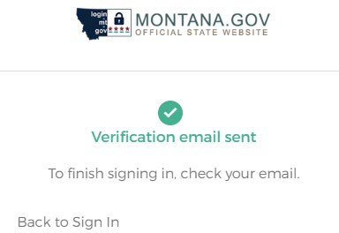
- Check your email account for an Okta activation email.
The email you receive will come from the sender address noreply@okta.com with the subject line “Activate Account”. If you do not see the email in your inbox, it may have been sent to your spam or junk folder. You can always try using your mailboxes search field, using either the senders address or subject line, to find where the email is located within your mailbox
- Click the Activate Account button in the email you received.
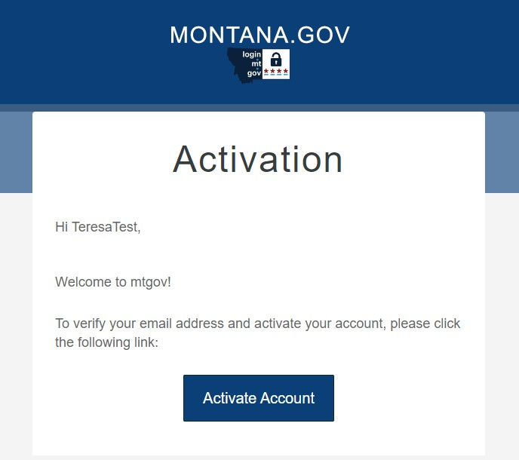
- If a screen like below comes up when completing your Okta security account activation, choose the option: ‘Not Representing a Business’
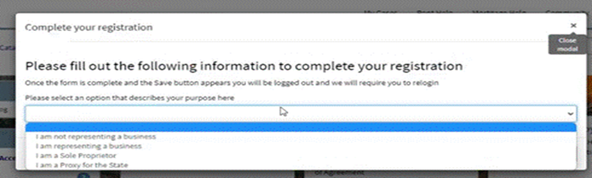

- If you are directed to the sign in page, use your e-mail and the password you created to sign in.
You may be asked to create a security question and select a security image. After doing this, click “Create My Account”
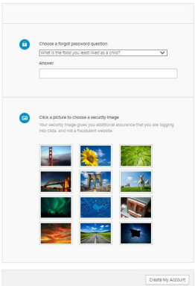
- Once you have successfully signed in to your OKTA account, you will be directed to your dashboard.
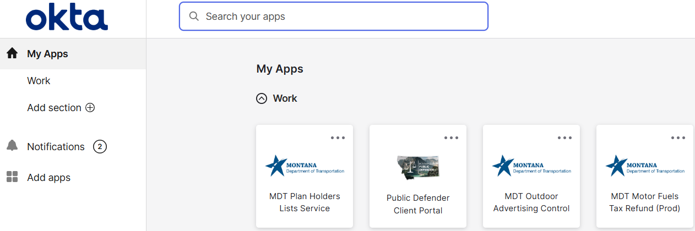

You will see many applications on the dashboard but note the HHS-APP-LABPORTAL application will not appear on your dashboard until access has been granted. You will receive an e-mail when that happens.

- Once you have been granted access to the Lab Portal using your OKTA account (you will receive an e-mail), you will have two options to sign in to the lab portal:

  - Go directly to the https://labportal.hhs.mt.gov link

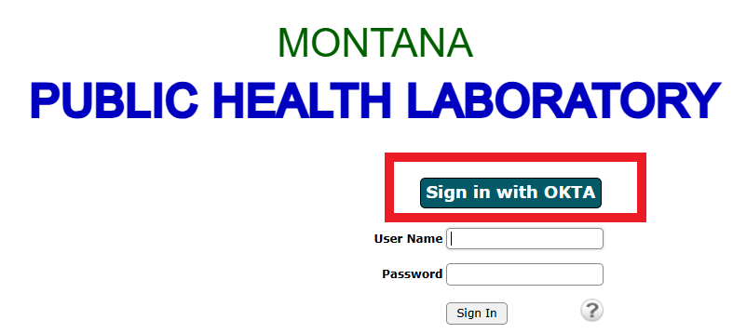

Click the “Sign on With OKTA” button. You will be directed to the OKTA sign in screen to sign in using your OKTA credentials.

  - Go to login.mt.gov and sign in to your OKTA account. Then search for the HHS-APP-LABPORTAL application or find the icon on your dashboard.

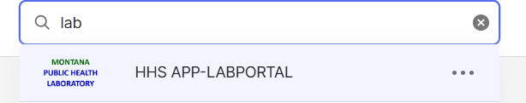

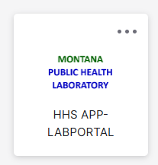

Click on the application to be signed in automatically.

How to Get IT Support for Okta Account Sign-up Issues
If you have issues signing up for an Okta security account, please contact the DPPHS Help Desk at 406-444- 9500.

Resetting Your Forgotten Okta Password
Have you forgotten your Okta password or received a message that you already have an account but don’t know your login information? Please contact the DPPHS Help Desk at 406-444-9500

