MAYO CLINIC ‘s LID-ON Plate Screening Method
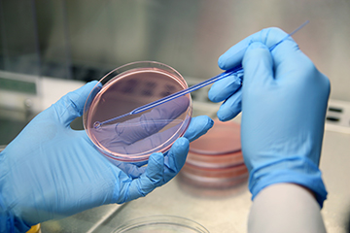
L - Lid stays on plate
I - Inspect visually through lid (assess for growth)
D - Direct to BSC or Bench (all suspicious growth)

O - Open and test safely (manipulate in the BSC only until completely ruled safe)
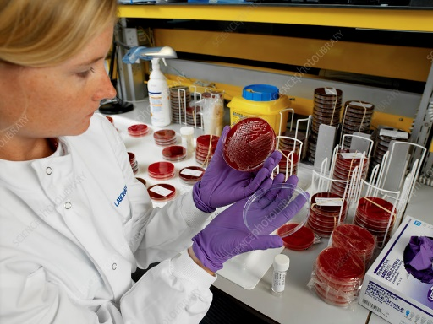
N - No Exposure!
Traditional bench plate examination typically involves either:
- Holding a stack of 4-5 plates in one hand and sequentially flipping the plate lids open to view growth on agar medium or
- Placing plates on a bench top, lid down, and lifting the lids to view growth on agar medium.
This can result in accidental exposure on the benchtop. Preparing gram stains and spot tests (especially catalase) can lead to aerosol production and is another means for exposure to Select Agents. Remember: even small amounts of aerosol production can infect lab personnel!
LID-ON Method for initial culture plate inspection features:
- The risk of accidental exposure is removed by not opening the lids during the initial inspection.
- Plate growth can be seen through the clear agar plate lid.
- Suspicious growth cultures (i.e., pinpoint growth on SBA or MAC plates or Bacillus-like growth) can be set aside for further evaluation in a BSC.
- Minimal to no disruption to the workflow.
For a video of the LID-ON plate screening method see:
https://news.mayocliniclabs.com/select-agents-module
This is an excellent module covering the LID-ON plate screening method as well as Select Agents. To stretch your diagnostic abilities, the module has 6 scenarios that are designed in a fun “Choose Your Own Adventure” format in which the case may be a Select Agent or a mimic organism with similar growth characteristics. This free training module offers 0.5 PACE Credits and is available until May 8, 2025.

