Brucella melitenensis Haemophilus influenzae
Growth on Chocolate Blood agar comparison
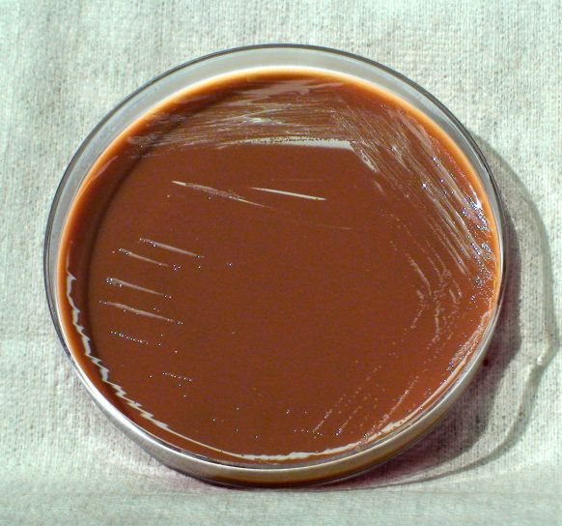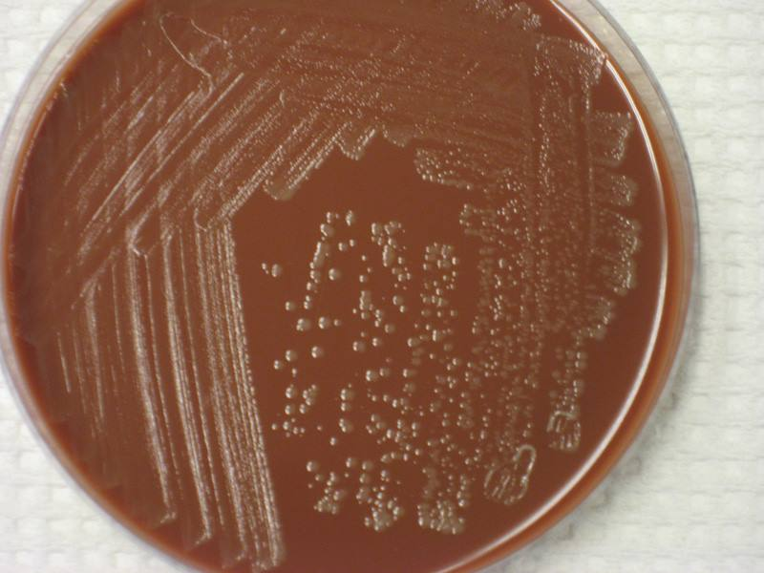
48 hours incubation 48 hours incubation
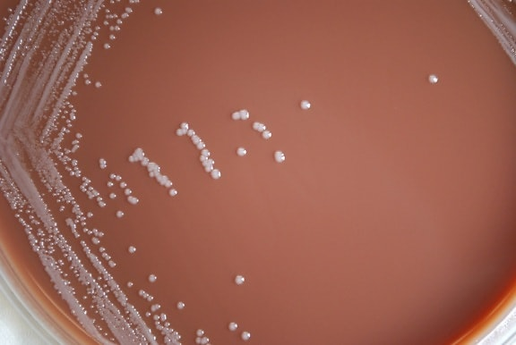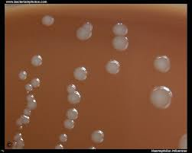
4-5 days incubation 2 days incubation
Classic Brucella spp. (non-Ochrobactrum spp.) are often difficult to differentiate from Haemophilus influenzae. Both organisms grow slowly on Chocolate agar and do not grow on MacConkey agar.
Gram Stain comparison
