Burkholderia mallei Burkholderia pseudomallei
Growth on Sheep Blood agar comparison
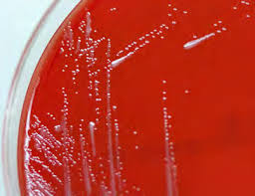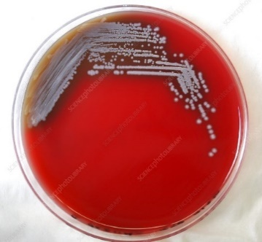

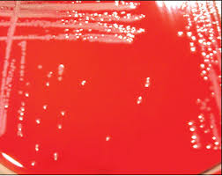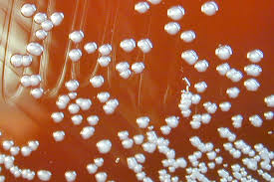
Both organisms grow on SBA and MacConkey agars slowly, are non-hemolytic, and non-fermentative. B. mallei has smooth, gray, translucent, odorless colonies whereas B. pseudomallei has creamy, white, musty/earthy smelling colonies on SBA at 48 hours.

Gram Stain comparison
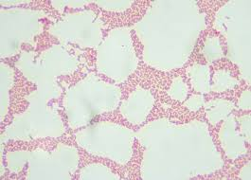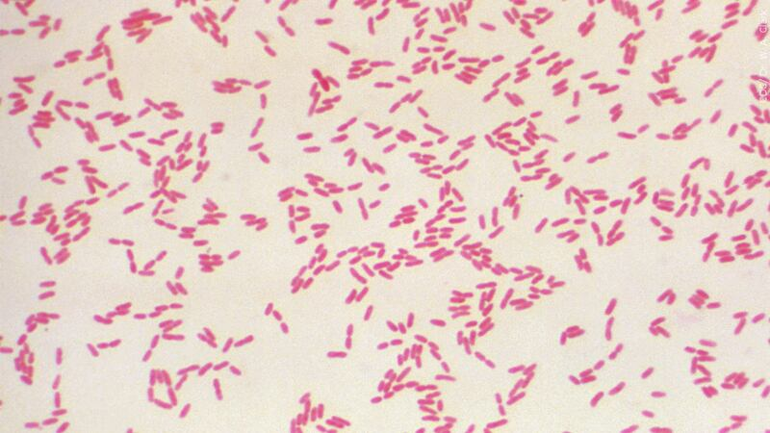
Gram stain: B. mallei is a small, straight, or slightly curved gram-negative coccobacillus with rounded ends. B. pseudomallei is a straight or slightly curved gram-negative bacillus and may show bipolar staining in direct specimens or young cultures.

