*These instructions are for Microsoft excel 365. If a different version is being used, the instructions may be a little different.

Navigate to the tableau site via your desktop or web browser

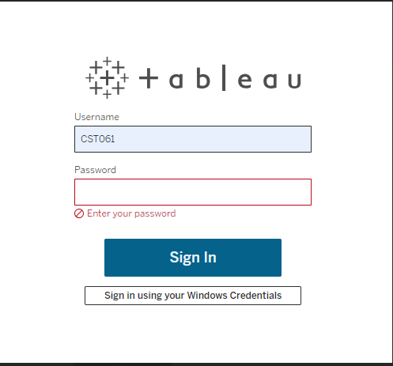
Login using your C/P# and password

From the homepage, click explore on the lefthand side
*note your homepage will look different depending on your “favorite” reports
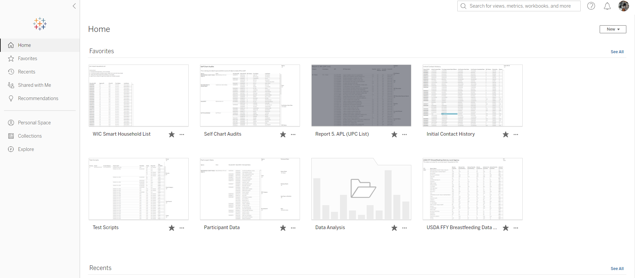

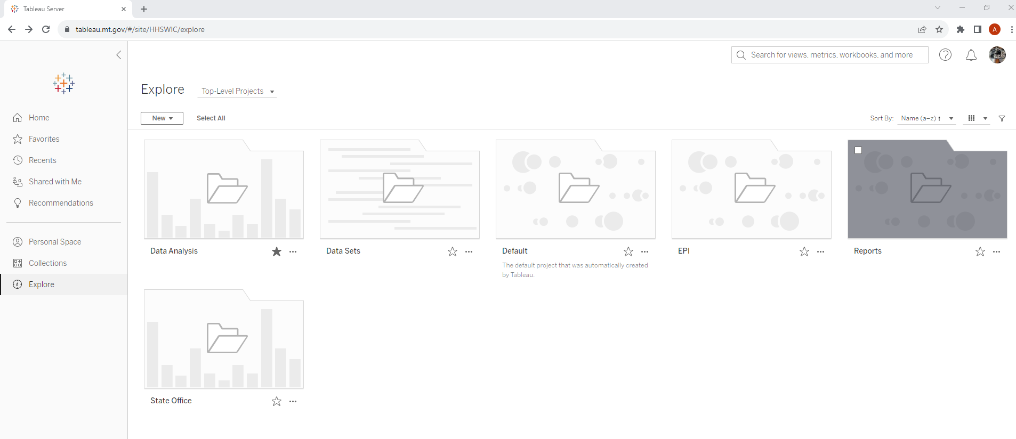
Click Reports

Click Certified No Benefits
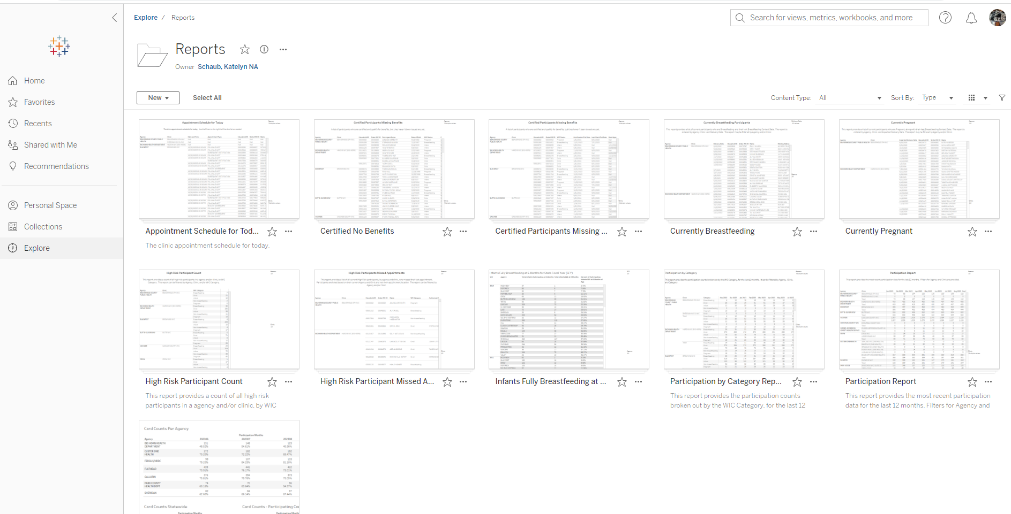

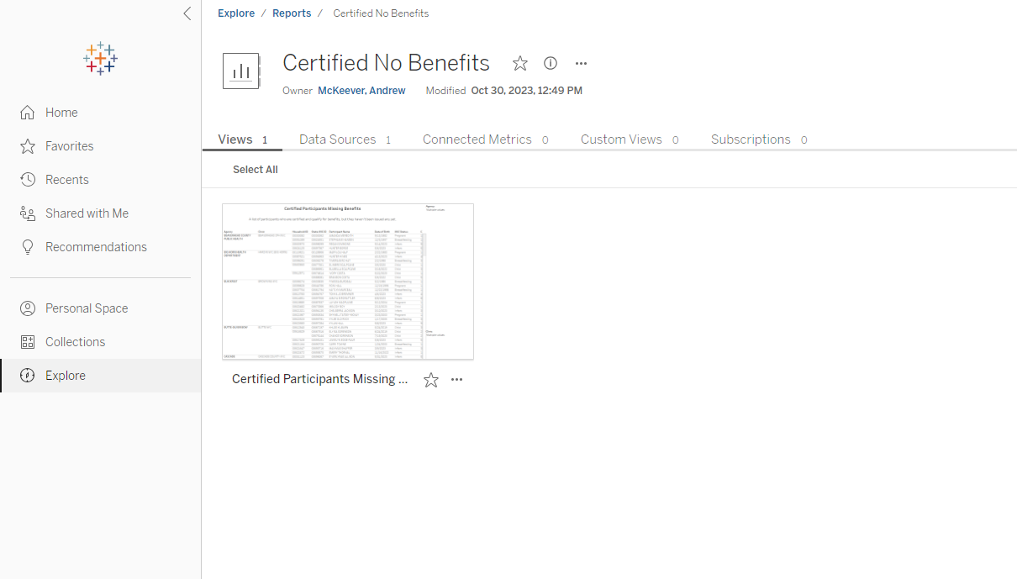
Click Certified Participants Missing….

On the right-hand side drop down the agency box and the clinic box. Your agency/clinic options will be same as SPIRIT and will not be the same as this screenshot.
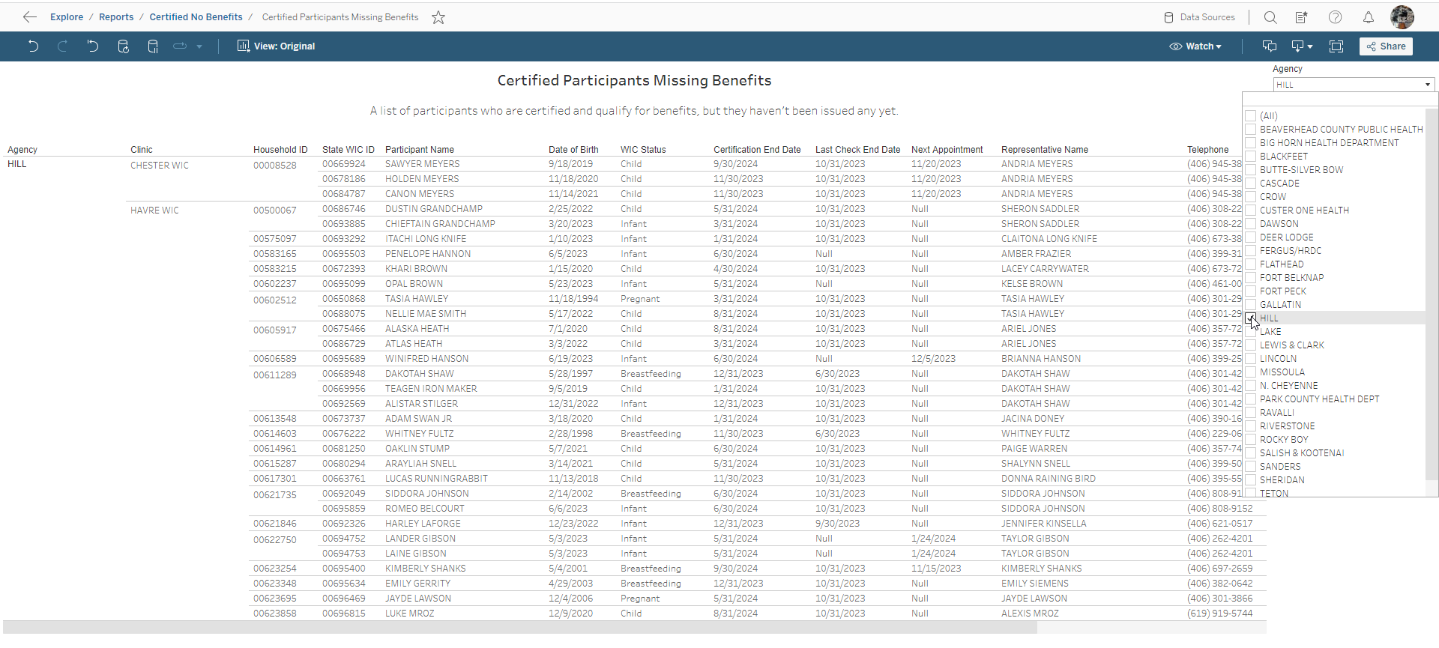

Click in the top right corner “choose a format to download”.
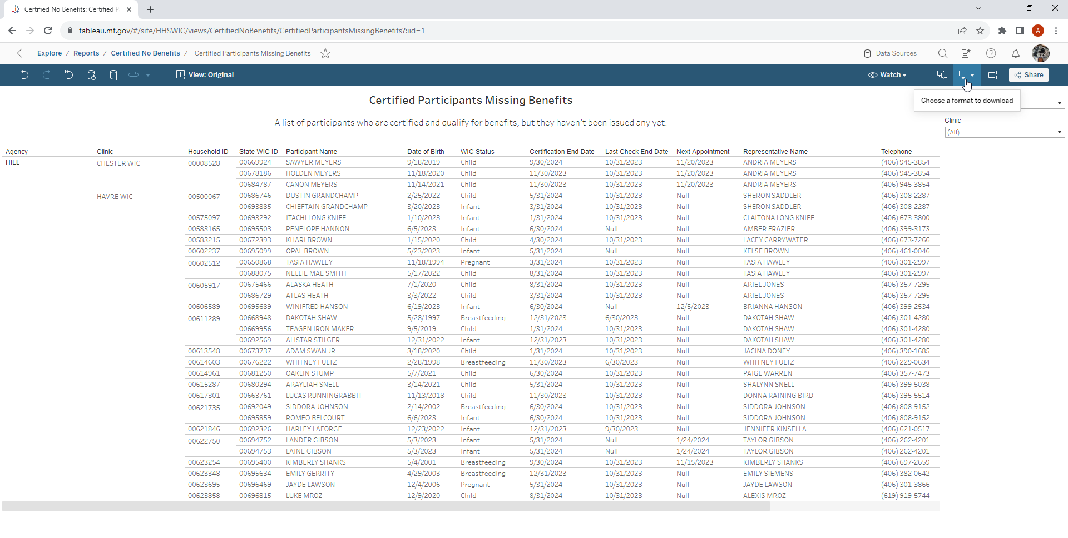

Choose “crosstab”
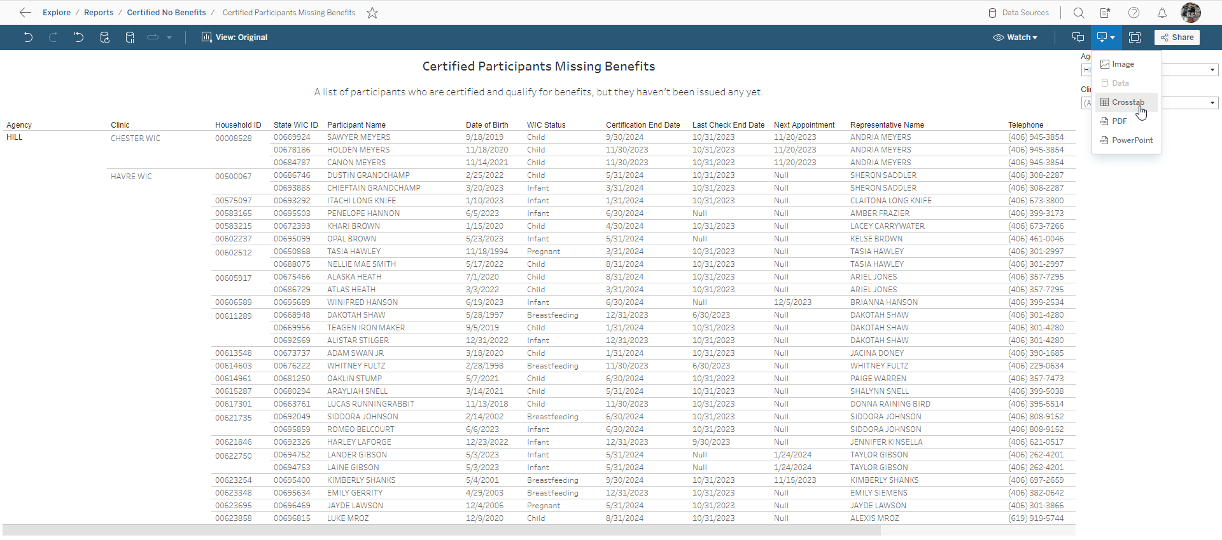

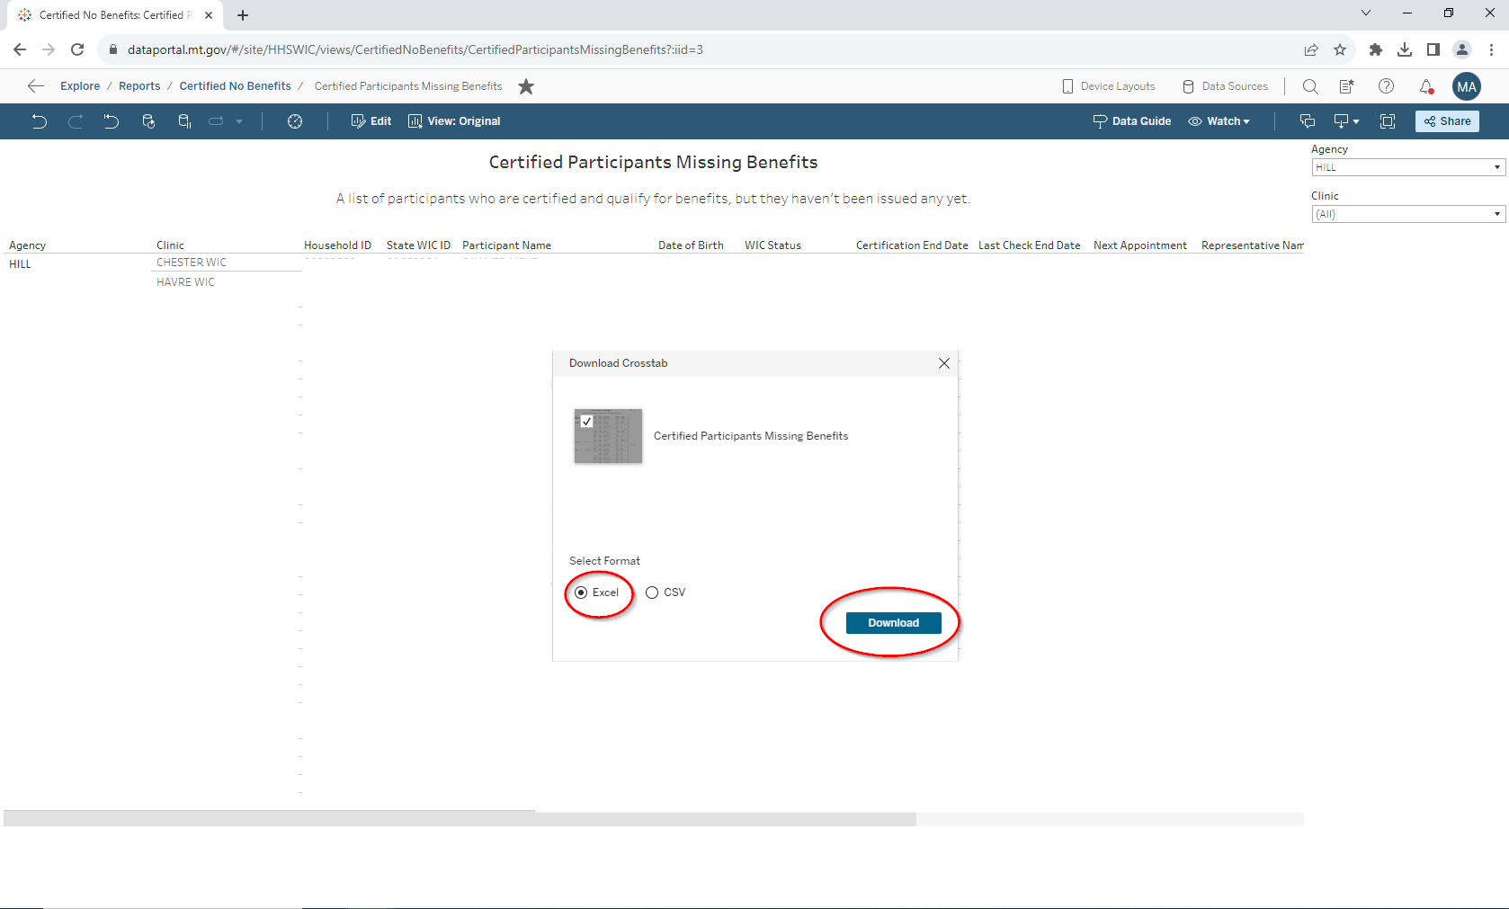
Choose excel and click download

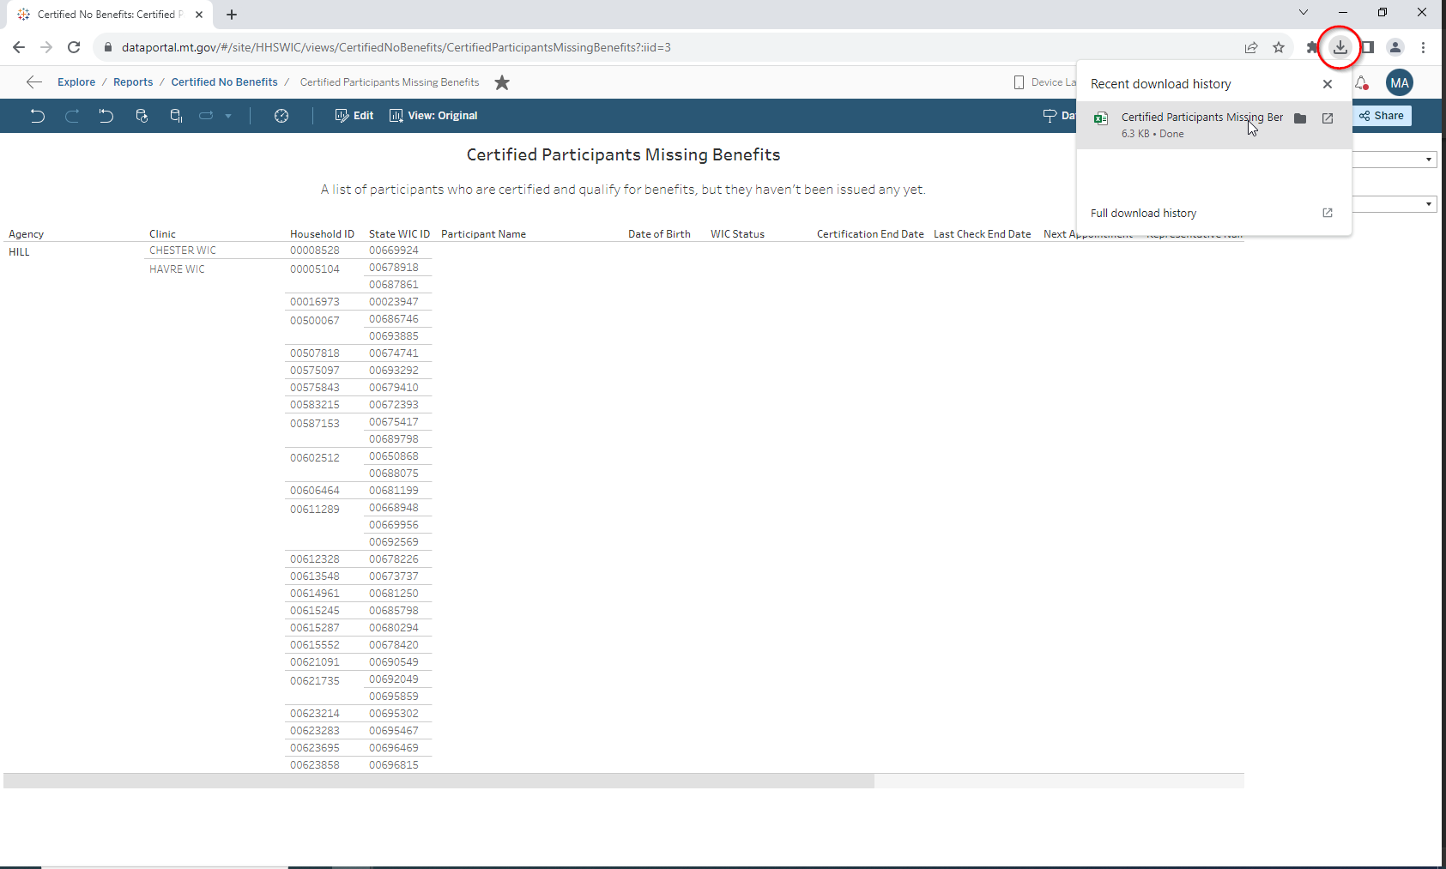
Click the downloaded file in the top right corner (chrome browser)

Open document
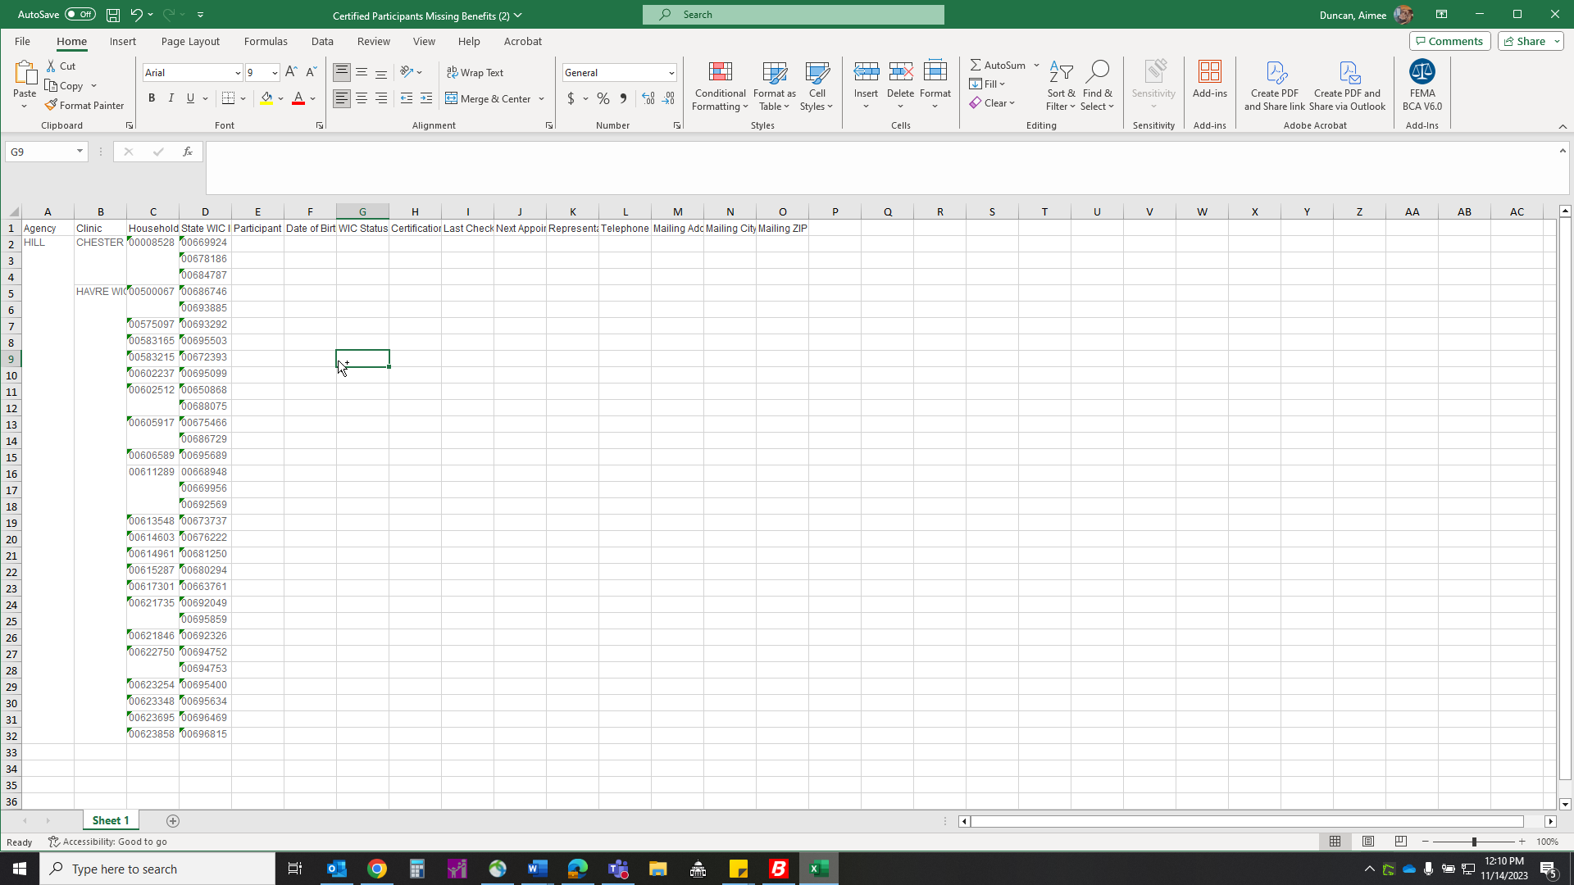

Click “page layout” at the top of the screen. Choose orientation and click “landscape”
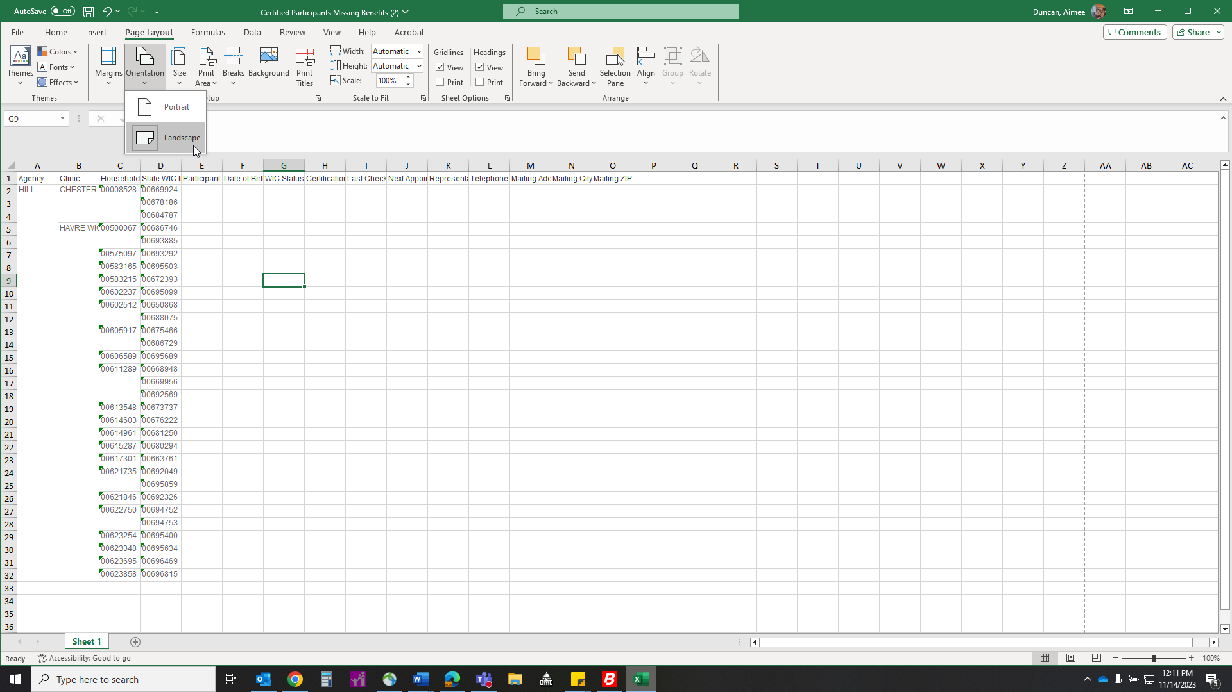

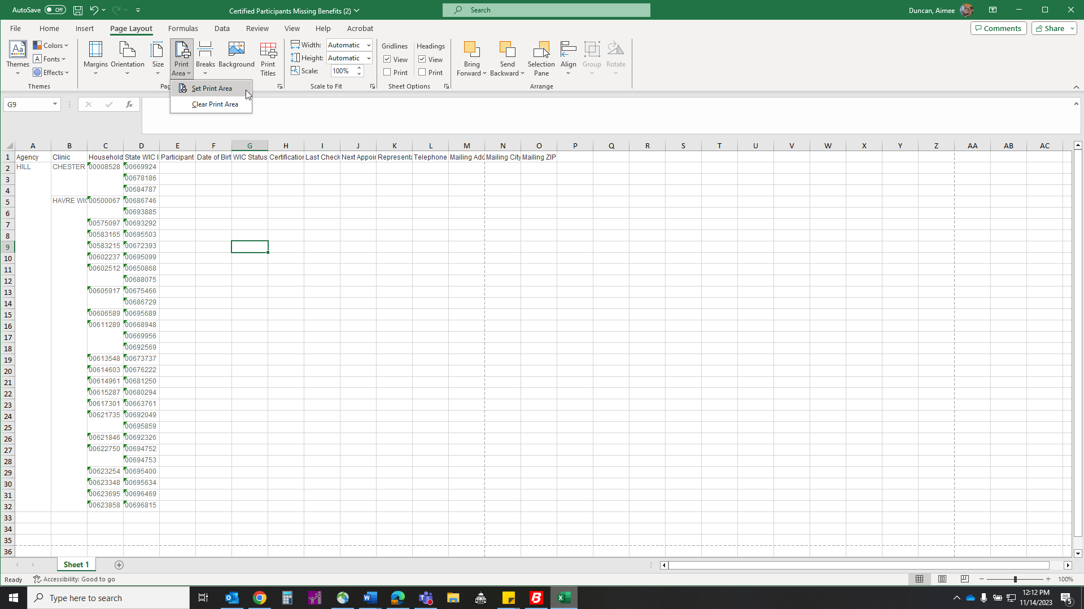
12. Select “print area” and “set print area

Select “print area” and “set print area

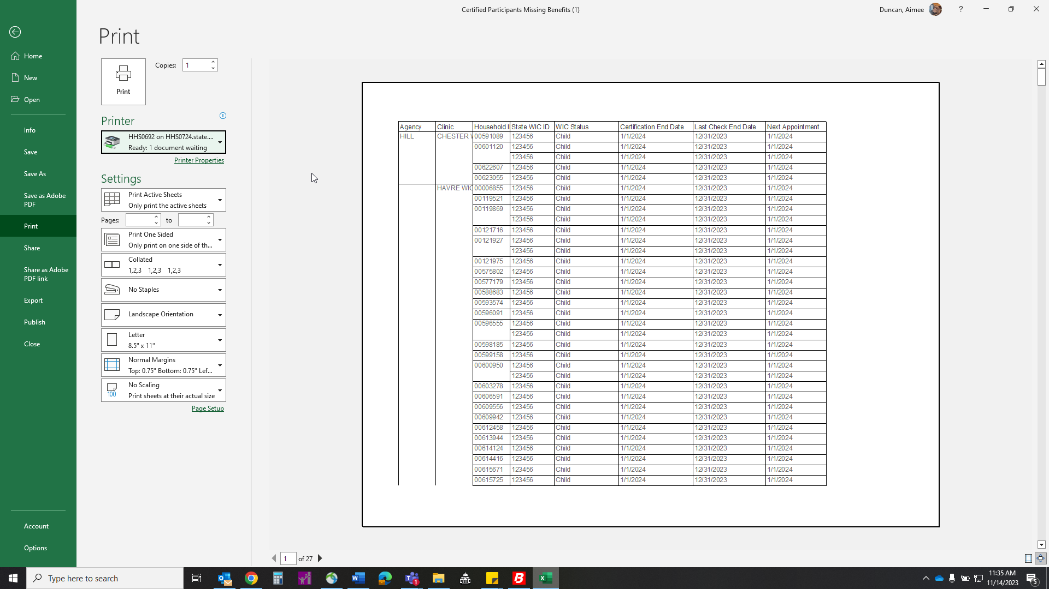

The edges of the printed area will show up as a dotted line
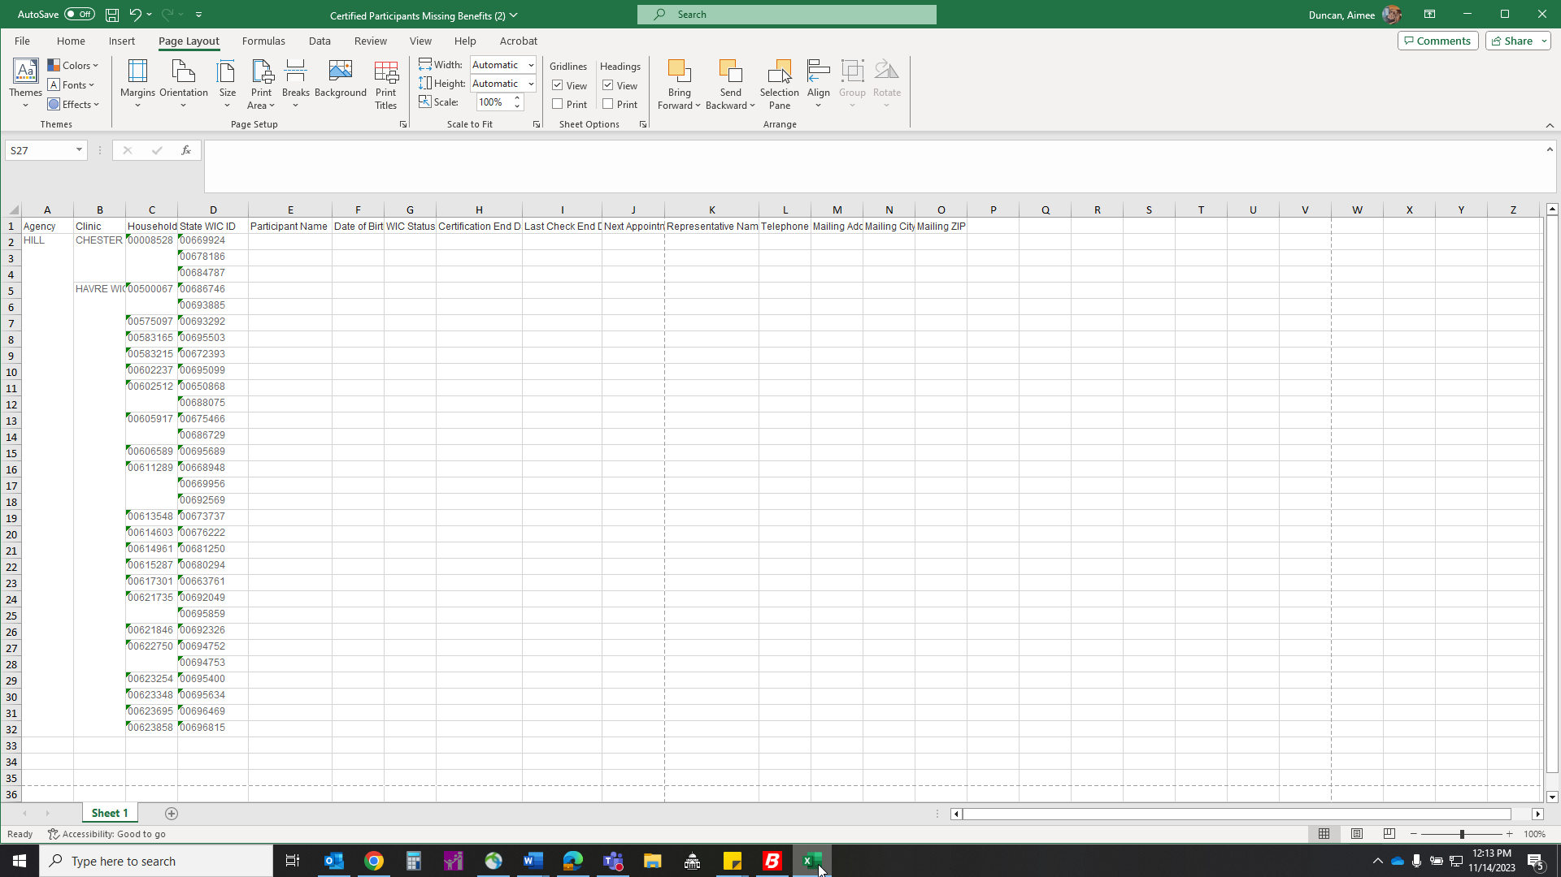

OPTIONAL* If you want to remove any columns in a report, Highlight (ctrl + click column header) and delete (right click, click delete) Ex: Keep HHID, WIC ID, cert end date, last check end date, next appointment
- This may be used if you want to get everything on one page for printing. This is not required.
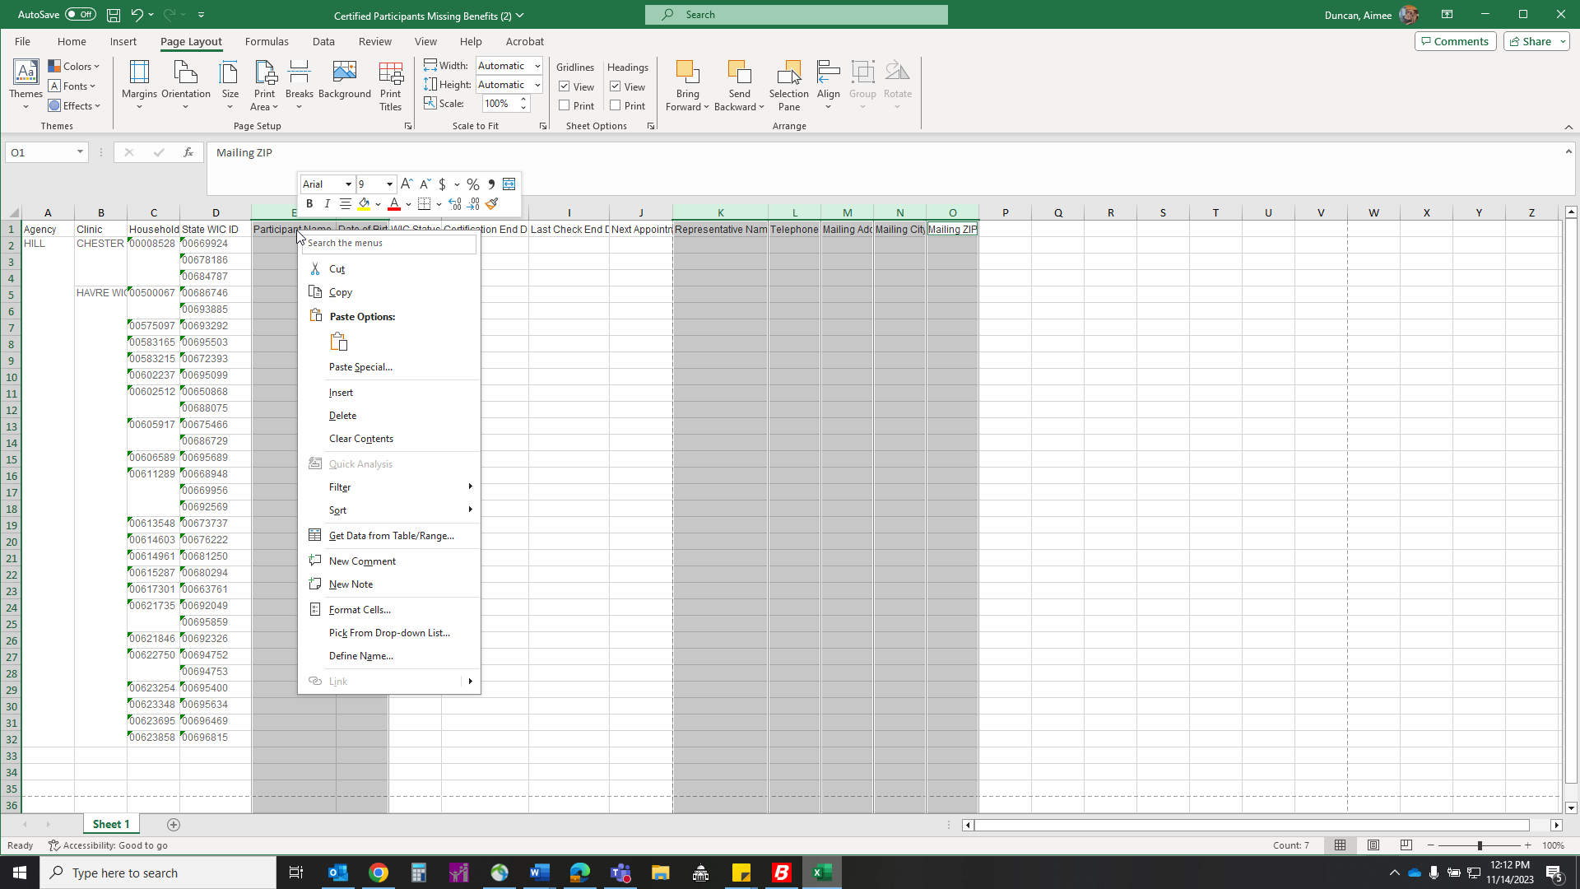

Adjust cells so that you can see all relevant information you would like and make sure they fall to the left of the dotted line, otherwise it will not print. You may need to drag the right edge of the cells to see all the information in the box.
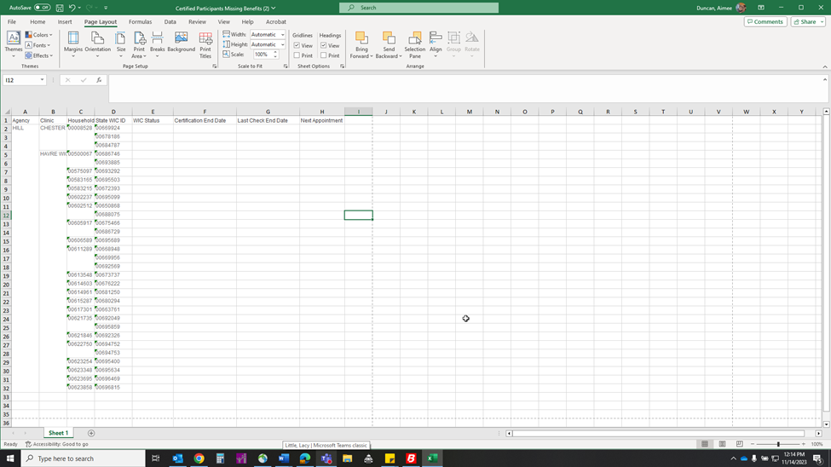

Drag to select all cells on the screen
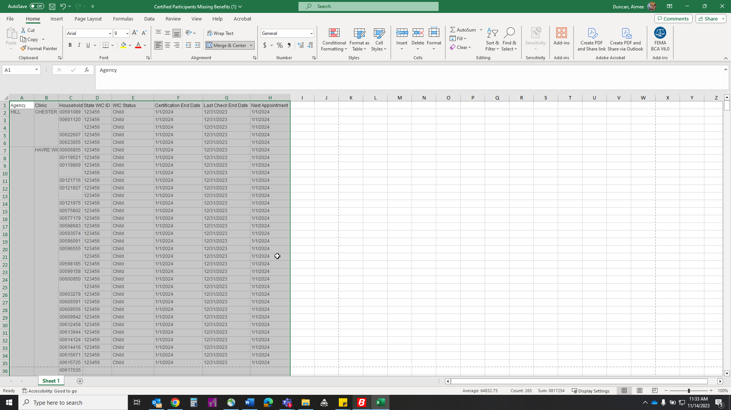

Select the border option, on the home tab, under the font on the toolbar. Click “all borders”
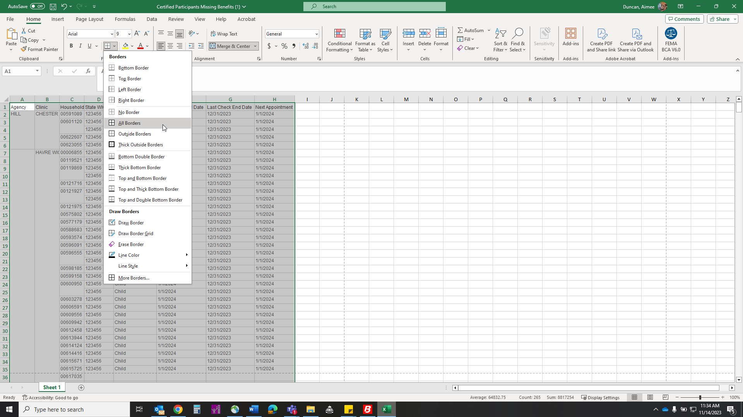
Next, we are going to print. Click file in the top left corner.

Select print from the menu on the left
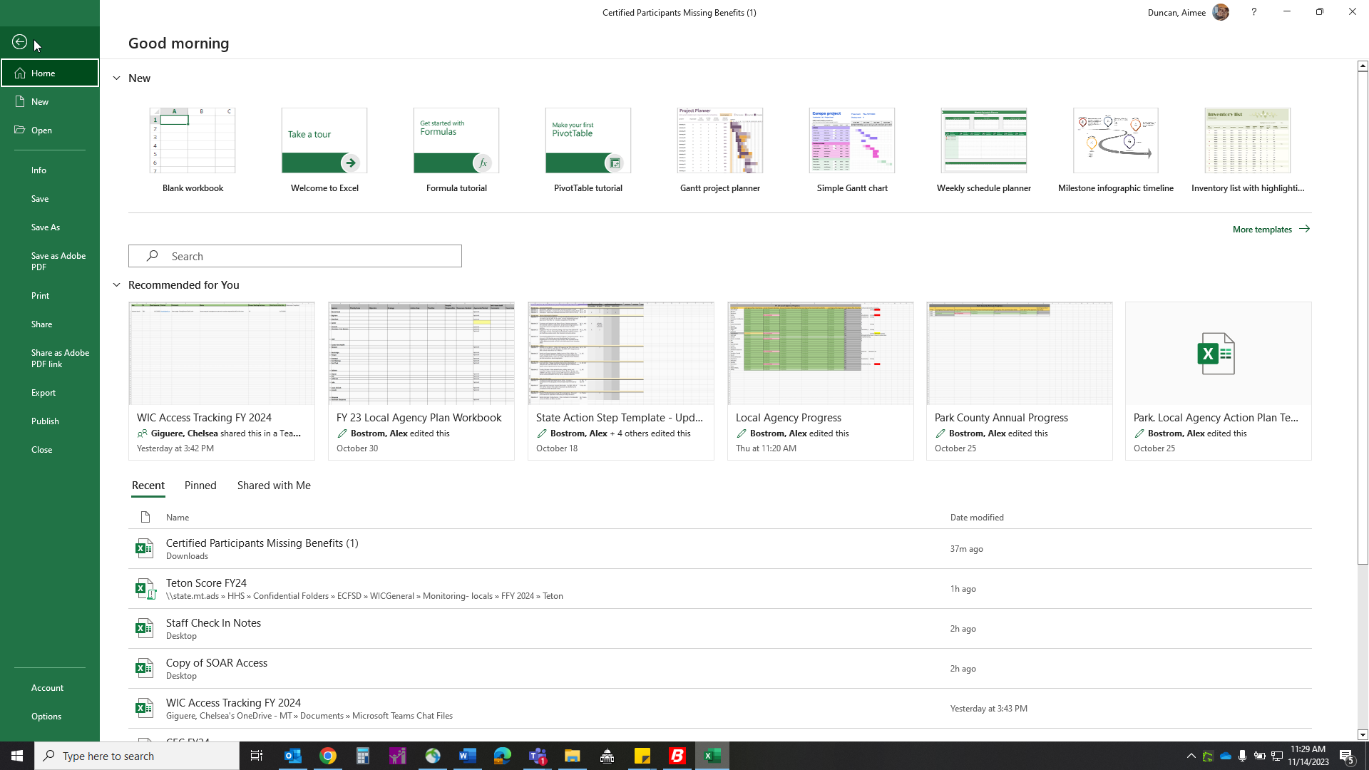

Preview your document before printing to ensure all information is present, Click Print

