Bacillus anthracis Bacillus cereus (not biovar anthracis)

Growth on Sheep Blood agar comparison
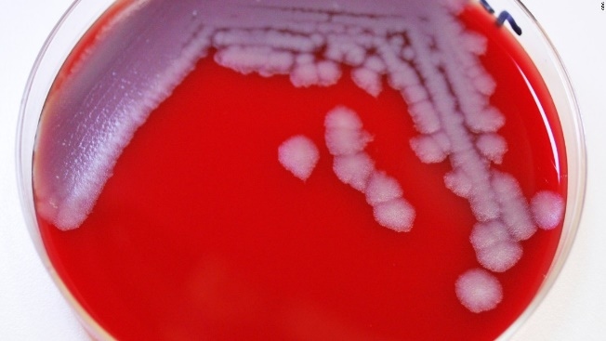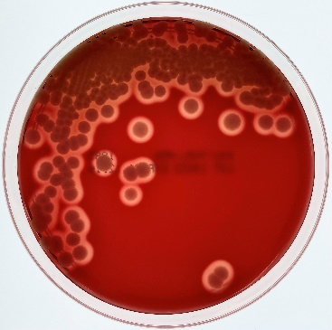
B. anthracis colonies: NON-hemolytic B. cereus colonies: HEMOLYTIC

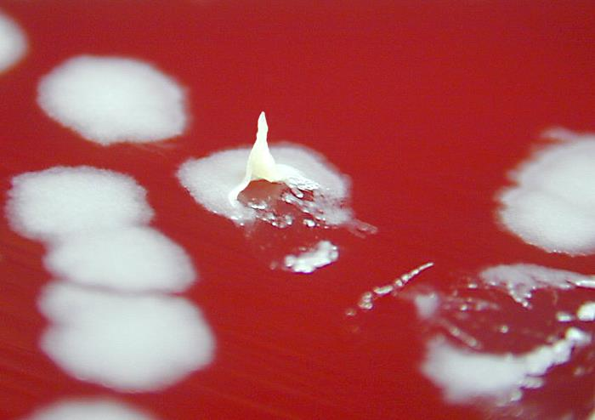
B. anthracis forms tenacious “Sticky” colonies. B. cereus does not form tenacious colonies.

Gram Stain comparison
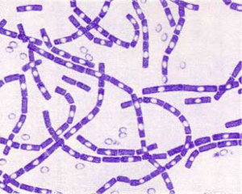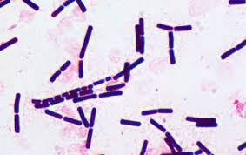
Large, gram-positive bacilli, catalase positive, and demonstrate endospore production better in vitro.

