Montana Census 2020
  - Make It Count!

Complete Count Committee Toolkits
Thank you for being part of the U.S. Census Bureau’s Complete Count Committee (CCC) program. On behalf of the State Complete Count Committee, we are providing you with a toolkit to assist with your efforts to promote the upcoming Census. Included in each CCC Toolkit is a banner, stickers, magnets, window clings, rack cards. These toolkits are designed to create excitement and get people talking about the Census, and self-respond once the count beings in early March. Below are some promotional ideas for each item.
Banner
A successful strategy is placing the banner in a high exposure area(s) like busy road-side intersections, heavily trafficked thoroughfares, and busy traffic signals. Walking area shopping locations are also a good contender for placing banners in and around your community. The goal is to ensure information about the upcoming 2020 Census is seen by as many residents as possible so hanging a banner at a special event or places where many people gather is important. Your CCC’s banner may be delivered later than the rest of the toolkit.
Census day is April 1st, but most households will BEgin to Fill out the form starting in early march. now is the time to start educating and promoting!
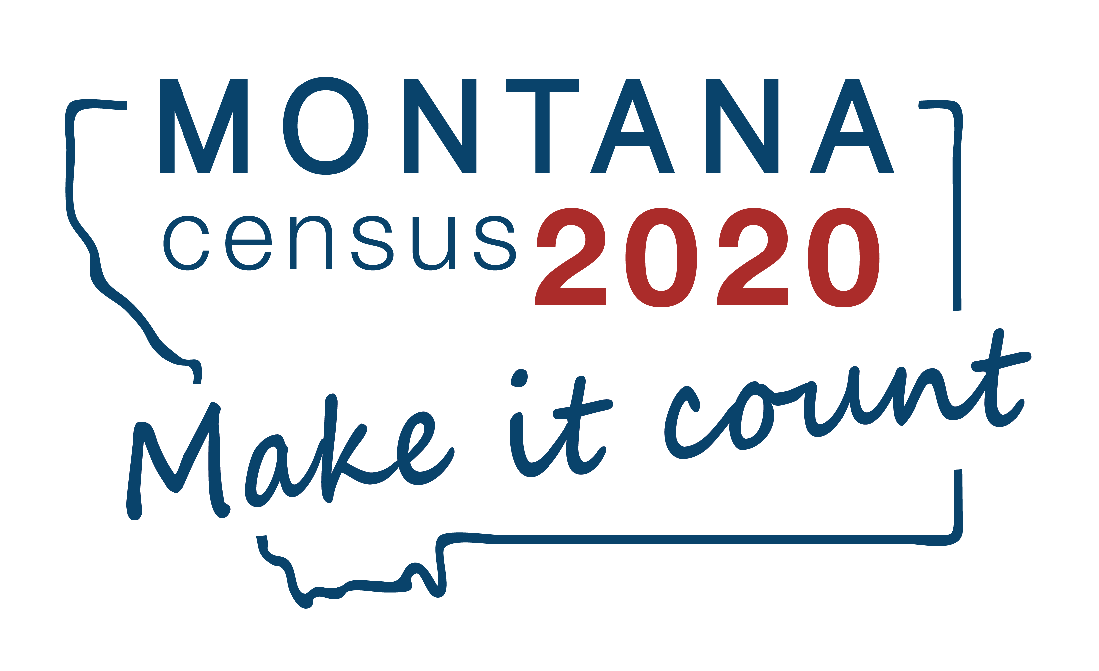

Stickers
Stickers can be thought of as mini billboards, giving people an opportunity to notice and gain top-of-mind awareness of the upcoming Census. People like to get something for free (especially if it features Montana) and stickers are a fun and interactive way to reach out to community members.

Magnets
Magnets are a great n0-residue option for promoting the Census. Consider where people go and find opportunities for magnet placement: a shared company refrigerator, a public bus stop, school lockers, inside restroom stalls. The magnets will not harm whatever they are placed on so get creative with where they can go.

Window Clings
Window space is valuable promotional real estate. Automobile windows, business or organization doors, and office space windows are a great place to use the no-residue, static clings. Some additional location ideas include supermarkets and gas stations, utility vehicle windows, health clinics and government building windows. Organizations and businesses can show they support the Census by placing window clings in highly visible locations.

Rack Cards
The rack cards are a convenient tool to help educate about the importance of the upcoming Census. This easy-to-hand-out card features information about what is at stake for Montana and how quick, easy, and secure responding to the Census is. Be sure to distribute the rack cards far and wide so they can be seen by as many people as possible. Some location ideas are Chambers of Commerce, visitors and community centers, hospitals and healthcare centers, restaurants, rest stops, public libraries, businesses, non-profits, or other high traffic location where they are likely to be seen, read, and taken.

State CCC Resources
The State CCC has been working diligintly to help promote the upcoming Census. Be sure you are staying up to date by:
- Checking CENSUS.MT.GOV frequently, especially the resources section for new flyers, videos, and other promotional material.
- Sign up for our weekly Montana 2020 Census Newsletter.
- Share content from our @MontanaCensus2020 Facebook page.
        - Be apart of our bi-weekly Census phone calls which will begin in late January.
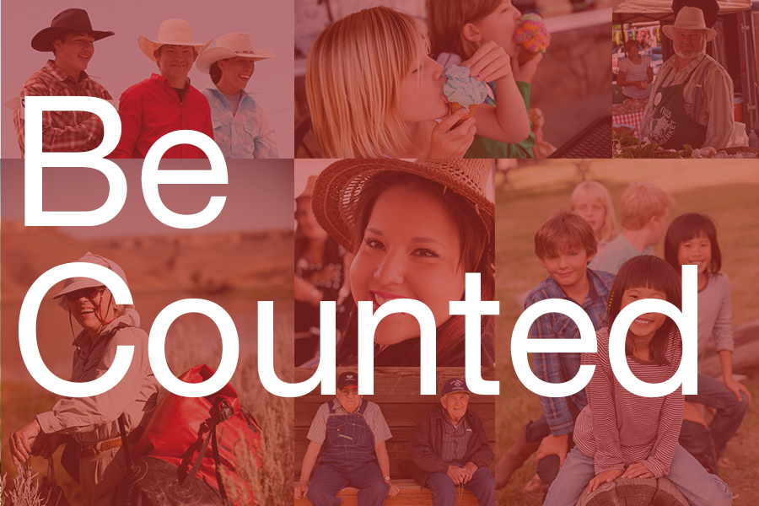
Contact Us
Montana Census 2020
Department of Commerce
301 S. Park Ave
Helena, MT 59620

406.841.2870

