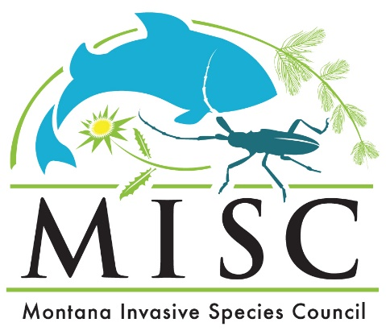
October 16, 2025
Meeting Agenda

Location: Fort Peck Fish Hatchery
277 MT-117, Fort Peck, MT 59223

All participants must register to attend before October 9, 2025.
Registration Link

8:30 AM Welcome, Roll Call & Minutes
Action: Vote on Meeting Minutes
9:00 AM MISC Staff Updates
2026 Summit Discussion
10:00 AM Committee Updates
Woody Invasives-Sara Ricklefs
Citizen Science-Bryce Maxell
SAP-Assess Invasiveness-Bryce Christiaens
10:30 AM Feral Swine Updates
Dale Knouse-Saskatchewan Crop Insurance Corporation-invited
Tahnee Szymanski-Montana Department of Livestock
12:00 PM Lunch
1:00 PM AIS Updates
Tom Woolf-Montana Fish, Wildlife & Parks
Ben Holen-North Dakota Game and Fish
2:30 PM Fort Peck Dam History/Fort Belknap
Dennis Longknife Jr.-Fort Belknap Indian Community
3:00 PM Round Robin Updates
4:30 PM Public Comment
5:00 PM Wrap-Up & Adjourn

October 17th Nashua Watercraft Inspection Station Visit
9:00 AM Meet at Intersection of US Hwy 2 and Route 438

The agenda is subject to change and times are approximate; actual times may vary up to one hour.

This meeting is open to the public. Persons who want to attend in-person or virtually must register before the end of day on October 9, 2025. Meeting information is available at invasivespecies.mt.gov/misc/meeting-schedule.

The Montana Department of Natural Resources and Conservation will make reasonable accommodations for persons with disabilities who wish to participate in the public meeting.

For questions about this meeting contact Russ Hartzell at 406-324-0021 or russ.hartzell2@mt.gov

