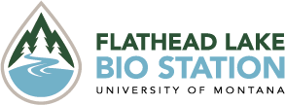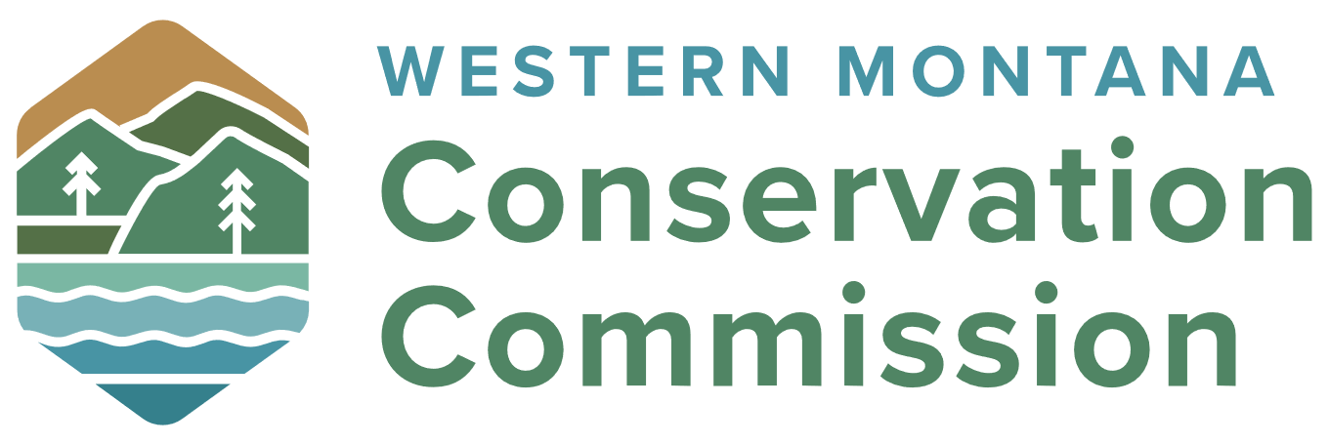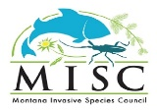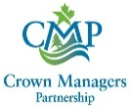

Early Detection and Monitoring Training
Monday June 2nd, 2025

Agenda

Monday June 2nd

10:00am Welcome/Introductions (Phil Matson, FLBS)

10:15am Management of AIS (FWP)

10:30am eDNA theory and overview for AIS Early Detection (FLBS)

10:45am – Station Rotations (30-minutes, 5 stations)

10:45am – Station 1: Plant ID and vouchers – FWP

11:15am – Station 2: Invert ID and vouchers - FWP

11:45am – Station 3: Sampling Techniques – FWP

12:15pm – Station 4: eDNA Sampling – FLBS

12:45pm – Station 5: After the Sampling: Decontamination/Data –FWP

1:15pm – Lunch (courtesy of Western Montana Conservation Commission)

2:00 – 4:00pm Field Trip*, All Taxa Survey (Marina Cay, Bigfork)

*Bring your own waders and cold/wet weather gear. RSVP to phil.matson@flbs.umt.edu

