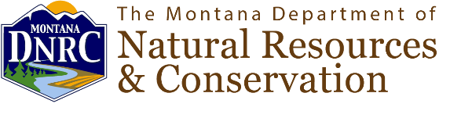
FOR IMMEDIATE RELEASE
March 25, 2025

Contact:
KarenDe Herman, Communications Specialist
Montana Department of Natural Resources and Conservation
406-444-5581

Montana Invasive Species Advisory Council Announces Open Positions
Applications due June 30, 2025
HELENA, Mont. – The Montana Invasive Species Council (MISC) today encouraged eligible Montanans to apply for open positions to serve a four-year term on the council. The council provides guidance on a science-based, comprehensive program to identify, prevent, eliminate, reduce, and mitigate invasive species in Montana. MISC coordinates with public and private partners to develop and implement statewide invasive species strategic plans.
The following council terms are open:
- Blackfeet Nation Representative
- County Weed Districts Representative
- Little Shell Tribal Government Representative
- Northern Cheyenne Government Representative
Advisory council members are appointed by the Governor and the council is attached to the Montana Department of Natural Resources and Conservation (DNRC).
Members are expected to attend up to four meetings per year and to serve on subcommittees for short-term projects as needed.
Those interested in serving on MISC are encouraged to apply on the Montana Board and Appointments website by June 30, 2025 using the search word “invasive.”
###
About DNRC: The DNRC’s mission is to help ensure that Montana's land and water resources provide benefits for present and future generations. For more information visit https://dnrc.mt.gov/.

